








Source and provide destination information and advice
D2.TTA.CL2.19
Trainer Guide

Source and provide destination information and advice
D2.TTA.CL2.19
Trainer Guide





Project Base
William Angliss Institute of TAFE
555 La Trobe Street
Melbourne 3000 Victoria
Telephone: | (03) 9606 2111
Facsimile: | (03) 9670 1330
Acknowledgements
Project Director: | Wayne Crosbie
Project Manager | Jim Irwin
Chief Writer: | Alan Hickman
Subject Writer: | Nick Hyland
Editor: | Jim Irwin
DTP/Production: | Daniel Chee, Mai Vu, Cindy Curran

The Association of Southeast Asian Nations (ASEAN) was established on 8 August 1967. The Member States of the Association are Brunei Darussalam, Cambodia, Indonesia, Lao PDR, Malaysia, Myanmar, Philippines, Singapore, Thailand and Viet Nam.
The ASEAN Secretariat is based in Jakarta, Indonesia.
General Information on ASEAN appears online at the ASEAN Website: www.asean.org.
All text is produced by William Angliss Institute of TAFE for the ASEAN Project on “Toolbox Development for Tourism Labour Divisions for Travel Agencies and Tour Operations”.
This publication is supported by the Australian Government’s aid program through the ASEAN-Australia Development Cooperation Program Phase II (AADCP II).
Copyright: Association of Southeast Asian Nations (ASEAN) 2015.
All rights reserved.
Disclaimer
Every effort has been made to ensure that this publication is free from errors or omissions. However, you should conduct your own enquiries and seek professional advice before relying on any fact, statement or matter contained in this book. The ASEAN Secretariat and William Angliss Institute of TAFE are not responsible for any injury, loss or damage as a result of material included or omitted from this course. Information in this module is current at the time of publication. Time of publication is indicated in the date stamp at the bottom of each page.
Some images appearing in this resource have been purchased from stock photography suppliers Shutterstock and iStockphoto and other third party copyright owners and as such are non-transferable and non-exclusive. Clip arts, font images and illustrations used are from the Microsoft Office Clip Art and Media Library. Some images have been provided by and are the property of William Angliss Institute.
Additional images have been sourced from Flickr and SXC and are used under Creative Commons licence: http://creativecommons.org/licenses/by/2.0/deed.en
File name: TG_Source_&_provide_destination_information_advice_170314





Table of contents
Competency Based Training (CBT) and assessment – An introduction for trainers 1
Competency standard 11
Notes and PowerPoint slides 23
Recommended training equipment 171
Instructions for Trainers for using PowerPoint – Presenter View 175
Appendix – ASEAN acronyms 177

Competency Based Training (CBT) and assessment – An introduction for trainers

Competency
Competency refers to the ability to perform particular tasks and duties to the standard of performance expected in the workplace.
Competency requires the application of specified knowledge, skills and attitudes relevant to effective participation, consistently over time and in the workplace environment.
The essential skills and knowledge are either identified separately or combined.
Knowledge identifies what a person needs to know to perform the work in an informed and effective manner.
Skills describe the application of knowledge to situations where understanding is converted into a workplace outcome.
Attitude describes the founding reasons behind the need for certain knowledge or why skills are performed in a specified manner.
Competency covers all aspects of workplace performance and involves:
- Performing individual tasks
- Managing a range of different tasks
- Responding to contingencies or breakdowns
- Dealing with the responsibilities of the workplace
- Working with others.

Unit of competency
Like with any training qualification or program, a range of subject topics are identified that focus on the ability in a certain work area, responsibility or function.
Each manual focuses on a specific unit of competency that applies in the hospitality workplace.
In this manual a unit of competency is identified as a ‘unit’.
Each unit of competency identifies a discrete workplace requirement and includes:
- Knowledge and skills that underpin competency
- Language, literacy and numeracy
- Occupational safety and health requirements.
Each unit of competency must be adhered to in training and assessment to ensure consistency of outcomes.

Element of competency
An element of competency describes the essential outcomes within a unit of competency.
The elements of competency are the basic building blocks of the unit of competency. They describe in terms of outcomes the significant functions and tasks that make up the competency.
In this manual elements of competency are identified as an ‘element’.

Performance criteria
Performance criteria indicate the standard of performance that is required to demonstrate achievement within an element of competency. The standards reflect identified industry skill needs.
Performance criteria will be made up of certain specified skills, knowledge and attitudes.

Learning
For the purpose of this manual learning incorporates two key activities:
- Training
- Assessment.
Both of these activities will be discussed in detail in this introduction.
Today training and assessment can be delivered in a variety of ways. It may be provided to participants:
- On-the-job – in the workplace
- Off-the-job – at an educational institution or dedicated training environment
- As a combination of these two options.
No longer is it necessary for learners to be absent from the workplace for long periods of time in order to obtain recognised and accredited qualifications.

Learning approaches
This manual will identify two avenues to facilitate learning:
Competency Based Training (CBT)
This is the strategy of developing a participant’s competency.
Educational institutions utilise a range of training strategies to ensure that participants are able to gain the knowledge and skills required for successful:
- Completion of the training program or qualification
- Implementation in the workplace.
The strategies selected should be chosen based on suitability and the learning styles of participants.

Competency Based Assessment (CBA)
This is the strategy of assessing competency of a participant.
Educational institutions utilise a range of assessment strategies to ensure that participants are assessed in a manner that demonstrates validity, fairness, reliability, flexibility and fairness of assessment processes.

Flexibility in learning
It is important to note that flexibility in training and assessment strategies is required to meet the needs of participants who may have learning difficulties. The strategies used will vary, taking into account the needs of individual participants with learning difficulties. However they will be applied in a manner which does not discriminate against the participant or the participant body as a whole.
Catering for participant diversity
Participants have diverse backgrounds, needs and interests. When planning training and assessment activities to cater for individual differences, trainers and assessors should:
- Consider individuals’ experiences, learning styles and interests
- Develop questions and activities that are aimed at different levels of ability
- Modify the expectations for some participants
- Provide opportunities for a variety of forms of participation, such as individual, pair and small group activities
- Assess participants based on individual progress and outcomes.
The diversity among participants also provides a good reason for building up a learning community in which participants support each other’s learning.
Participant centred learning
This involves taking into account structuring training and assessment that:
- Builds on strengths – Training environments need to demonstrate the many positive features of local participants (such as the attribution of academic success to effort, and the social nature of achievement motivation) and of their trainers (such as a strong emphasis on subject disciplines and moral responsibility). These strengths and uniqueness of local participants and trainers should be acknowledged and treasured
- Acknowledges prior knowledge and experience – The learning activities should be planned with participants’ prior knowledge and experience in mind
- Understands learning objectives – Each learning activity should have clear learning objectives and participants should be informed of them at the outset. Trainers should also be clear about the purpose of assignments and explain their significance to participants
- Teaches for understanding – The pedagogies chosen should aim at enabling participants to act and think flexibly with what they know
- Teaches for independent learning – Generic skills and reflection should be nurtured through learning activities in appropriate contexts of the curriculum. Participants should be encouraged to take responsibility for their own learning
- Enhances motivation – Learning is most effective when participants are motivated. Various strategies should be used to arouse the interest of participants
- Makes effective use of resources – A variety of teaching resources can be employed as tools for learning
- Maximises engagement – In conducting learning activities, it is important for the minds of participants to be actively engaged
- Aligns assessment with learning and teaching – Feedback and assessment should be an integral part of learning and teaching
- Caters for learner diversity – Trainers should be aware that participants have different characteristics and strengths and try to nurture these rather than impose a standard set of expectations.
Active learning
The goal of nurturing independent learning in participants does not imply that they always have to work in isolation or solely in a classroom. On the contrary, the construction of knowledge in tourism and hospitality studies can often best be carried out in collaboration with others in the field. Sharing experiences, insights and views on issues of common concern, and working together to collect information through conducting investigative studies in the field (active learning) can contribute a lot to their eventual success.
Active learning has an important part to play in fostering a sense of community in the class. First, to operate successfully, a learning community requires an ethos of acceptance and a sense of trust among participants, and between them and their trainers. Trainers can help to foster acceptance and trust through encouragement and personal example, and by allowing participants to take risks as they explore and articulate their views, however immature these may appear to be. Participants also come to realise that their classmates (and their trainers) are partners in learning and solving.
Trainers can also encourage cooperative learning by designing appropriate group learning tasks, which include, for example, collecting background information, conducting small-scale surveys, or producing media presentations on certain issues and themes. Participants need to be reminded that, while they should work towards successful completion of the field tasks, developing positive peer relationships in the process is an important objective of all group work.

Competency Based Training (CBT)
Principle of Competency Based Training
Competency based training is aimed at developing the knowledge, skills and attitudes of participants, through a variety of training tools.
Training strategies
The aims of this curriculum are to enable participants to:
- Undertake a variety of subject courses that are relevant to industry in the current environment
- Learn current industry skills, information and trends relevant to industry
- Learn through a range of practical and theoretical approaches
- Be able to identify, explore and solve issues in a productive manner
- Be able to become confident, equipped and flexible managers of the future
- Be ‘job ready’ and a valuable employee in the industry upon graduation of any qualification level.
To ensure participants are able to gain the knowledge and skills required to meet competency in each unit of competency in the qualification, a range of training delivery modes are used.
Types of training
In choosing learning and teaching strategies, trainers should take into account the practical, complex and multi-disciplinary nature of the subject area, as well as their participant’s prior knowledge, learning styles and abilities.
Training outcomes can be attained by utilising one or more delivery methods:
Lecture/tutorial
This is a common method of training involving transfer of information from the trainer to the participants. It is an effective approach to introduce new concepts or information to the learners and also to build upon the existing knowledge. The listener is expected to reflect on the subject and seek clarifications on the doubts.
Demonstration
Demonstration is a very effective training method that involves a trainer showing a participant how to perform a task or activity. Through a visual demonstration, trainers may also explain reasoning behind certain actions or provide supplementary information to help facilitate understanding.
Group discussions
Brainstorming in which all the members in a group express their ideas, views and opinions on a given topic. It is a free flow and exchange of knowledge among the participants and the trainer. The discussion is carried out by the group on the basis of their own experience, perceptions and values. This will facilitate acquiring new knowledge. When everybody is expected to participate in the group discussion, even the introverted persons will also get stimulated and try to articulate their feelings.
The ideas that emerge in the discussions should be noted down and presentations are to be made by the groups. Sometimes consensus needs to be arrived at on a given topic. Group discussions are to be held under the moderation of a leader guided by the trainer. Group discussion technique triggers thinking process, encourages interactions and enhances communication skills.
Role play
This is a common and very effective method of bringing into the classroom real life situations, which may not otherwise be possible. Participants are made to enact a particular role so as to give a real feel of the roles they may be called upon to play. This enables participants to understand the behaviour of others as well as their own emotions and feelings. The instructor must brief the role players on what is expected of them. The role player may either be given a ready-made script, which they can memorize and enact, or they may be required to develop their own scripts around a given situation. This technique is extremely useful in understanding creative selling techniques and human relations. It can be entertaining and energizing and it helps the reserved and less literate to express their feelings.

Simulation games
When trainees need to become aware of something that they have not been conscious of, simulations can be a useful mechanism. Simulation games are a method based on "here and now" experience shared by all the participants. The games focus on the participation of the trainees and their willingness to share their ideas with others. A "near real life" situation is created providing an opportunity to which they apply themselves by adopting certain behaviour. They then experience the impact of their behaviour on the situation. It is carried out to generate responses and reactions based on the real feelings of the participants, which are subsequently analysed by the trainer.
While use of simulation games can result in very effective learning, it needs considerable trainer competence to analyse the situations.
Individual /group exercises
Exercises are often introduced to find out how much the participant has assimilated. This method involves imparting instructions to participants on a particular subject through use of written exercises. In the group exercises, the entire class is divided into small groups, and members are asked to collaborate to arrive at a consensus or solution to a problem.
Case study
This is a training method that enables the trainer and the participant to experience a real life situation. It may be on account of events in the past or situations in the present, in which there may be one or more problems to be solved and decisions to be taken. The basic objective of a case study is to help participants diagnose, analyse and/or solve a particular problem and to make them internalize the critical inputs delivered in the training. Questions are generally given at the end of the case study to direct the participants and to stimulate their thinking towards possible solutions. Studies may be presented in written or verbal form.
Field visit
This involves a carefully planned visit or tour to a place of learning or interest. The idea is to give first-hand knowledge by personal observation of field situations, and to relate theory with practice. The emphasis is on observing, exploring, asking questions and understanding. The trainer should remember to brief the participants about what they should observe and about the customs and norms that need to be respected.
Group presentation
The participants are asked to work in groups and produce the results and findings of their group work to the members of another sub-group. By this method participants get a good picture of each other's views and perceptions on the topic and they are able to compare them with their own point of view. The pooling and sharing of findings enriches the discussion and learning process.
Practice sessions
This method is of paramount importance for skills training. Participants are provided with an opportunity to practice in a controlled situation what they have learnt. It could be real life or through a make-believe situation.

Games
This is a group process and includes those methods that involve usually fun-based activity, aimed at conveying feelings and experiences, which are everyday in nature, and applying them within the game being played. A game has set rules and regulations, and may or may not include a competitive element. After the game is played, it is essential that the participants be debriefed and their lessons and experiences consolidated by the trainer.
Research
Trainers may require learners to undertake research activities, including online research, to gather information or further understanding about a specific subject area.

Competency Based Assessment (CBA)
Principle of Competency Based Assessment
Competency based assessment is aimed at compiling a list of evidence that shows that a person is competent in a particular unit of competency.
Competencies are gained through a multitude of ways including:
- Training and development programs
- Formal education
- Life experience
- Apprenticeships
- On-the-job experience
- Self-help programs.
All of these together contribute to job competence in a person. Ultimately, assessors and participants work together, through the ‘collection of evidence’ in determining overall competence.
This evidence can be collected:
- Using different formats
- Using different people
- Collected over a period of time.
The assessor who is ideally someone with considerable experience in the area being assessed, reviews the evidence and verifies the person as being competent or not.
Flexibility in assessment
Whilst allocated assessment tools have been identified for this subject, all attempts are made to determine competency and suitable alternate assessment tools may be used, according to the requirements of the participant.
The assessment needs to be equitable for all participants, taking into account their cultural and linguistic needs.
Competency must be proven regardless of:
- Language
- Delivery Method
- Assessment Method.
Assessment objectives
The assessment tools used for subjects are designed to determine competency against the ‘elements of competency’ and their associated ‘performance criteria’.
The assessment tools are used to identify sufficient:
- Knowledge, including underpinning knowledge
- Skills
- Attitudes
Assessment tools are activities that trainees are required to undertake to prove participant competency in this subject.
All assessments must be completed satisfactorily for participants to obtain competence in this subject. There are no exceptions to this requirement, however, it is possible that in some cases several assessment items may be combined and assessed together.
Types of assessment
Allocated Assessment Tools
There are a number of assessment tools that are used to determine competency in this subject:
- Work projects
- Written questions
- Oral questions
- Third Party Report
- Observation Checklist.
Instructions on how assessors should conduct these assessment methods are explained in the Assessment Manuals.
Alternative assessment tools
Whilst this subject has identified assessment tools, as indicated above, this does not restrict the assessor from using different assessment methods to measure the competency of a participant.
Evidence is simply proof that the assessor gathers to show participants can actually do what they are required to do.
Whilst there is a distinct requirement for participants to demonstrate competency, there are many and diverse sources of evidence available to the assessor.
Ongoing performance at work, as verified by a supervisor or physical evidence, can count towards assessment. Additionally, the assessor can talk to customers or work colleagues to gather evidence about performance.
A range of assessment methods to assess competency include:
- Practical demonstrations
- Practical demonstrations in simulated work conditions
- Problem solving
- Portfolios of evidence
- Critical incident reports
- Journals
- Oral presentations
- Interviews
- Videos
- Visuals: slides, audio tapes
- Case studies
- Log books
- Projects
- Role plays
- Group projects
- Group discussions
- Examinations.
Recognition of Prior Learning
Recognition of Prior Learning is the process that gives current industry professionals who do not have a formal qualification, the opportunity to benchmark their extensive skills and experience against the standards set out in each unit of competency/subject.
Also known as a Skills Recognition Audit (SRA), this process is a learning and assessment pathway which encompasses:
- Recognition of Current Competencies (RCC)
- Skills auditing
- Gap analysis and training
- Credit transfer.
Assessing competency
As mentioned, assessment is the process of identifying a participant’s current knowledge, skills and attitudes sets against all elements of competency within a unit of competency. Traditionally in education, grades or marks were given to participants, dependent on how many questions the participant successfully answered in an assessment tool.
Competency based assessment does not award grades, but simply identifies if the participant has the knowledge, skills and attitudes to undertake the required task to the specified standard.
Therefore, when assessing competency, an assessor has two possible results that can be awarded:
- Pass Competent (PC)
- Not Yet Competent (NYC).
Pass Competent (PC)
If the participant is able to successfully answer or demonstrate what is required, to the expected standards of the performance criteria, they will be deemed as ‘Pass Competent’ (PC).
The assessor will award a ‘Pass Competent’ (PC) if they feel the participant has the necessary knowledge, skills and attitudes in all assessment tasks for a unit.
Not Yet Competent’ (NYC)
If the participant is unable to answer or demonstrate competency to the desired standard, they will be deemed to be ‘Not Yet Competent’ (NYC).
This does not mean the participant will need to complete all the assessment tasks again. The focus will be on the specific assessment tasks that were not performed to the expected standards.
The participant may be required to:
a) Undertake further training or instruction
b) Undertake the assessment task again until they are deemed to be ‘Pass Competent’.

Competency standard
UNIT TITLE: SOURCE AND PROVIDE DESTINATION INFORMATION AND ADVICE |  |  |  | NOMINAL HOURS: 50
UNIT NUMBER: D2.TTA.CL2.19
UNIT DESCRIPTOR: This unit deals with skills and knowledge required to obtain and make available current destination information to colleagues and clients.
ELEMENTS AND PERFORMANCE CRITERIA | UNIT VARIABLE AND ASSESSMENT GUIDE
Element 1: Generate initial destination knowledge  - Identify sources of destination information  - Describe criteria for capturing destination information  - Identify client needs relating to destination information that may be required  - Research destination information  - Capture and record and classify destination and general product information  Element 2: Update destination knowledge  - Register to receive updated destination information  - Integrate updated information into existing destination information  - Initiate new files for new information and/or new destinations  Element 3: Communicate destination knowledge  - Identify client and colleague needs relating to destination information that is required  - Share destination information  - Advise clients in relation to information about specific destinations  - Present hard copy information to clients  Element 4: Review provision of destination knowledge  - Evaluate sources of destination information  - Evaluate methods of provision of destination information  - Evaluate effectiveness of destination information provision  - Amend or confirm sources of destination information | Unit Variables  The Unit Variables provide advice to interpret the scope and context of this unit of competence, allowing for differences between enterprises and workplaces. It relates to the unit as a whole and facilitates holistic assessment.  This unit applies to the obtaining current destination information and making it available to colleagues and clients, within the labour divisions of the hotel and travel industries and may include:  1. Front Office  2. Housekeeping  3. Food and Beverage Service  4. Food Production  5. Travel Agencies  6. Tour Operation  Sources may relate to:  - Internal business sources, including databases, brochures, destination and product libraries and books  - Direct contact with:  - Travel suppliers including airlines, cruise operators, railway operators, bus lines, car rental businesses, limousine hire, taxis  - Suppliers and providers of support and ancillary services, including accommodation, conference and similar venues  - Tour operators and wholesalers  - Travel agencies and associations  - Peak travel bodies  - Government tourism industry bodies and authorities, including domestic and international bodies  - Literature, including reference maps, city guides, books, magazines and newspapers  - Websites, including individual companies, directories, news sites, surveys and research sites  - Personal network of contacts, including those within the host enterprise and those external to the business.  Criteria for capturing destination information must include:  - Accuracy  - Currency  - Completeness  - Reliability and reputation of source  - Cost  - Ease-of-access  - Copyright-free status of information.  Client needs relating to destination information will vary depending on the products and services provided by the host enterprise and may include:  - Major tourist attractions, including natural and man-made  - Directions on moving around the destination, including maps and directories  - Major tourist areas within destinations, including designation and location of various unique precincts  - Geographical features, including near-by regional features  - Famous buildings and landmarks, including near-by regional features  - Festivals and religious occasions  - Local economy, including state of the economy, financial institutions, access to funds, currency used and exchange rates  - Local customs, including observances, religious requirements, actions that may give unintentional offence, needs for local specific sensitivity and special features of the destination community/ies  - Legislation and regulations, including offences and personal responsibilities across a wide range of topics with special reference to specific prohibitions that may not exist in client home country or the country of departure  - Local facilities, including public and fee-for service  - Health, safety and security considerations  - Government warnings, travel advisories and updates  - Specific sporting, shopping, cultural, religious and other facilities and services  - Degree and sophistication of basic infrastructure, including roads, power and utilities  - Climate and seasonal weather conditions  - Ability of destination to cater for clients with special needs, including age-related needs, language, and disabilities  - Food and beverages, including identification of local dishes and drinks  - Range of choice and availability of products and services, for all facilities, retail purchases, accommodation, basic needs, transport and specific client needs  - Passport and visa requirements  - Customs and taxes.  Research refers to formal and informal research techniques and may include:  - Informal discussions with colleagues and clients  - Formal study, including study undertaken on-the-job provided by employers or vocational training undertaken in personal time and at personal expense  - Reading literature, including brochures, magazines, media articles, trade journals, guide books and destination material  - Attending relevant information sessions and events, including product launches, updates, seminars, trade conferences and exhibitions  - Visiting destinations, venues, attractions and sites, including familiarisations  - Direct contact with organisations from the targeted destination  - Accessing the internet and targeted destination websites  - Watching videos, television and films.  Record and classify information may include the use of:  - Card reference systems  - Files and notes of destinations  - Files and notes for touring routes and locations  - Files and notes for target market groups  - Computerised databases – including division of data into folders, sub-folders and files  - Index to assist in identifying required information  - Compliance with internal guidelines and authorities regarding the entering of data onto systems.  General product information may be found, in addition to the above sources, in the following:  - Industry, establishment and destination brochures – including those produced by private companies and public tourist agencies and authorities  - Sales and supplier information kits provided by destination providers – including accommodation outlets, providers and support businesses, shopping centres and precincts, attractions and event organisers  - Product manuals  - Advertising fliers.  General product information may include:  - Styles of product and services available within destinations  - Seasonal availability of product, including low and high seasons, and weather-related seasonal influences  - Geographic location of products and services at the destinations.  Register to receive updated destination information may include:  - Registering on-line  - Paying a fee  - Establishing required password and username, if required  - Lodging host enterprise details with information source  - Establishing the bona fides of the host enterprise  - Joining an association or body in order to enable access.  Integrate updated information may include:  - Deleting dated information  - Deleting information files and folders no longer required  - Implementing version control procedures  - Up-dating relevant control index to reflect revised information files and folders  - Adding data to identify date of last update.  Initiate new files may include:  - Up-dating relevant control index to reflect new information files and folders  - Informing colleagues of the presence of new information.  Client and colleague needs may include:  - Reference to specific requests or questions that have been made  - Specific data sharing with sales staff and specialist destination colleagues  - Providing detailed information to new employees  - Specific requirements relating to target client groups with which nominated colleagues are engaged.  Share destination information may include:  - Advising verbally, including face-to-face and over the telephone  - Providing hard copy information, including internal distribution and mailing/couriering to agencies and sub-agencies  - Forwarding files electronically.  Advise clients may include:  - Advising verbally, including face-to-face and over the telephone  - Providing hard copy information, including face-to-face handouts and mailing/couriering to client address  - Forwarding files electronically  - Arranging a meeting with the client  - Conducting in-house destination information evenings/sessions for targeted groups  - Delivering advice personally in client office or home  - Promoting destinations to groups as part of the selling process, including the delivery of a presentation  - Providing advice and suggestions factoring in identified requirements and constraints, including budget, duration, timing and personal preferences  - Preparing draft itineraries and quotations  - Offering alternatives  - Making recommendations based on personal knowledge and experience.  Evaluate sources of destination information may include:  - Seeking feedback from colleagues  - Seeking feedback from clients on their return from destinations  - Comparing information from different sources regarding the same destination  - Relating destination information to personal experience and knowledge  - Undertaking a cost-benefit analysis, where applicable  - Assessing source against criteria for capturing destination information.  Evaluate methods of provision may include:  - Seeking feedback from clients on the utility of current methods  - Appraising new options  - Assessing methods used by the competition  - Revising current information provision methods on the basis of feedback and emerging options.  Evaluate effectiveness of destination information may include:  - Seeking feedback from clients on satisfaction with information provided, including scope and content  - Identifying deficiencies in information provided  - Creating new areas for information provision.  Amend or confirm sources may include:  - Checking and verifying information provided by sources being used  - Researching new sources  - Determining sources used by other businesses for provision of destination information.  Assessment Guide  The following skills and knowledge must be assessed as part of this unit:  - Enterprise policies and procedures in regard to sourcing, accessing and using destination information  - Principles relating to copyright and intellectual property issues  - Ability to use standard research techniques  - Communication, interpersonal and information-sharing skills  - Basic keyboarding and data entry skills  - Industry knowledge relating to basic destination information  - Market research data regarding the target market segments for the host enterprise.  Linkages To Other Units  - Operate an automated information system  - Source and package tourism products and services  - Promote tourism products and services  - Prepare and submit quotations  - Access and retrieve computer-based data  - Communicate on the telephone  - Receive and process reservations  - Book and co-ordinate supplier services  - Construct and ticket a non-air travel plan  - Construct and ticket domestic airfares  - Construct and ticket promotional international airfares  - Construct and ticket regular international airfares  - Access and interpret product information  - Prepare and deliver a presentation.  Critical Aspects of Assessment  Evidence of the following is essential:  - Understanding of arrangements that exist to determine and authenticate sources of information that are to be used  - Demonstrated ability to research, obtain and provide hard copy current destination information for a nominated range of domestic and international destinations to meet given end-user needs  - Demonstrated ability to capture and electronically record destination information for a nominated range of domestic and international destinations to meet given end-user needs  - Demonstrated ability to update nominated destination information categories/classifications for a given list of domestic and international destinations  - Demonstrated ability to provide verbal advice, including options and recommendations, to a client in relation to a single nominated destination across a range of identified destination information categories/classifications  - Demonstrated ability to obtain verbal or written feedback from a client in relation to the form and content of previously provided destination information.  Context of Assessment  Assessment must ensure:  - Actual or simulated workplace application of strategies, techniques and procedures for researching, obtaining, recording and supplying destination information.  Resource Implications  Training and assessment must include use of actual systems, databases, materials, information sources and actual or simulated clients in an actual or simulated office environment; and access to workplace standards, procedures, policies, guidelines, tools and equipment.  Assessment Methods  The following methods may be used to assess competency for this unit:  - Observation of practical candidate performance  - Simulated exercises
- Portfolio of documentation and information obtained in the course of research, sourcing and information gathering, recording and updating activities
- Role plays
- Oral and written questions
- Third party reports completed by a supervisor
- Project and assignment work.
Key Competencies in this Unit
Level 1 = competence to undertake tasks effectively
Level 2 = competence to manage tasks
Level 3 = competence to use concepts for evaluating
 | Key Competencies | Level | Examples
 | Collecting, organising and analysing information | 2 | Source, evaluate, capture information on destinations from a variety of sources on a variety of topics
 | Communicating ideas and information | 1 | Request destination information from sources; advise clients in relation to destination information obtained
 | Planning and organising activities | 1 | Determine sources of destination information to research and schedule those research activities to integrate with other work activities
 | Working with others and in teams | 1 | Share destination information with colleagues/clients
 | Using mathematical ideas and techniques | 1 | Cost elements of captured information; determine travel times and distances
 | Solving problems | 1 | Identify and access alternative and/or additional sources of destination information where necessary; resolve itinerary conflicts
 | Using technology | 1 | Use internet/computerised systems to research, access, capture, record, transmit destination information

Notes and PowerPoint slides
Slide

Slide No | Trainer Notes
 | Insert Notes

Slide
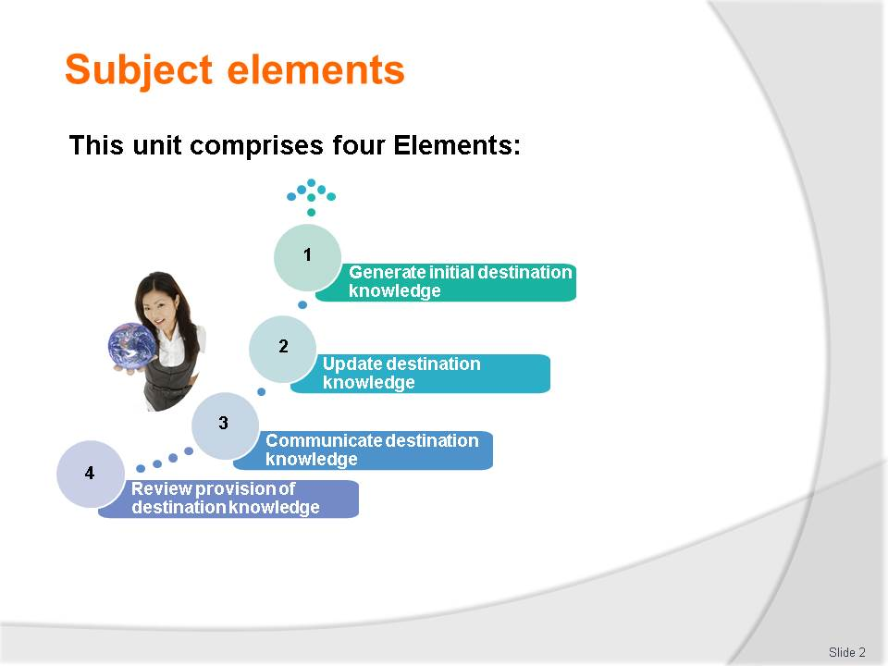
Slide No | Trainer Notes
Trainer advises this Unit comprises four Elements, as listed on the slide explaining:
- Each Element comprises a number of Performance Criteria which will be identified throughout the class and explained in detail
- Trainees can obtain more detail from their Trainee Manual
- At times the course presents advice and information about various protocols but where their workplace requirements differ to what is presented, the workplace practices and standards, as well as policies and procedures must be observed.

Slide
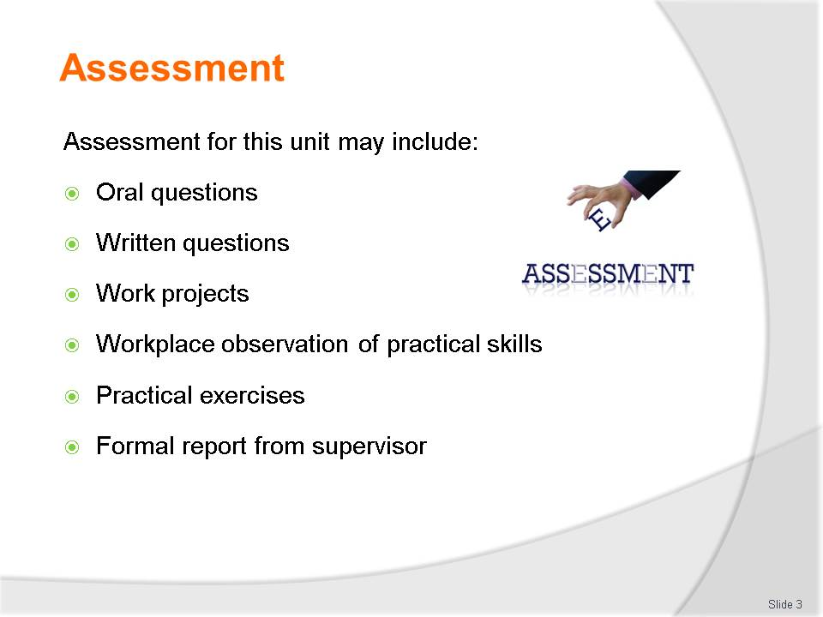
Slide No | Trainer Notes
Trainer advises that assessment for this Unit may take several forms all of which are aimed at verifying they have achieved competency for the Unit as required.
Trainer indicates the methods of assessment that will be applied to them for this Unit.

Slide

Slide No | Trainer Notes
Introduce topic.
Class Activity – General Discussion
Ask general questions:
- What is a destination?
- What destination information is sought by clients?

Slide
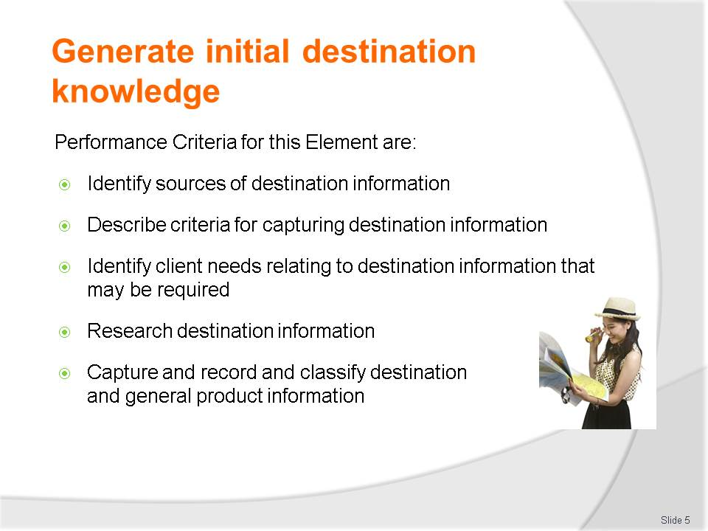e
Slide No | Trainer Notes
 | Trainer identifies the Performance Criteria for this Element, as listed on the slide.

Slide
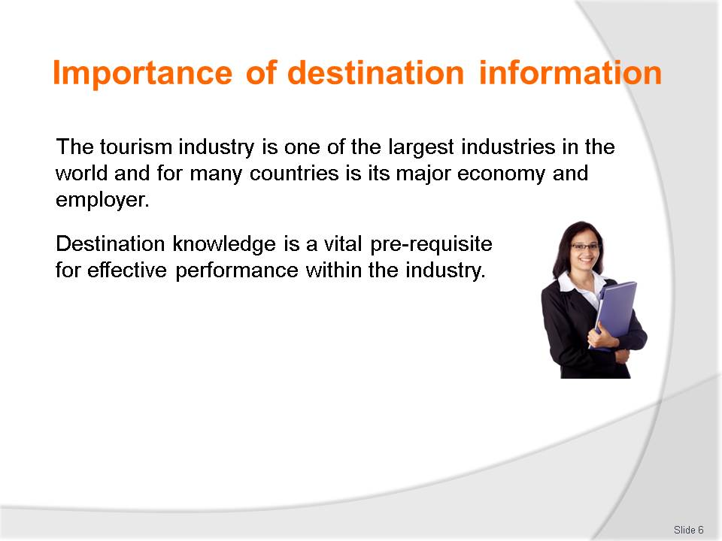
Slide No | Trainer Notes
Class Activity – Questions
Get audience to answer following questions:
- What information do you need to know to effectively do your job?
- What destination information do you need to know that customers may enquire about?
- Where can you get this information?

Slide
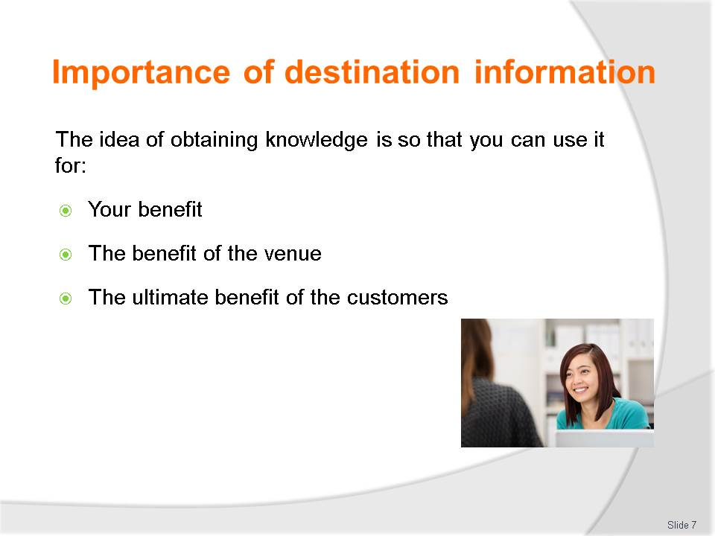
Slide No | Trainer Notes
Class Activity – General Discussion
Identify the benefits for each point.

Slide
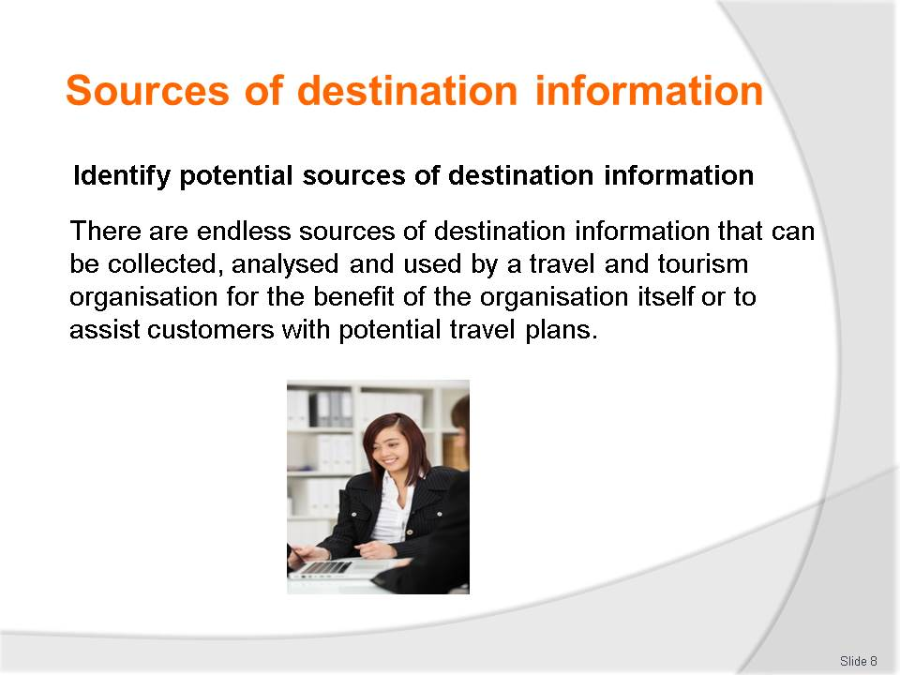
Slide No | Trainer Notes
Class Activity – General Discussion
- What are examples of these sources? Trainer can lead with one or two examples and draw more examples one from each student in the class at least.

Slide
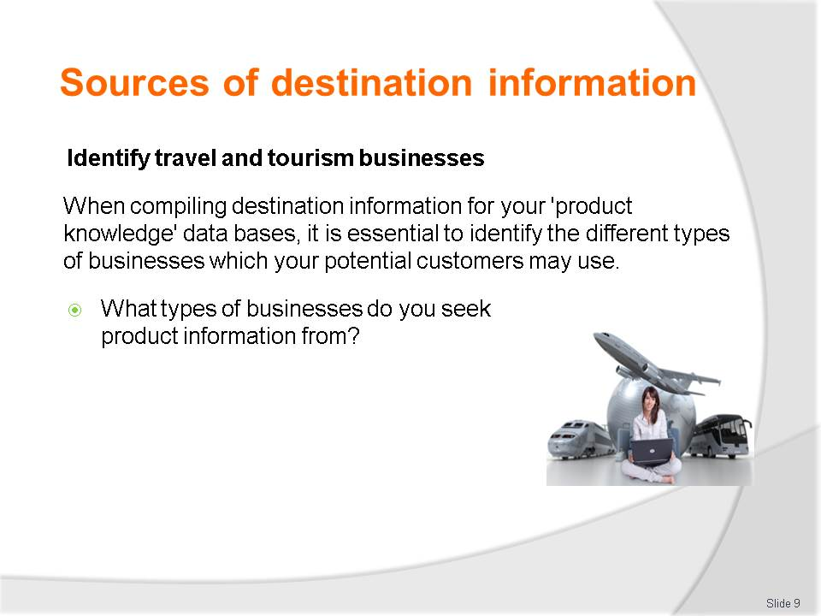
Slide No | Trainer Notes
Class Activity – General Discussion
Discuss question in the slide.

Slide
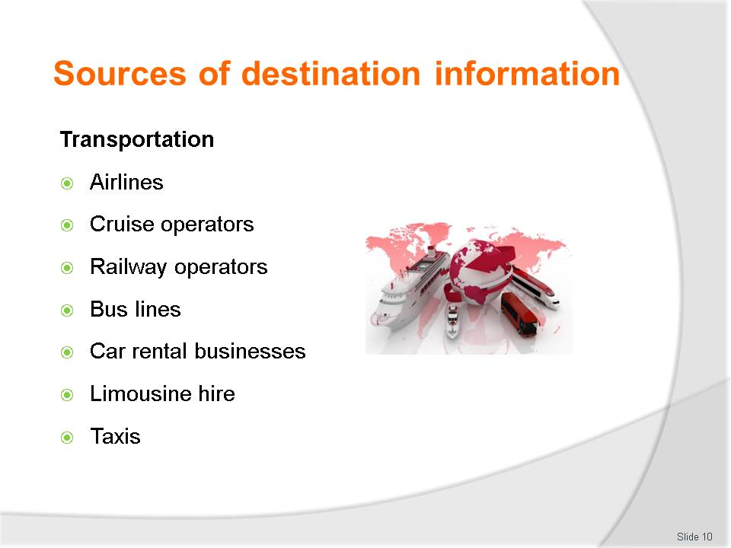
Slide No | Trainer Notes
Class Activity – Identify businesses for each type of business
- Identify actual companies for each type of tourism business.

Slide
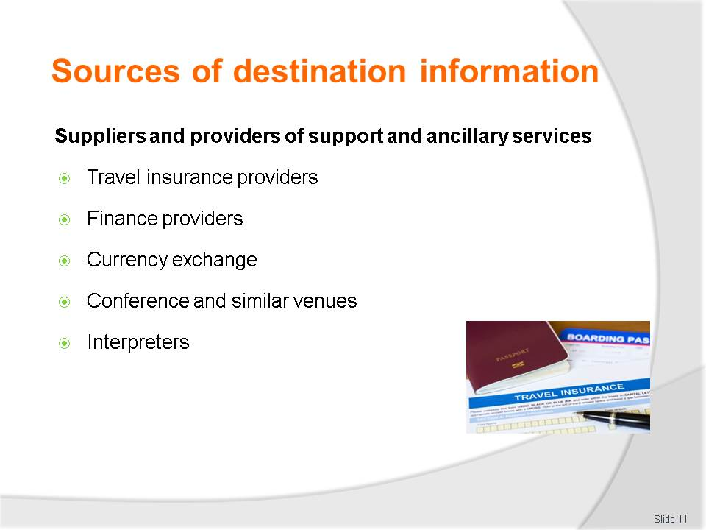
Slide No | Trainer Notes
Class Activity – Identify businesses for each type of business
- Identify actual companies for each type of tourism business.

Slide
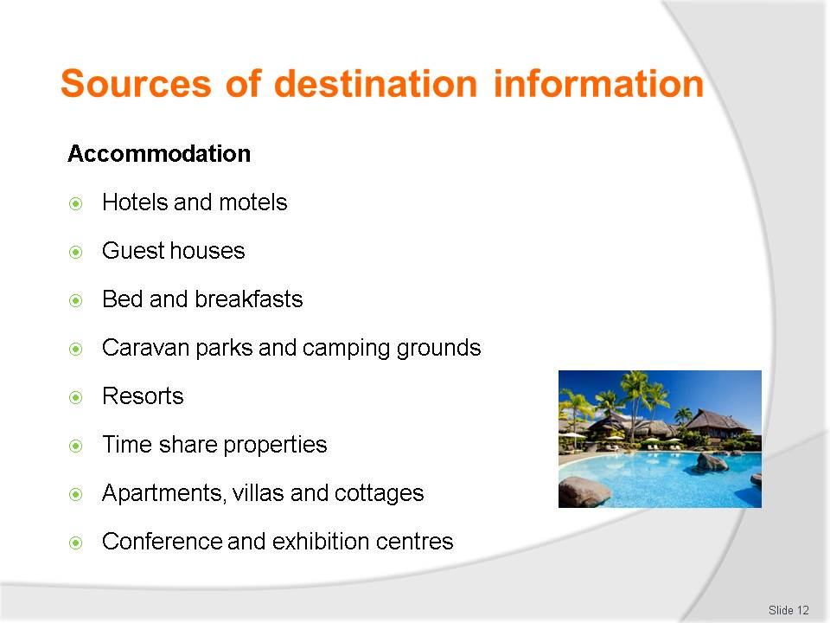
Slide No | Trainer Notes
Class Activity – Identify businesses for each type of business
- Identify actual companies for each type of tourism business.

Slide
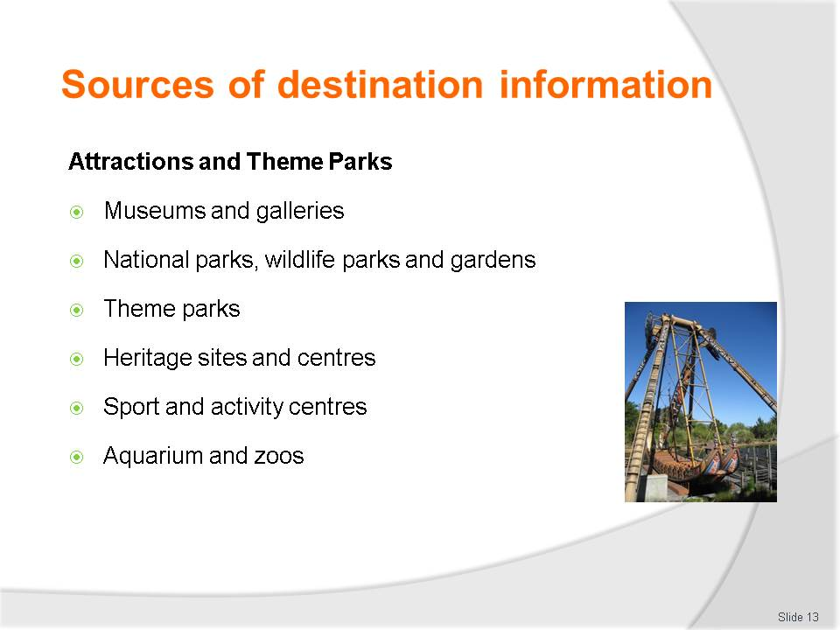
Slide No | Trainer Notes
Class Activity – Identify businesses for each type of business
- Identify actual companies for each type of tourism business.

Slide
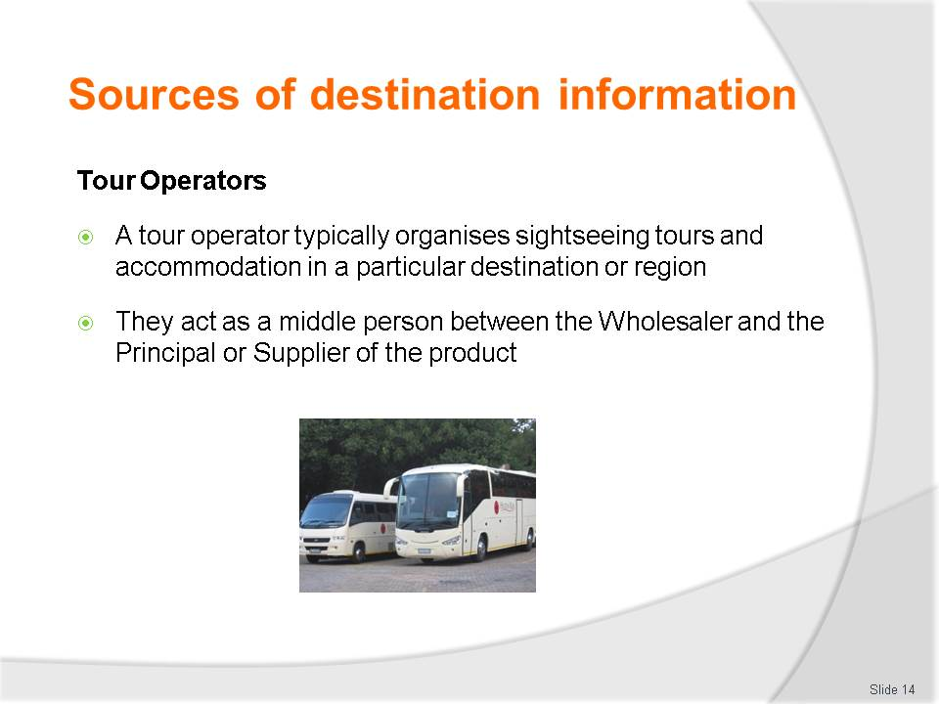
Slide No | Trainer Notes
Class Activity – Identify businesses for each type of business
- Identify actual companies for each type of tourism business.

Slide

Slide No | Trainer Notes
Class Activity – Identify businesses for each type of business
- Identify actual companies for each type of tourism business.

Slide
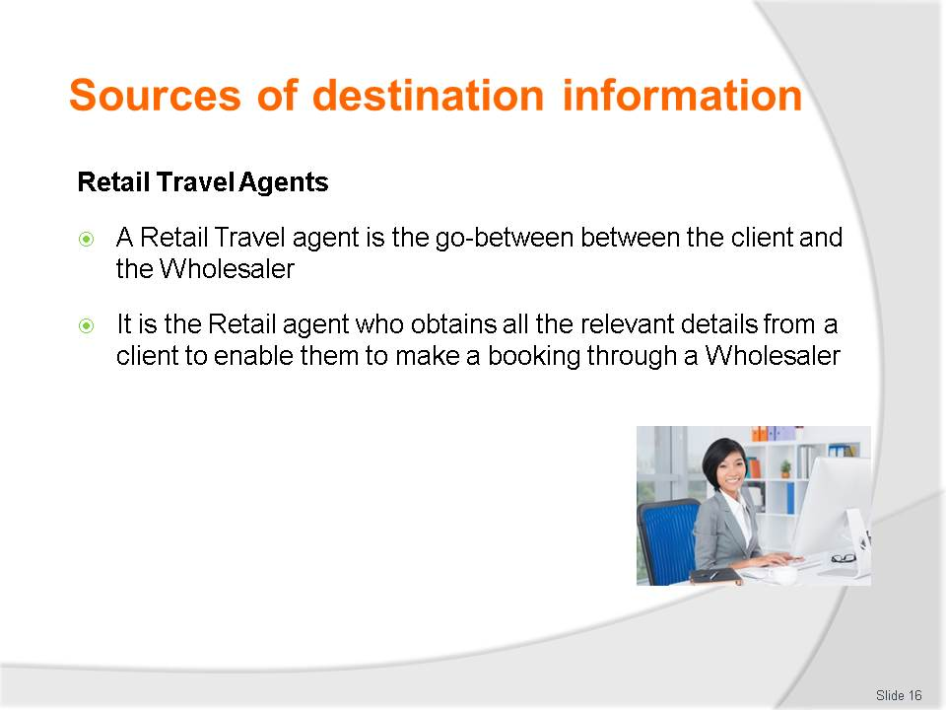
Slide No | Trainer Notes
Class Activity – Identify businesses for each type of business
- Identify actual companies for each type of tourism business.

Slide
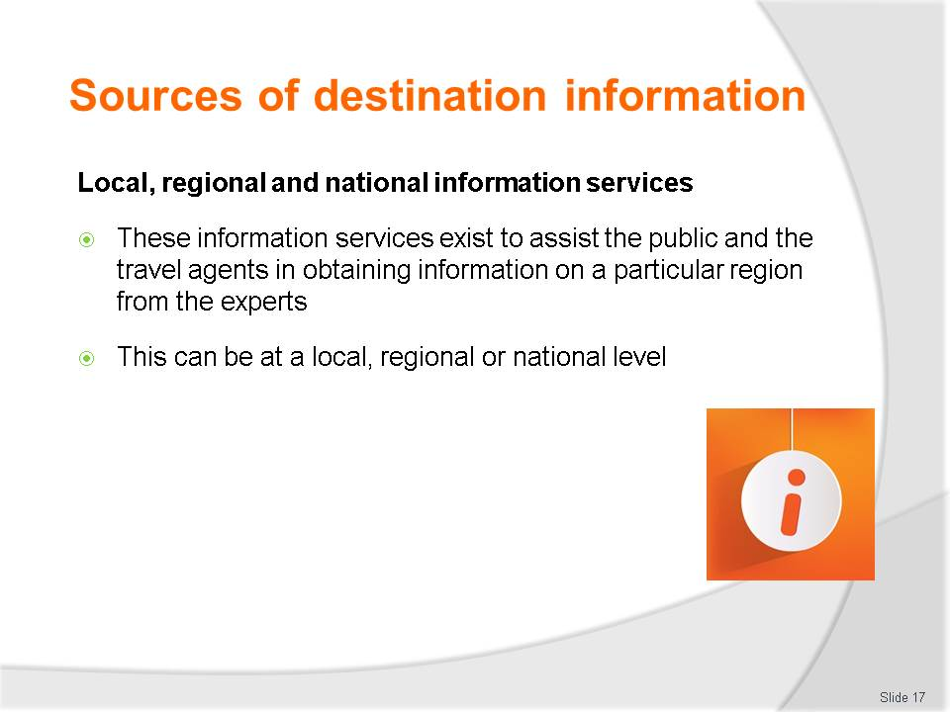
Slide No | Trainer Notes
Class Activity – Identify businesses for each type of business
- Identify actual companies for each type of tourism business.

Slide
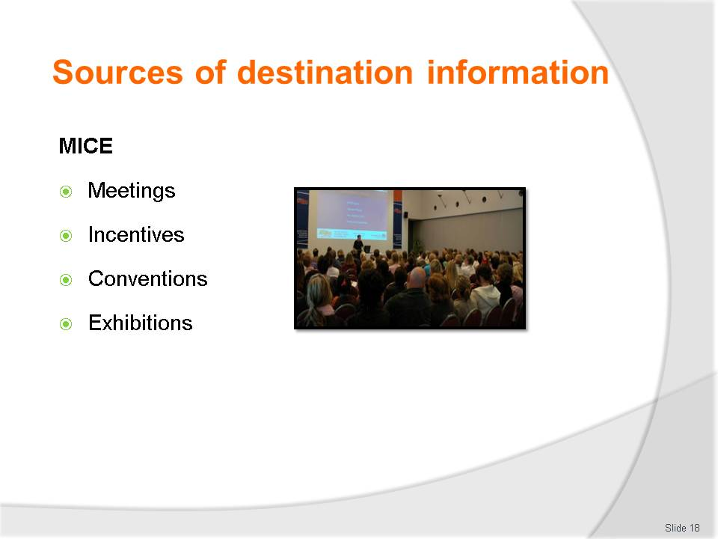
Slide No | Trainer Notes
Class Activity – Identify businesses for each type of business
- Identify actual companies for each type of tourism business.

Slide
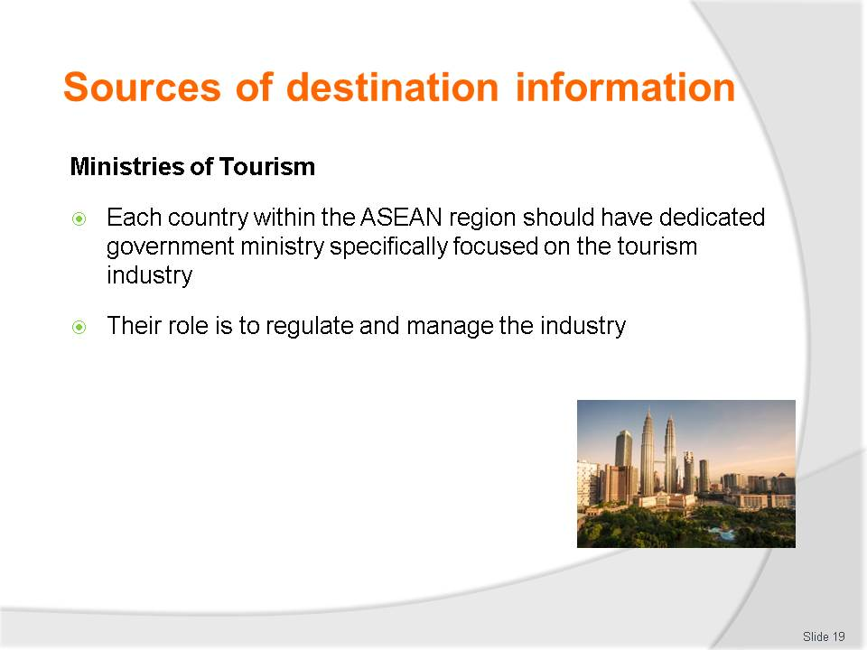
Slide No | Trainer Notes
Class Activity – Identify businesses for each type of business
- Identify actual companies for each type of tourism business.

Slide
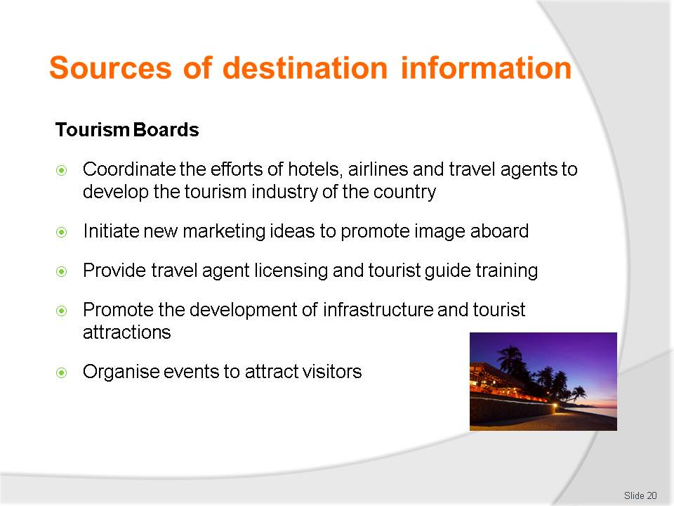
Slide No | Trainer Notes
Class Activity – Identify businesses for each type of business
- Identify actual companies for each type of tourism business.

Slide
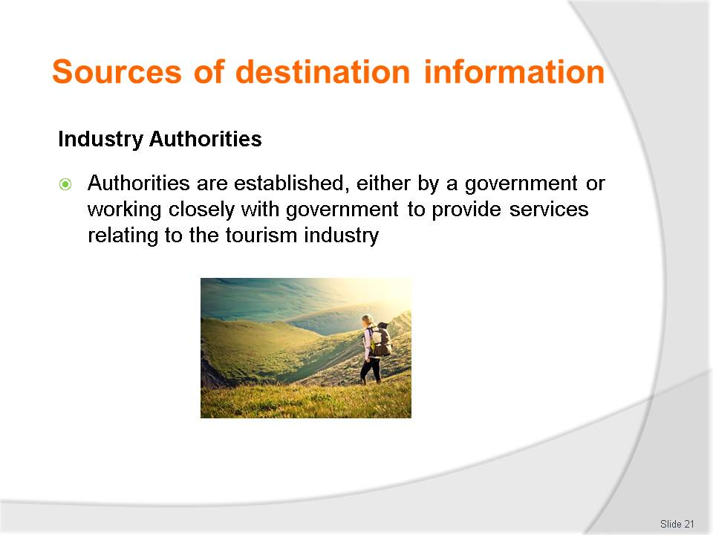
Slide No | Trainer Notes
Class Activity – Identify businesses for each type of business
- Identify actual companies for each type of tourism business.

Slide
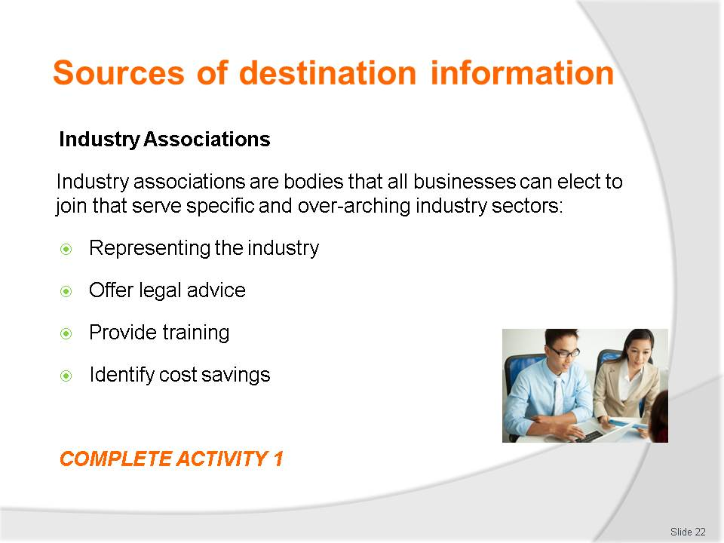
Slide No | Trainer Notes
Class Activity – Identify businesses for each type of business & Activity
- Identify actual companies for each type of tourism business
- Complete Activity 1.

Slide
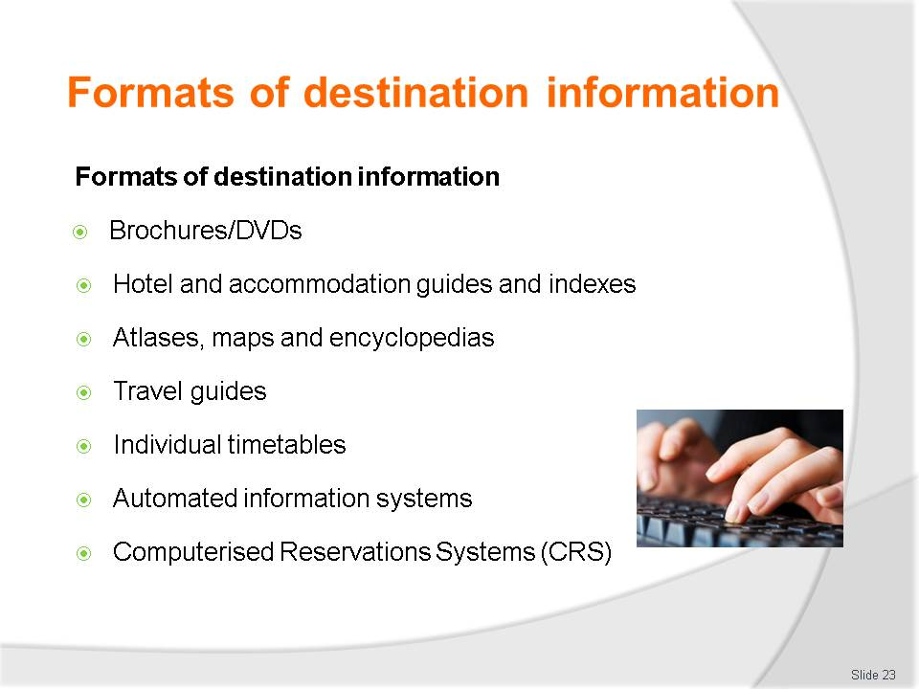
Slide No | Trainer Notes
Class Activity – Identify formats of information
- Trainer to show different formats of information
- What information can be gathered from each format?

Slide
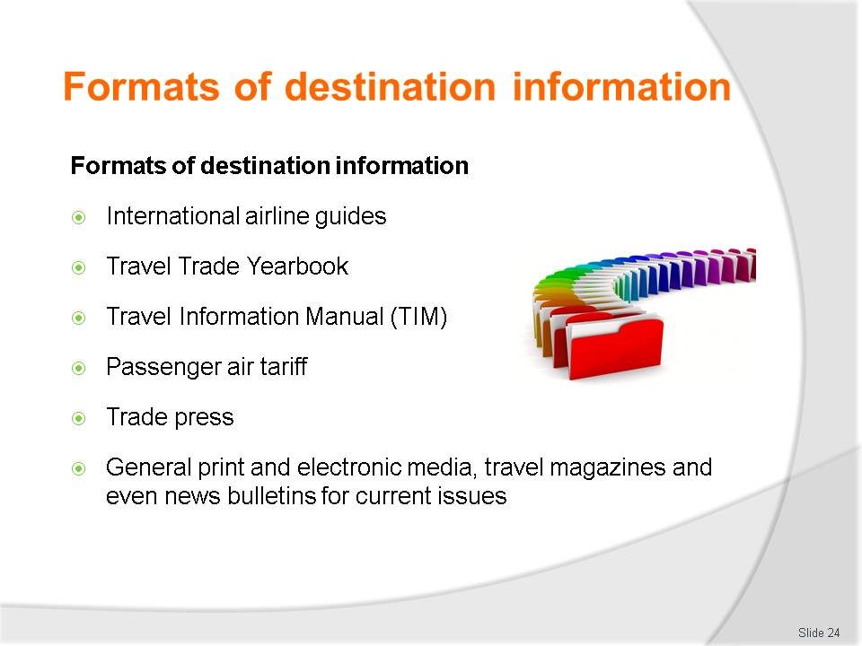
Slide No | Trainer Notes
Class Activity – Identify formats of information
- Trainer to show different formats of information
- What information can be gathered from each format?

Slide
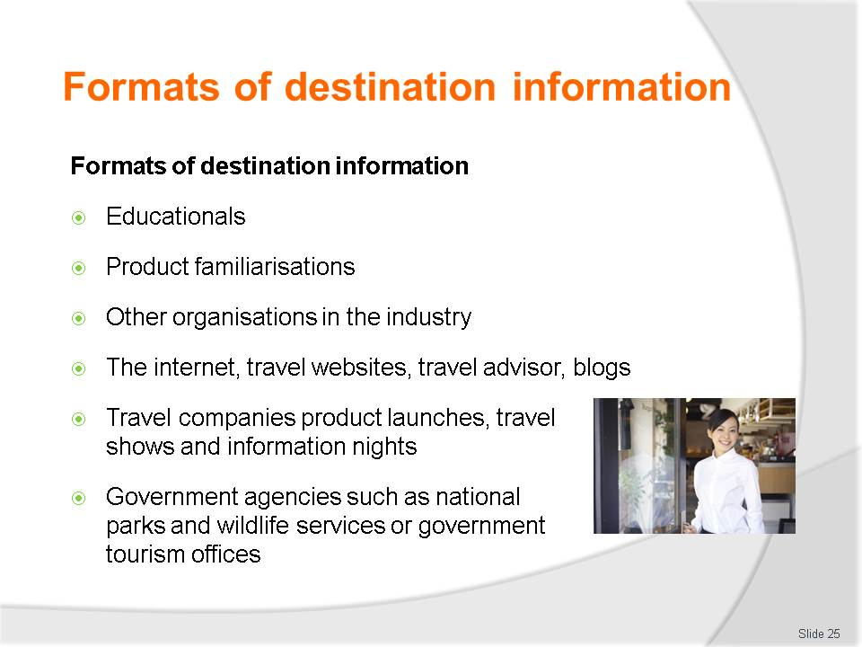
Slide No | Trainer Notes
Class Activity – Identify formats of information
- Trainer to show different formats of information
- What information can be gathered from each format?

Slide
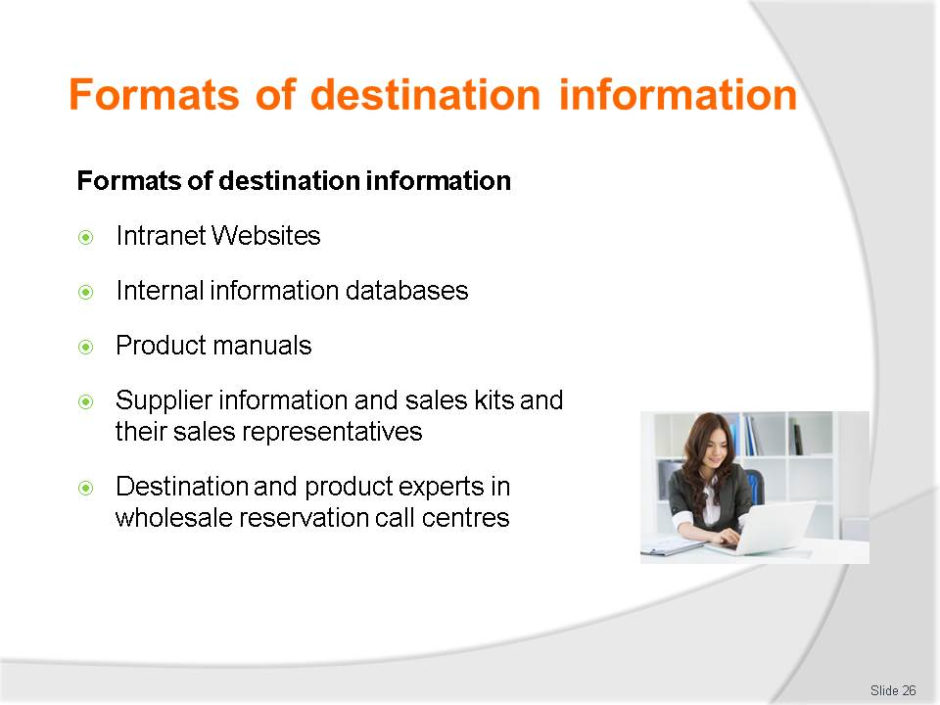
Slide No | Trainer Notes
Class Activity – Identify formats of information
- Trainer to show different formats of information
- What information can be gathered from each format?

Slide
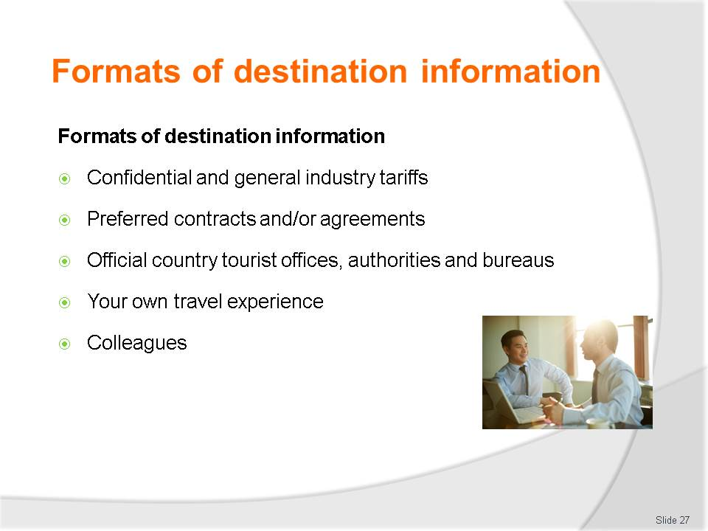
Slide No | Trainer Notes
Class Activity – Identify formats of information
- Trainer to show different formats of information
- What information can be gathered from each format?

Slide
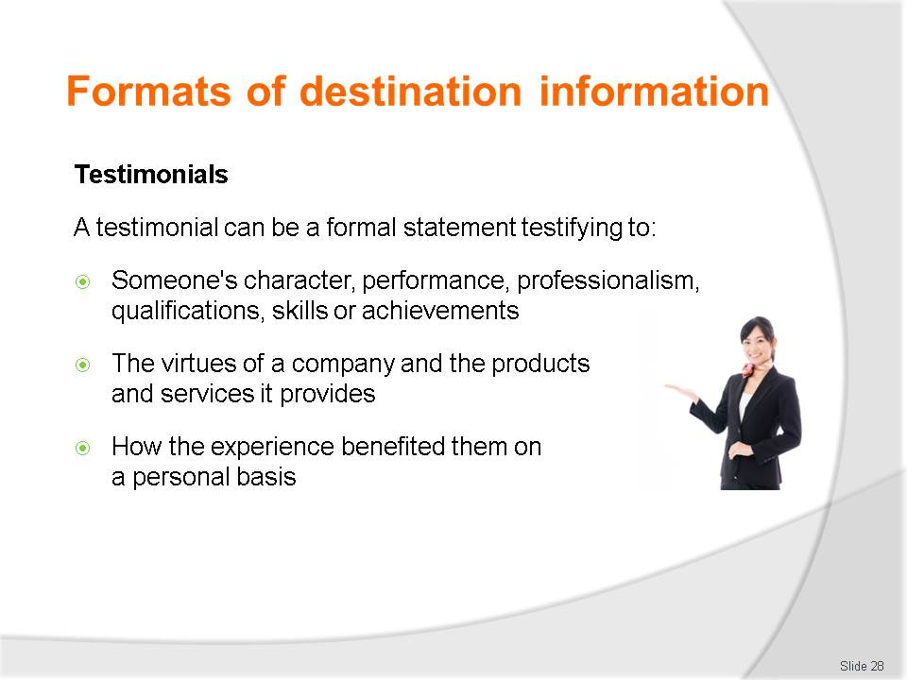
Slide No | Trainer Notes
Class Activity – Identify importance of testimonials
- Why is it important to gather testimonials?
- How can they be beneficial?

Slide
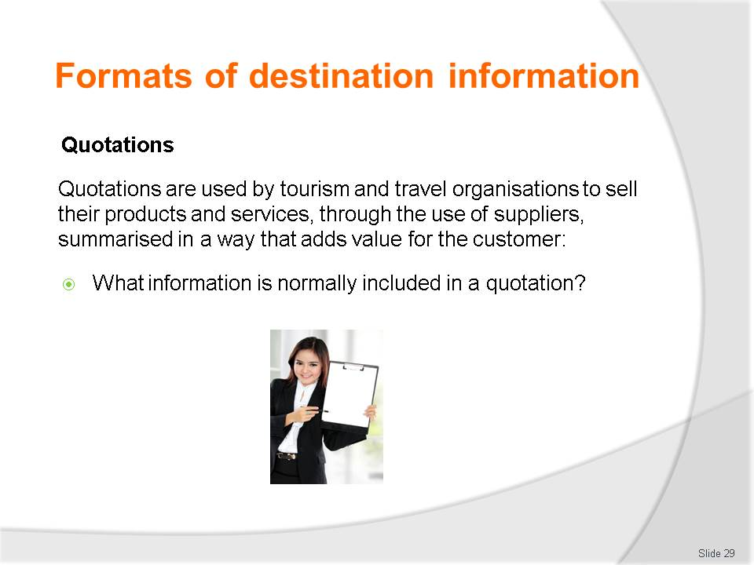
Slide No | Trainer Notes
Class Activity – Discussion & provide example of a quotation
- Provide examples of each.

Slide
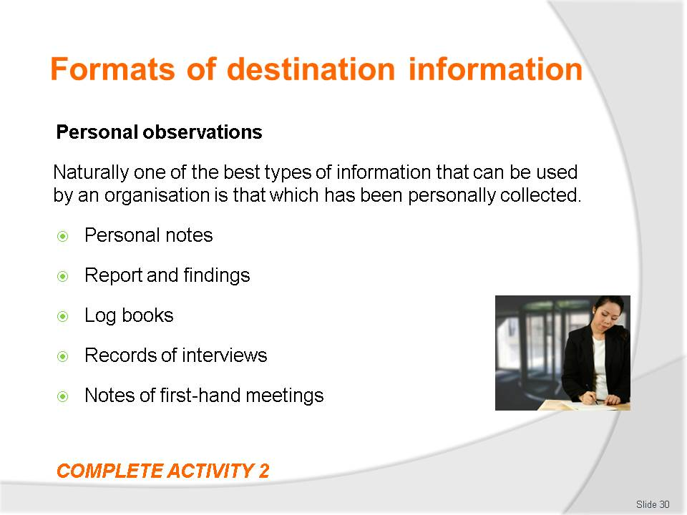
Slide No | Trainer Notes
Class Activity – Discussion & Activity
- From a personal perspective, explain how personal observations have provided you with critical information.
- Complete Activity 2.

Slide
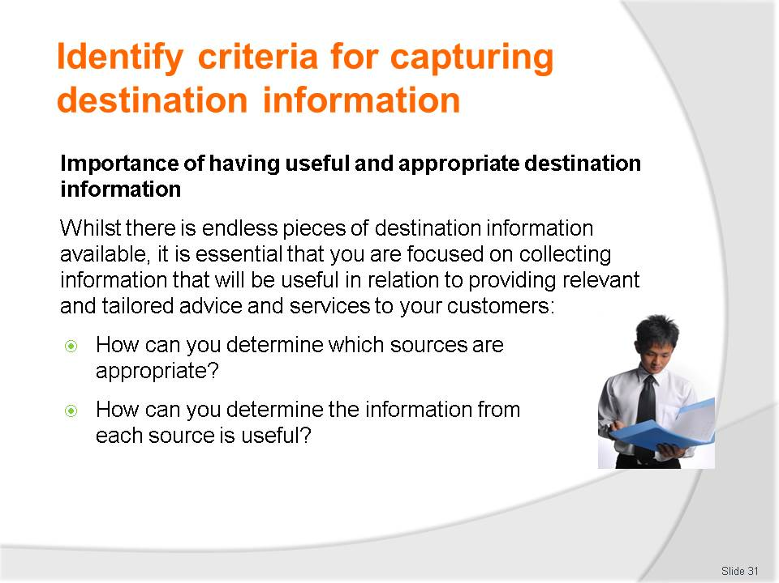
Slide No | Trainer Notes
Class Activity – General Discussion
- Discuss questions in the slide.

Slide
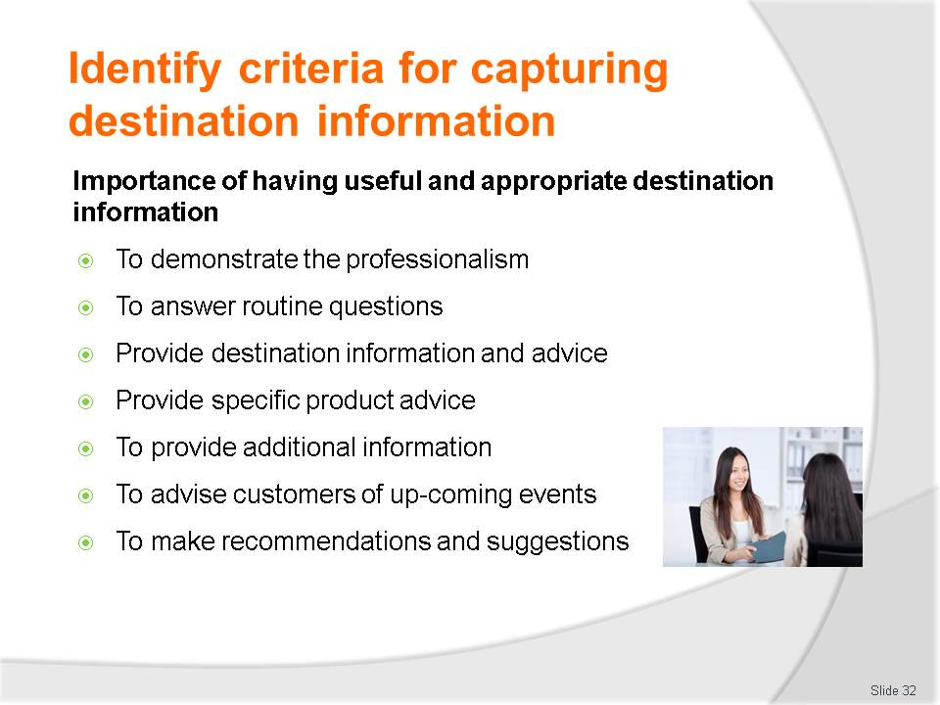
Slide No | Trainer Notes
Class Activity – Discuss importance
- Discuss importance for each of these points.

Slide
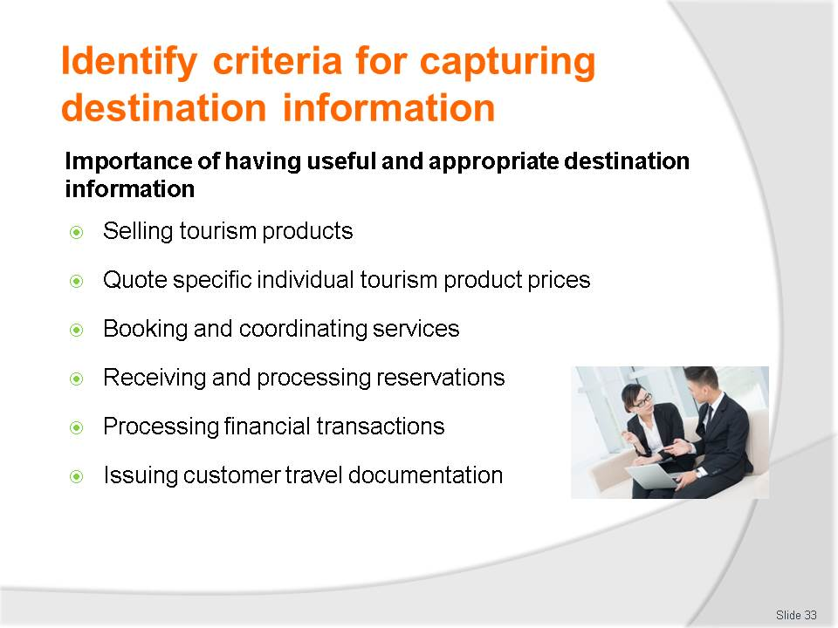
Slide No | Trainer Notes
Class Activity – Discuss importance
- Discuss importance for each of these points.

Slide
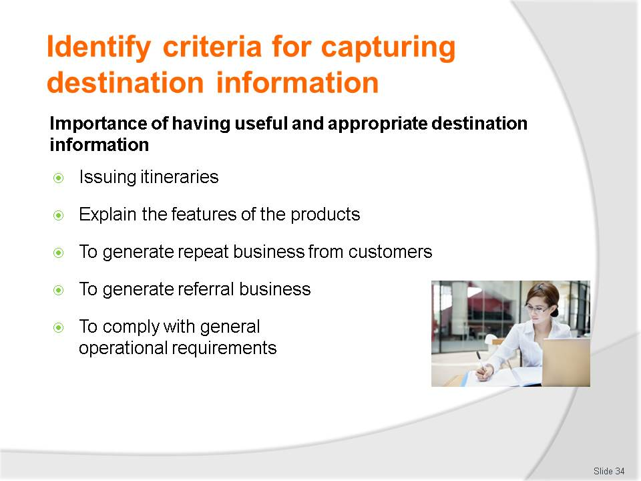
Slide No | Trainer Notes
Class Activity – Discuss importance
- Discuss importance for each of these points.

Slide
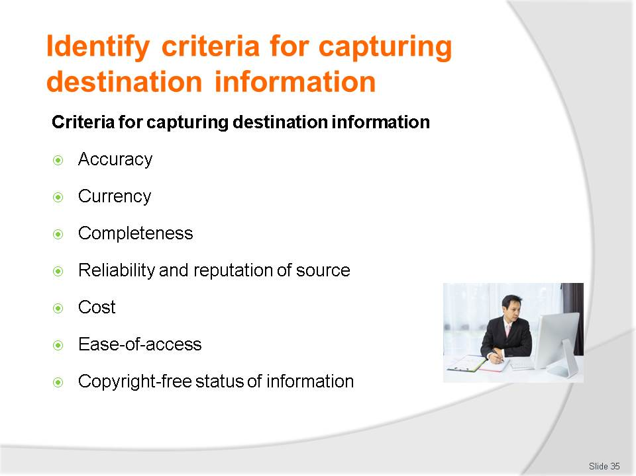
Slide No | Trainer Notes
Class Activity – Discuss importance
- Discuss importance for each of these criteria points.

Slide
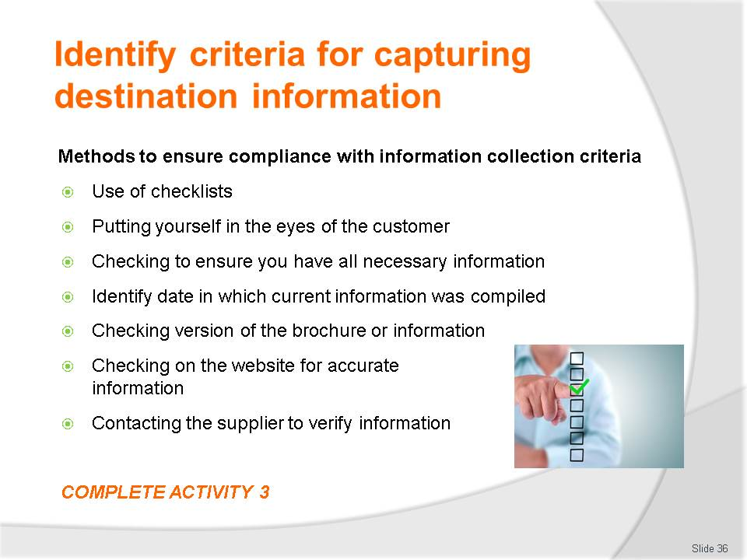
Slide No | Trainer Notes
Class Activity – Discuss importance & Activity
- Discuss importance for each of these criteria points
- Complete Activity 3.

Slide
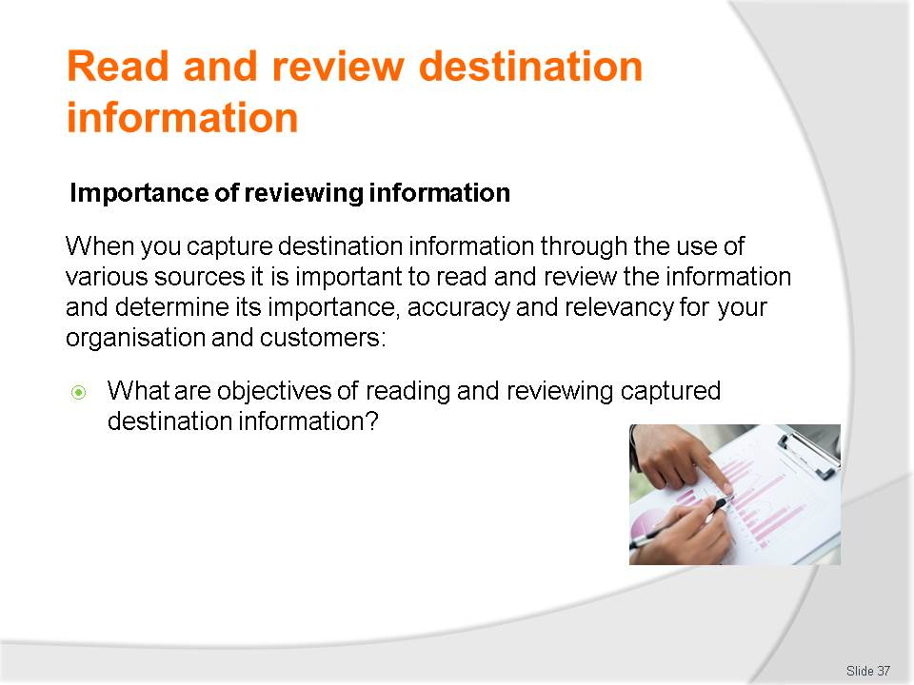
Slide No | Trainer Notes
Class Activity – Discuss
- How can you do this?

Slide
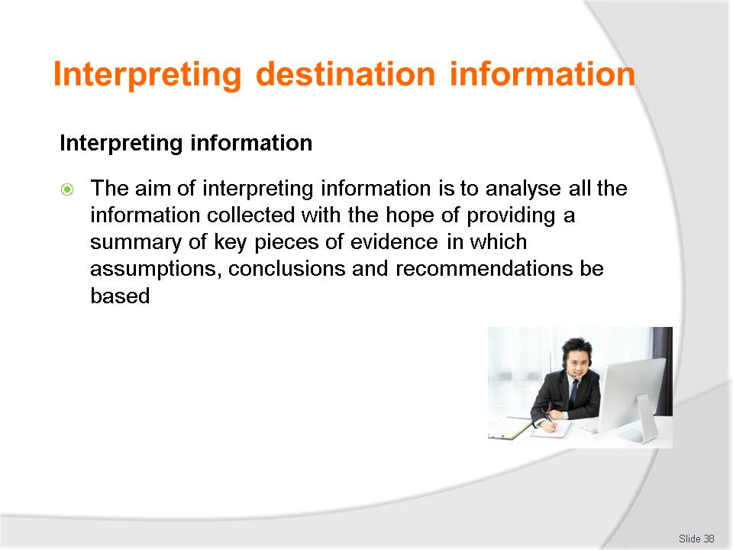
Slide No | Trainer Notes
Class Activity – Discuss
- What activities are associated with interpreting information?

Slide
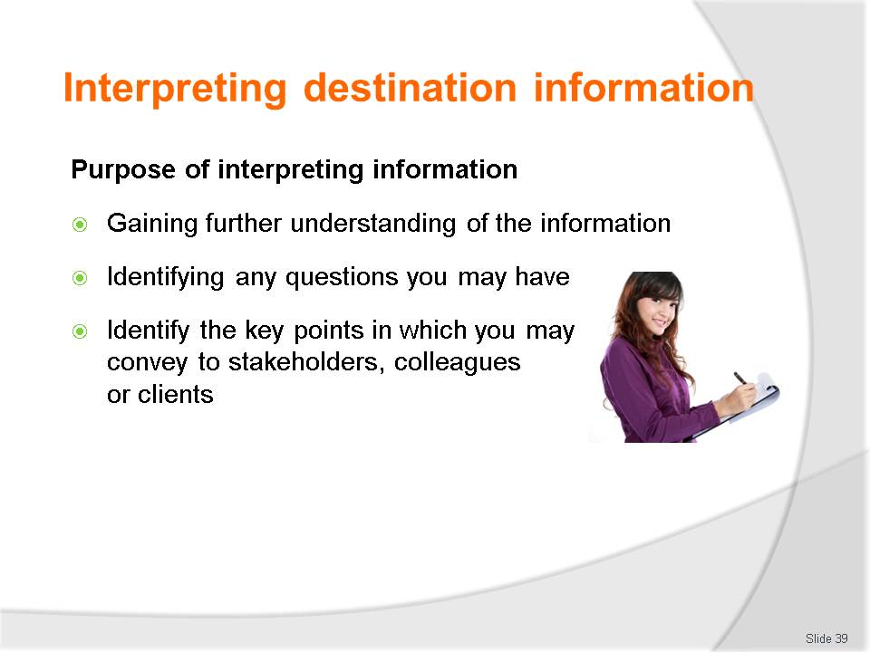
Slide No | Trainer Notes
Class Activity – Discuss
- Why is this important?

Slide
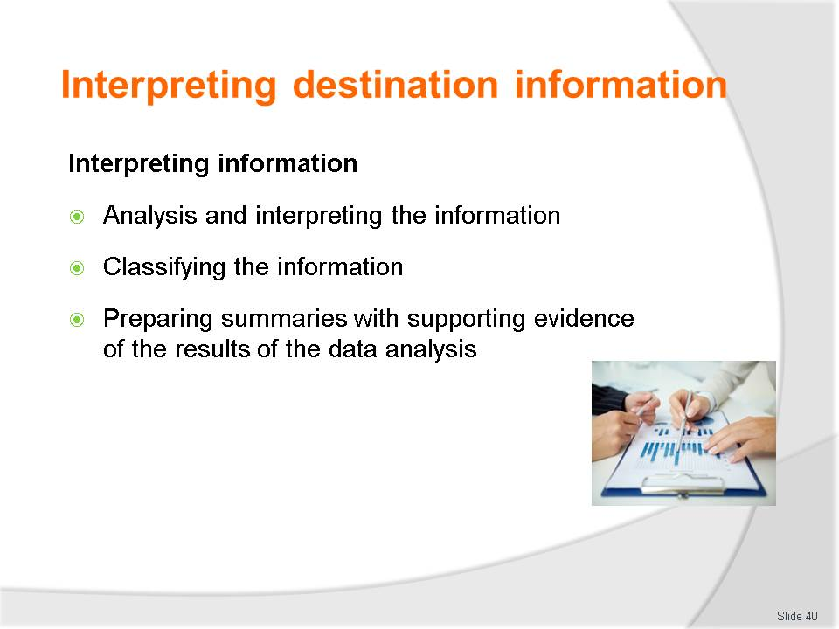
Slide No | Trainer Notes
Class Activity – Discuss
- Discuss the steps associated with each of these points.

Slide
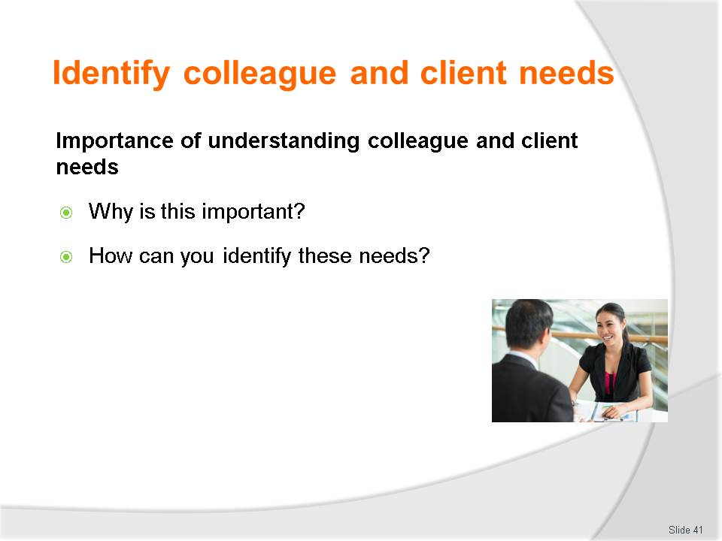
Slide No | Trainer Notes
Class Activity – Discussion
- Discuss questions in the slide.

Slide
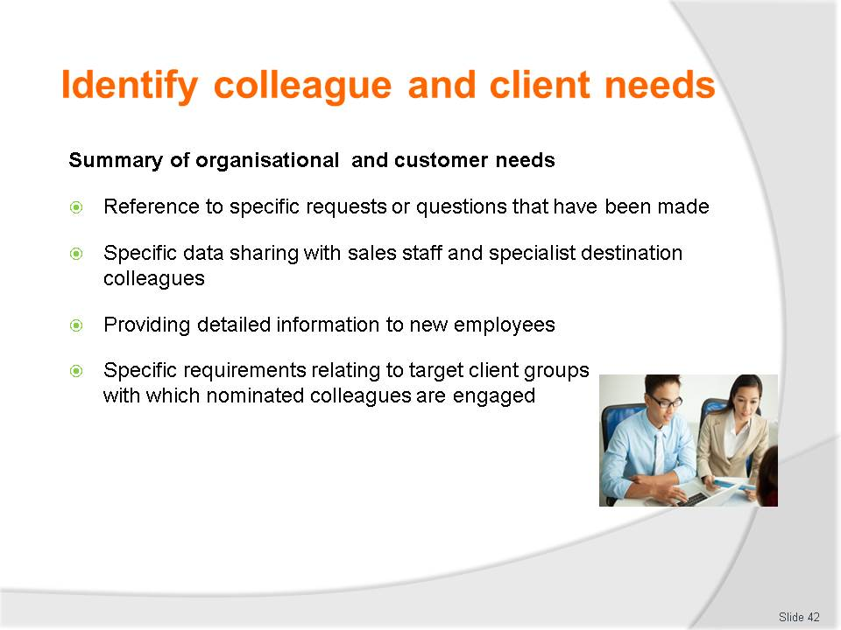
Slide No | Trainer Notes
Class Activity – Discussion
Ask general questions:
- How can you accommodate these needs?

Slide
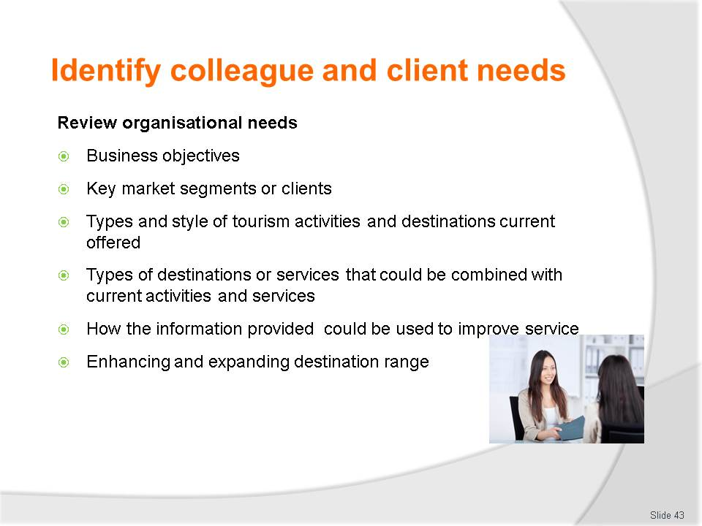
Slide No | Trainer Notes
Class Activity – Discussion
Ask general questions:
- What are examples of requirements for each need?

Slide

Slide No | Trainer Notes
Class Activity – Discussion & Activity
Ask general questions:
- What are examples of requirements for each need?
- Complete Activity 4.

Slide
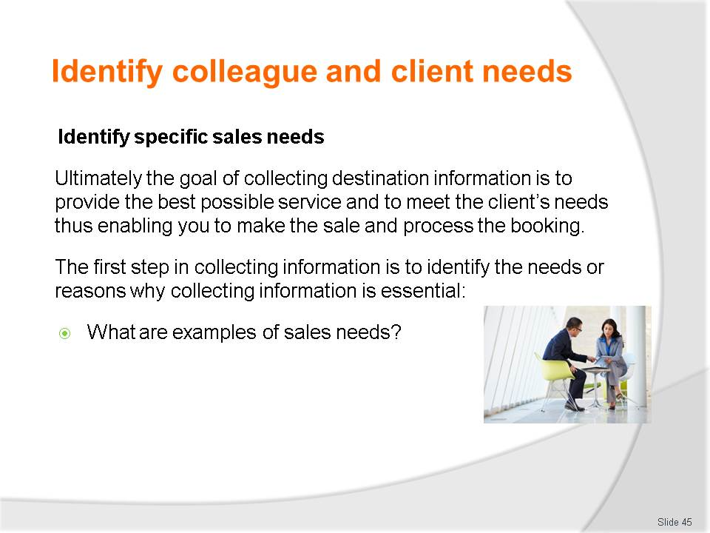
Slide No | Trainer Notes
Class Activity – Discuss
- Discuss the question in the slide.

Slide

Slide No | Trainer Notes
Class Activity – Discuss
- Discuss the importance of each of these sales needs.

Slide
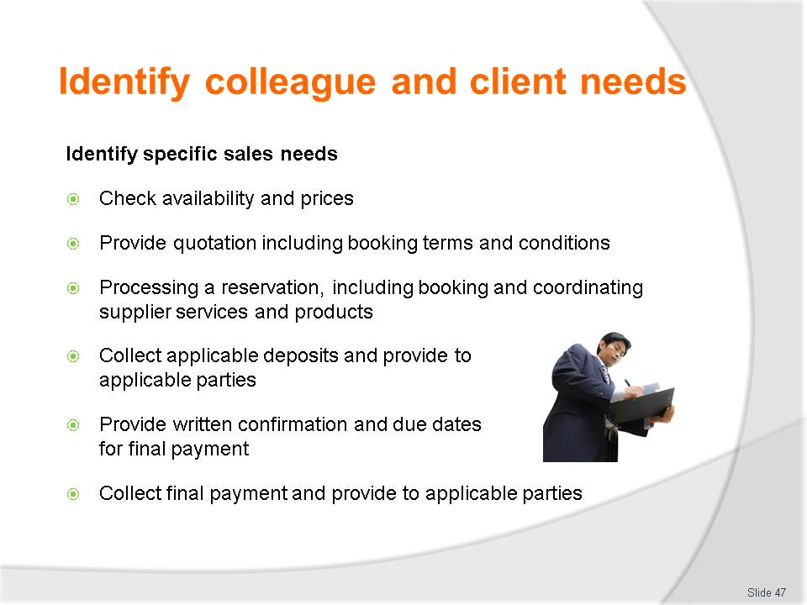
Slide No | Trainer Notes
Class Activity – Discuss
- Discuss the importance of each of these sales needs.

Slide
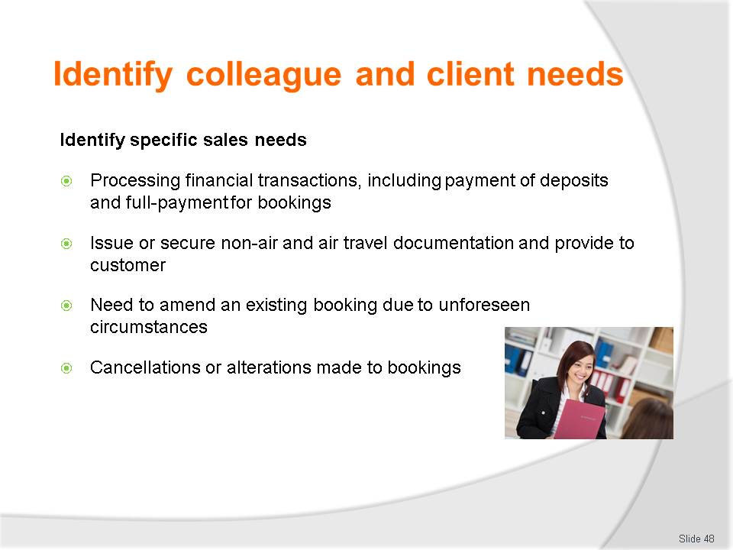
Slide No | Trainer Notes
Class Activity – Discuss
- Discuss the importance of each of these sales needs.

Slide
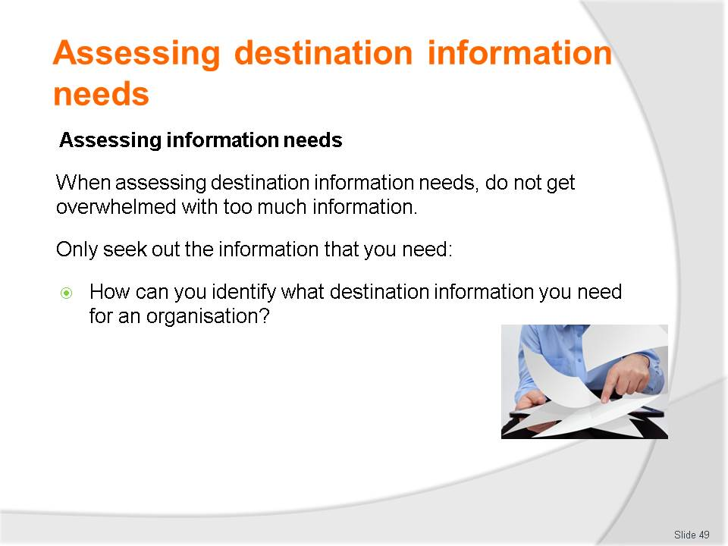
Slide No | Trainer Notes
Class Activity – General Discussion
- Discuss question in the slide
- Refer to Criteria 1.3 (Identify client needs relating to destination information that may be required) of Trainee Manual for questions that you can ask to determine informational needs.

Slide
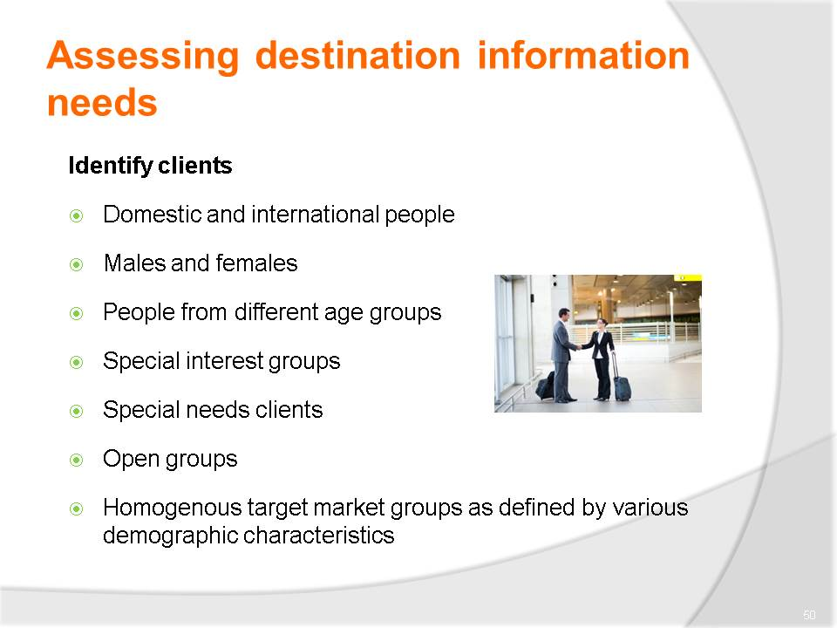
Slide No | Trainer Notes
Class activity – Discussion
- Provide examples of each type of client
- What are their needs?

Slide
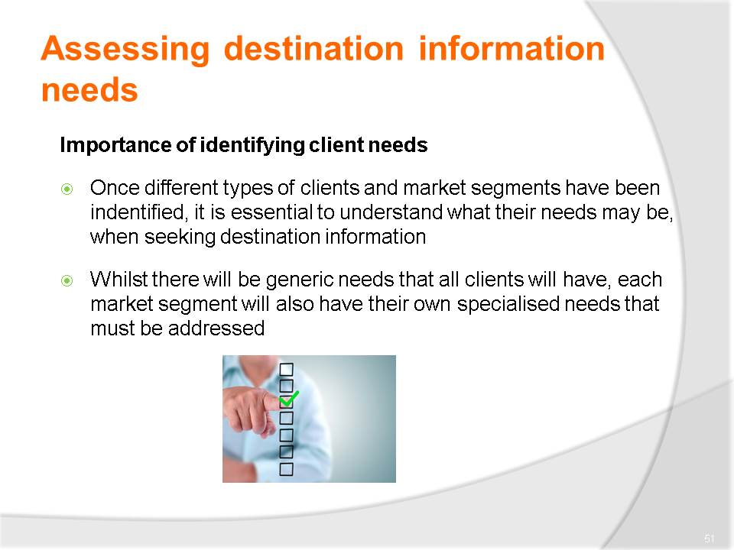
Slide No | Trainer Notes
Class activity – Discussion
- How can you identifying client requirements?

Slide
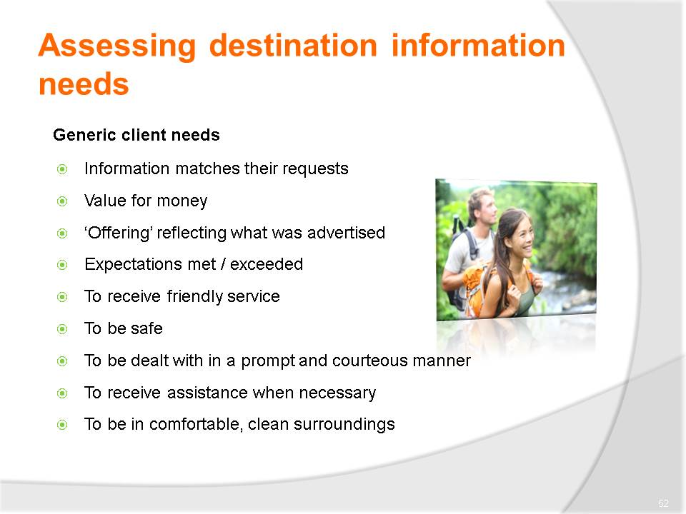
Slide No | Trainer Notes
Class activity – Discussion
- Discuss these needs?
- How can you cater to these?

Slide
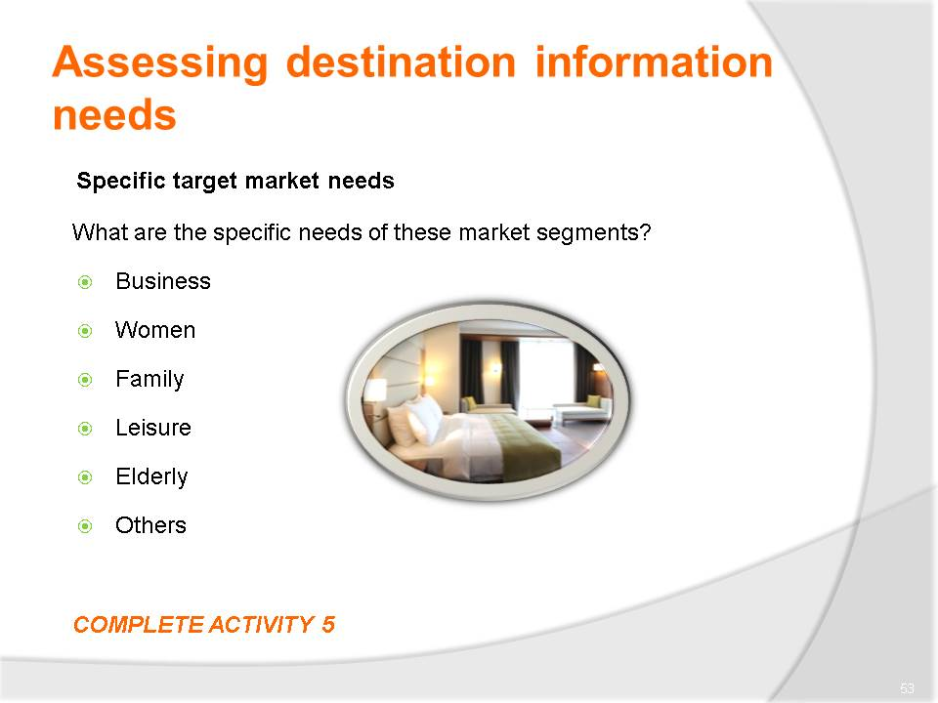
Slide No | Trainer Notes
Class activity – Discussion & Activity
- What are the needs for each of these customer types?
- Discuss these needs?
- How can you cater to these?
- Complete Activity 5.

Slide
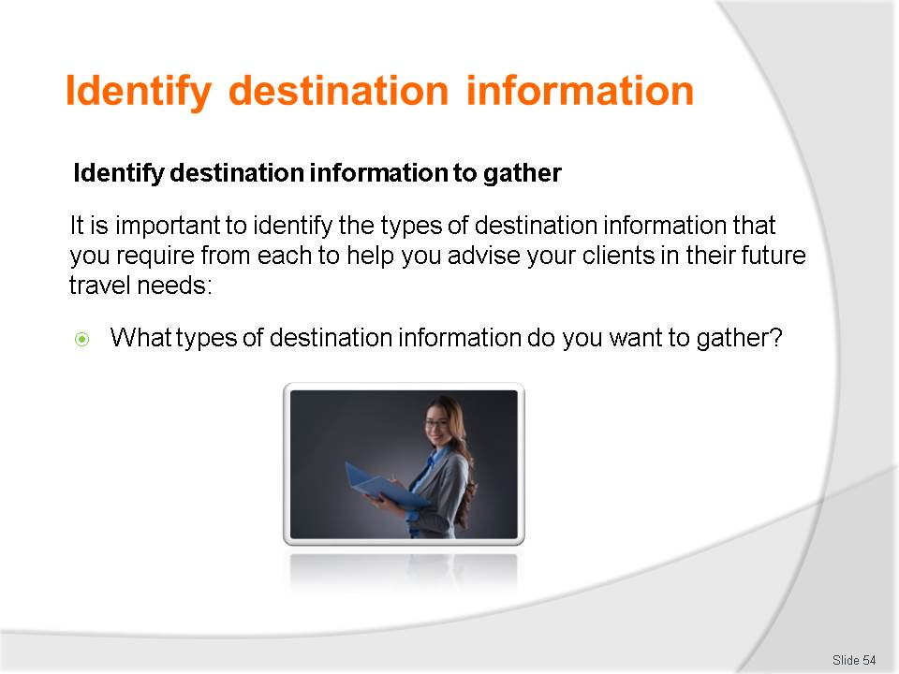
Slide No | Trainer Notes
Class Activity – Question
- Discuss the question in the slide.

Slide
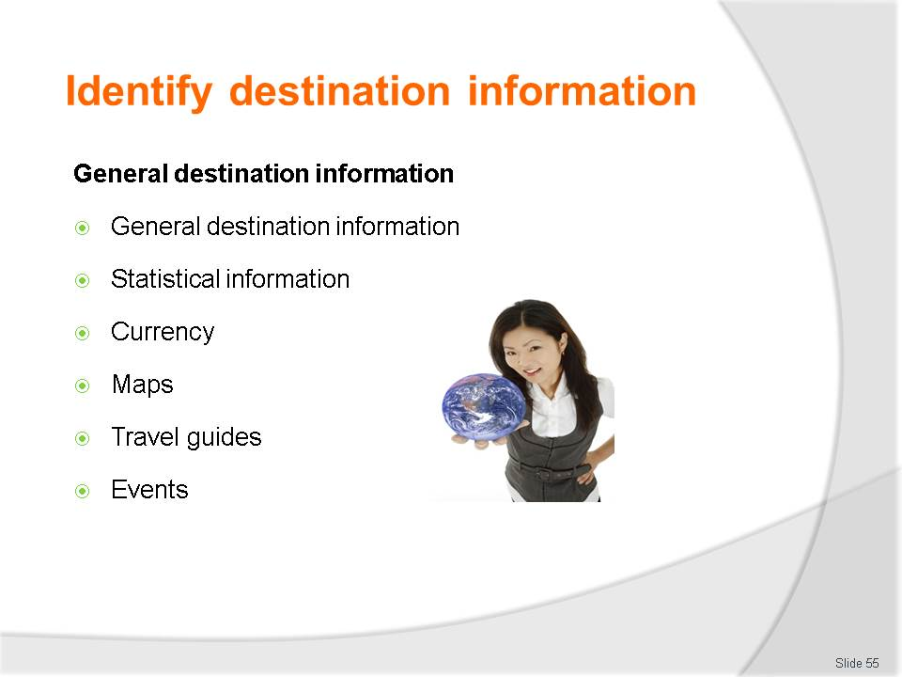
Slide No | Trainer Notes
Class Activity – Question
- Discuss the types of information to be collected under each point?
- How can you collect this information?
- What format would you like it in?

Slide
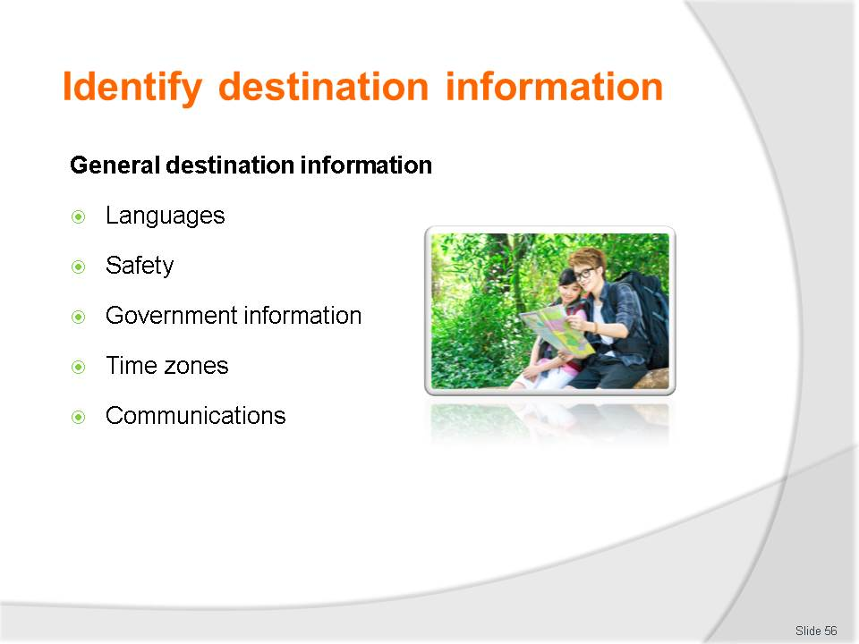
Slide No | Trainer Notes
Class Activity – Question
- Discuss the types of information to be collected under each point?
- How can you collect this information?
- What format would you like it in?

Slide
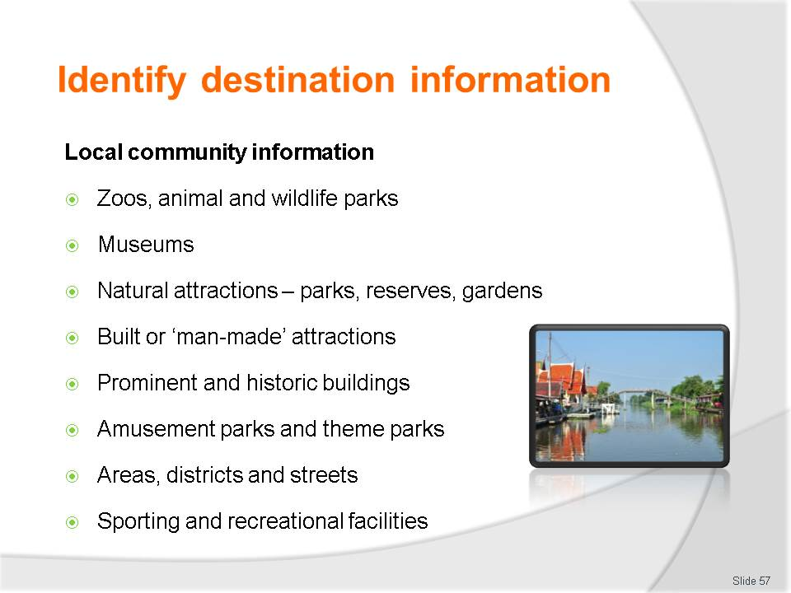e
Slide No | Trainer Notes
Class Activity – Question
- Discuss the types of information to be collected under each point?
- How can you collect this information?
- What format would you like it in?

Slide
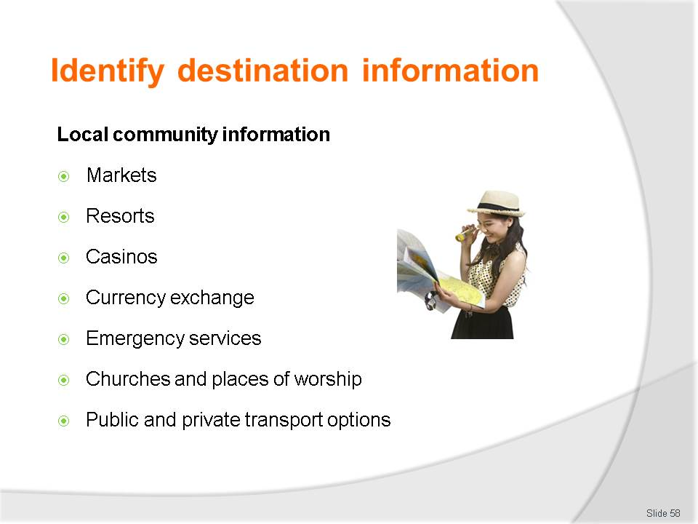
Slide No | Trainer Notes
Class Activity – Question
- Discuss the types of information to be collected under each point?
- How can you collect this information?
- What format would you like it in?

Slide
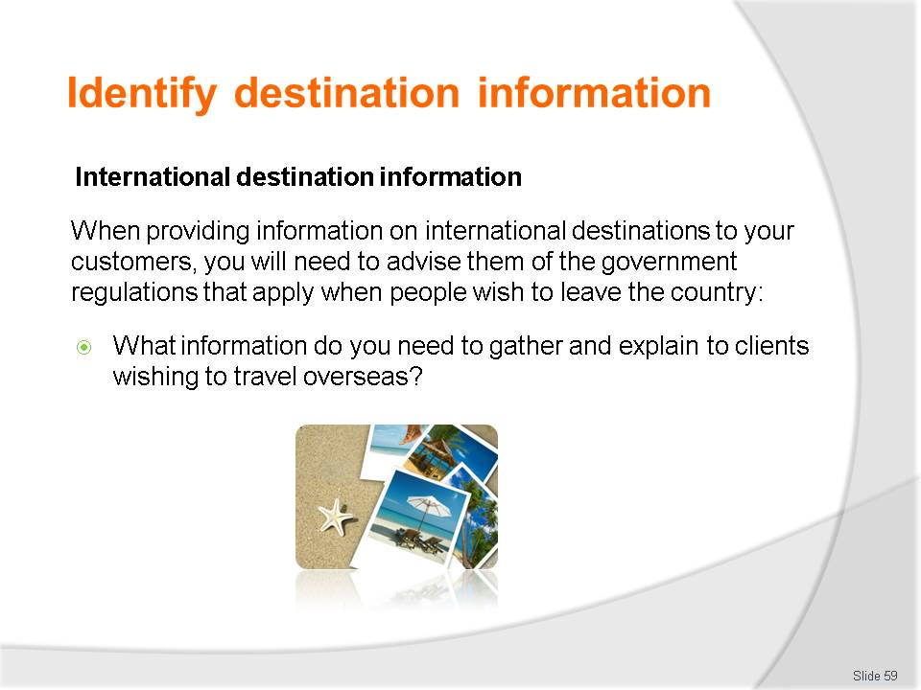
Slide No | Trainer Notes
Class Activity – Question
- Discuss the questions in the slide.

Slide
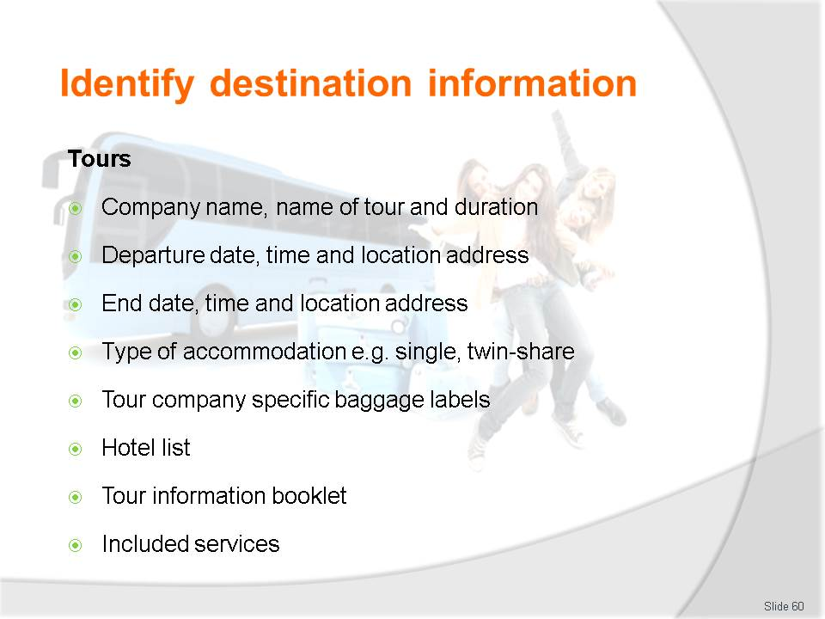
Slide No | Trainer Notes
Class Activity – Question
- Discuss the types of information to be collected under each point?
- How can you collect this information?
- What format would you like it in?

Slide
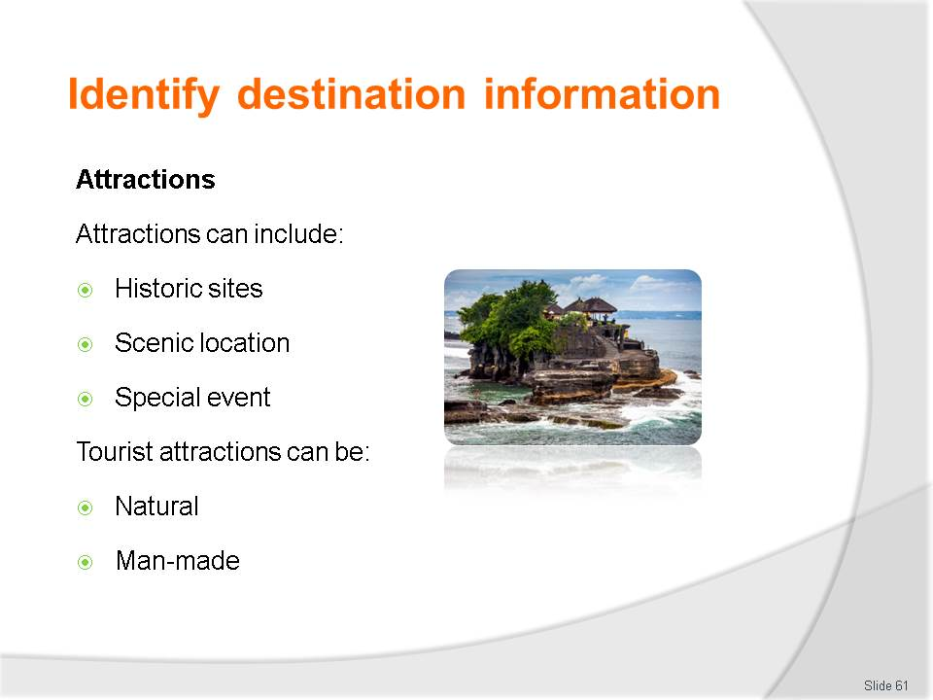
Slide No | Trainer Notes
Class Activity – Question
- Discuss the types of information to be collected under each point?
- How can you collect this information?
- What format would you like it in?

Slide
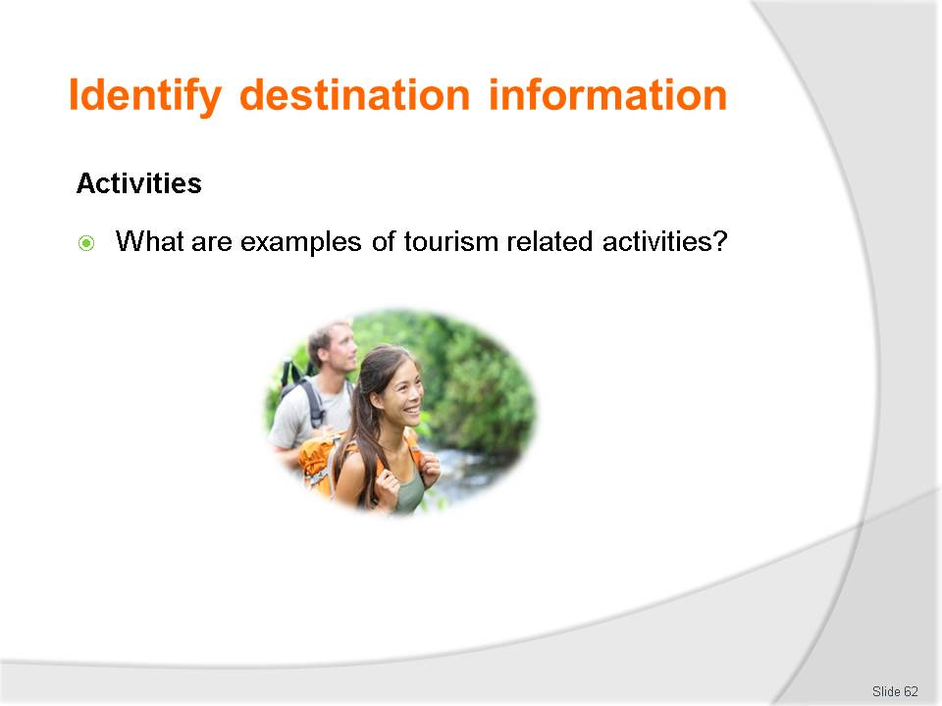
Slide No | Trainer Notes
Class Activity – Question
- Discuss the questions in the slide.

Slide
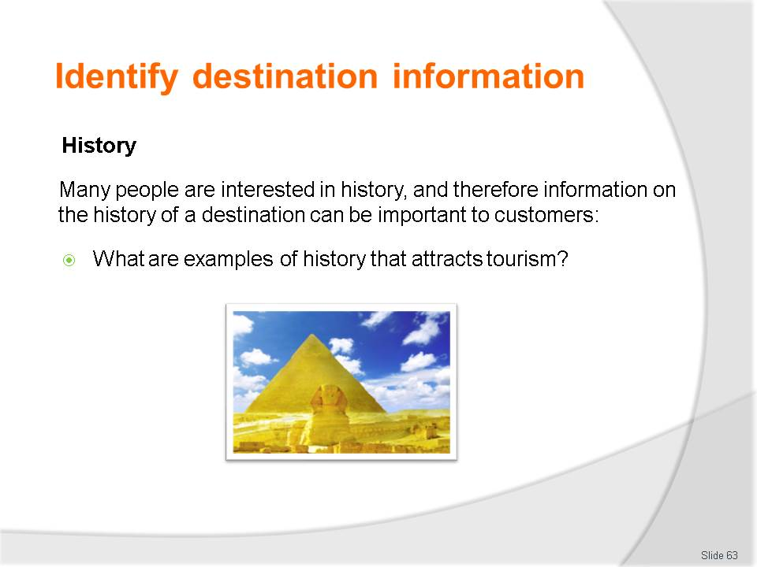
Slide No | Trainer Notes
Class Activity – Question
- Discuss the questions in the slide.

Slide
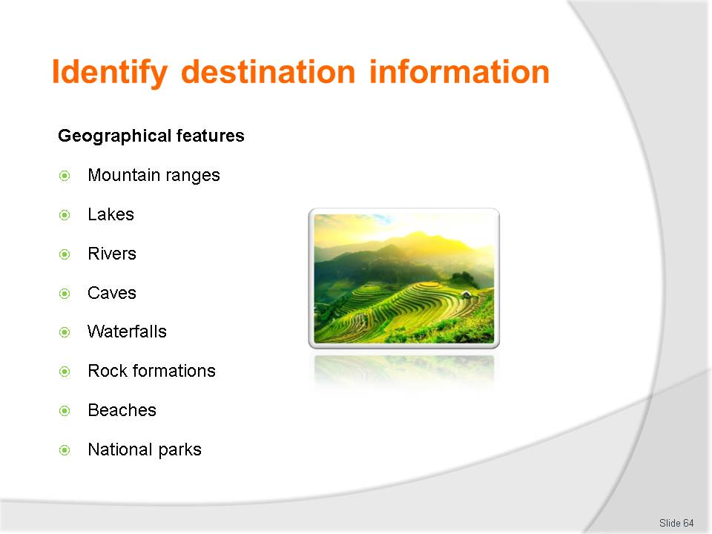
Slide No | Trainer Notes
Class Activity – Question
- Discuss the types of information to be collected under each point?
- How can you collect this information?
- What format would you like it in?

Slide
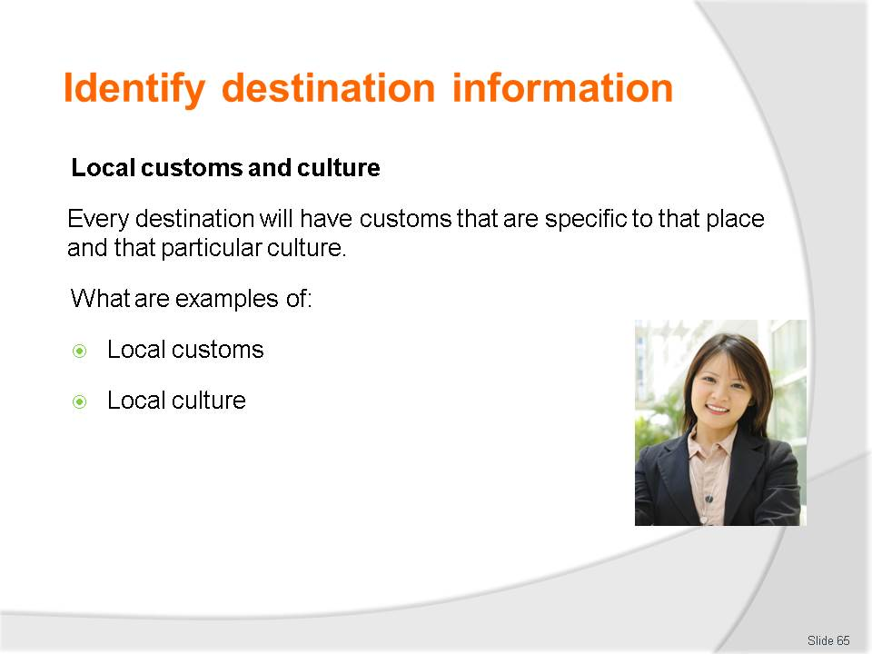
Slide No | Trainer Notes
Class Activity – Question
- Discuss the questions in the slide.

Slide
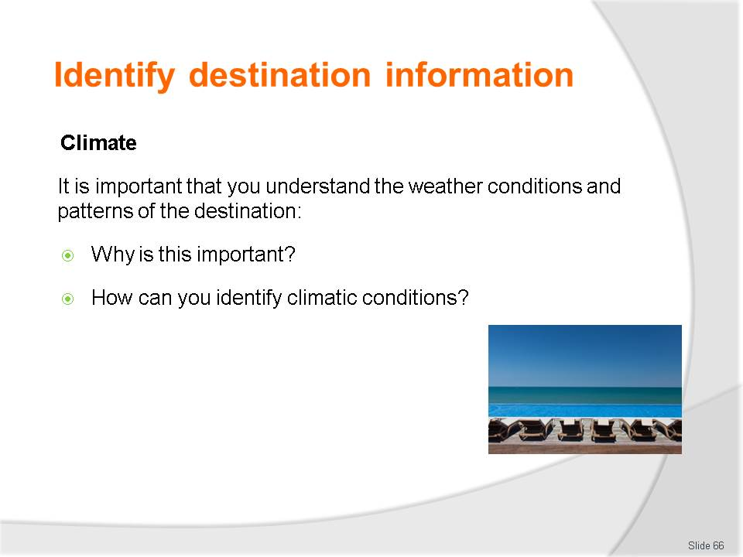
Slide No | Trainer Notes
Class Activity – Question
- Discuss the questions in the slide.

Slide
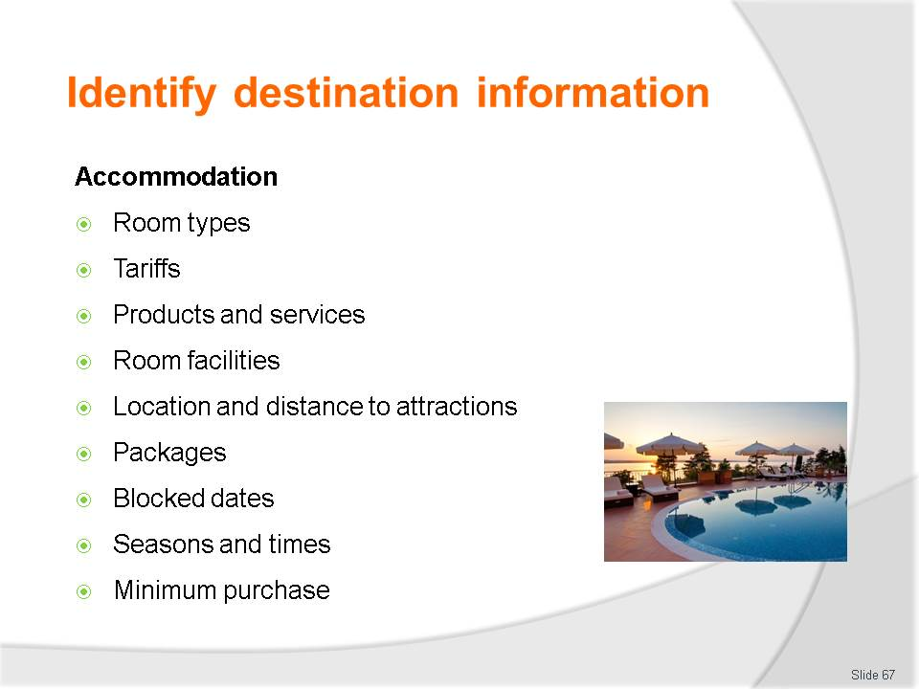
Slide No | Trainer Notes
Class Activity – Question
- Discuss the types of information to be collected under each point?
- How can you collect this information?
- What format would you like it in?

Slide
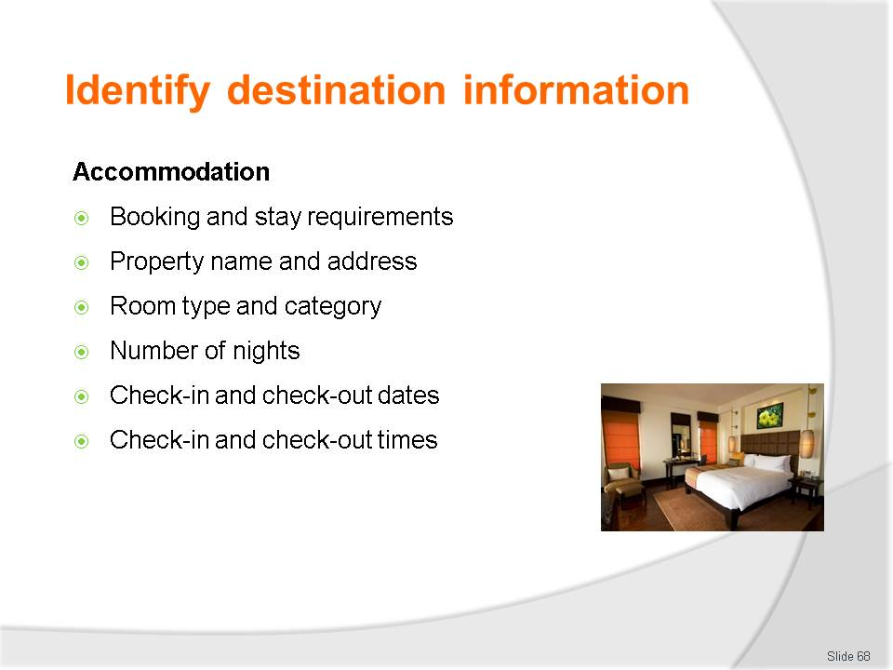
Slide No | Trainer Notes
Class Activity – Question
- Discuss the types of information to be collected under each point?
- How can you collect this information?
- What format would you like it in?

Slide
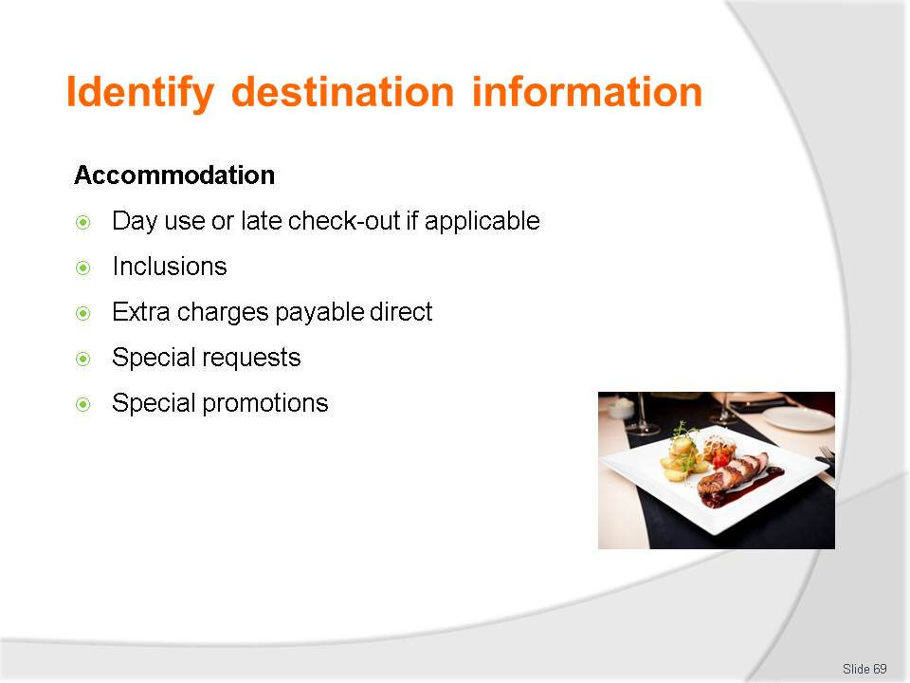
Slide No | Trainer Notes
Class Activity – Question
- Discuss the types of information to be collected under each point?
- How can you collect this information?
- What format would you like it in?

Slide
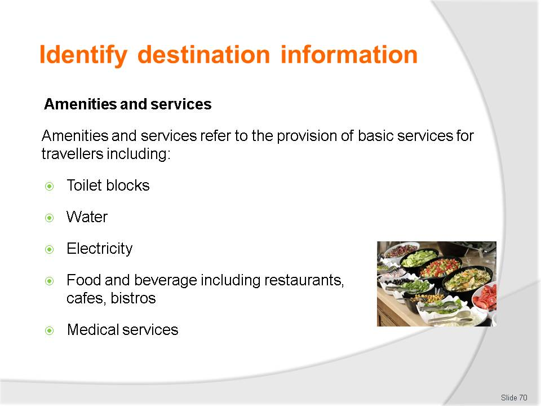
Slide No | Trainer Notes
Class Activity – Question
- Discuss the types of information to be collected under each point?
- How can you collect this information?
- What format would you like it in?

Slide
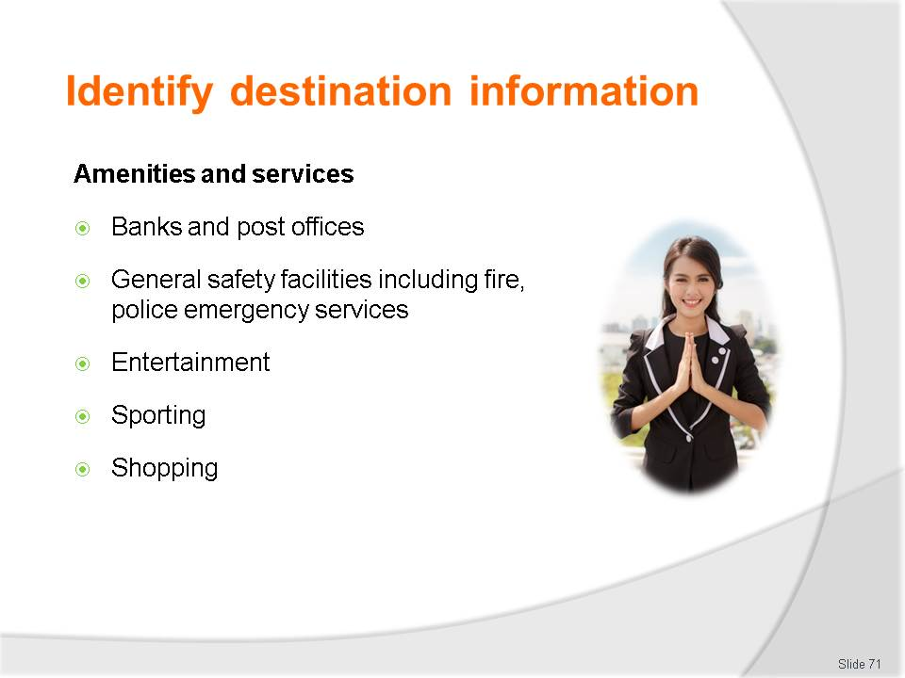
Slide No | Trainer Notes
Class Activity – Question
- Discuss the types of information to be collected under each point?
- How can you collect this information?
- What format would you like it in?

Slide
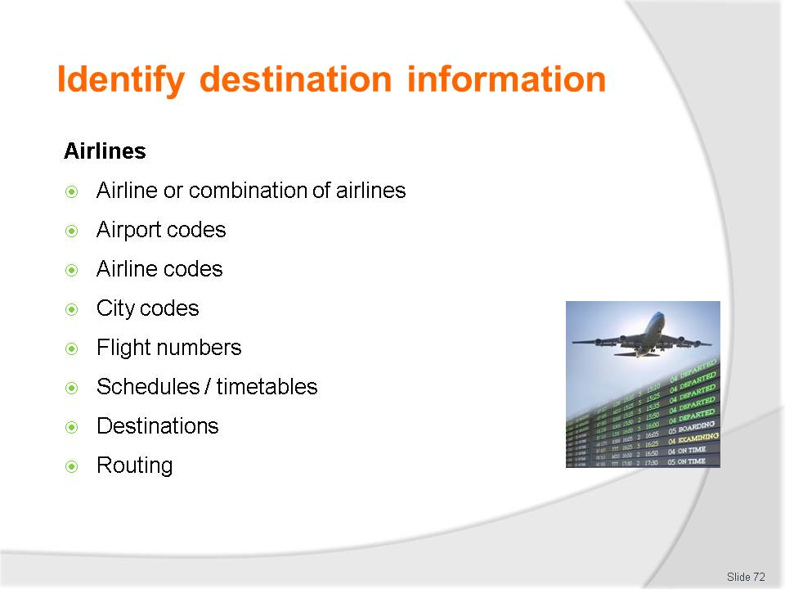
Slide No | Trainer Notes
Class Activity – Question
- Discuss the types of information to be collected under each point?
- How can you collect this information?
- What format would you like it in?

Slide
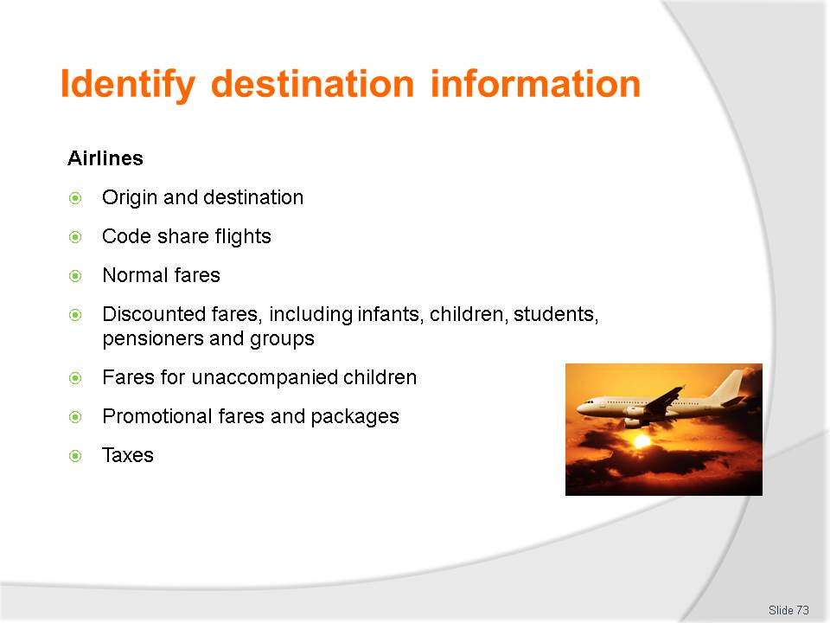
Slide No | Trainer Notes
Class Activity – Question
- Discuss the types of information to be collected under each point?
- How can you collect this information?
- What format would you like it in?

Slide
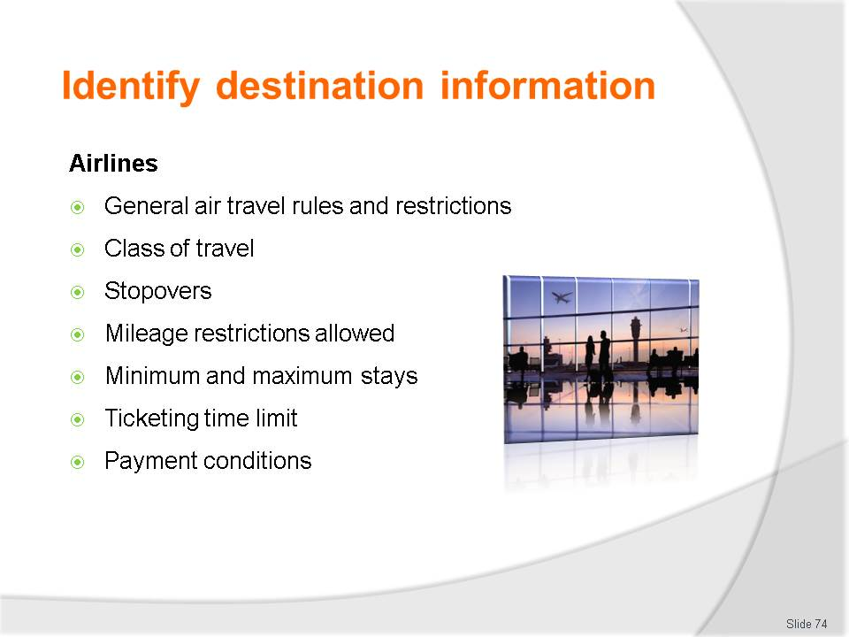
Slide No | Trainer Notes
Class Activity – Question
- Discuss the types of information to be collected under each point?
- How can you collect this information?
- What format would you like it in?

Slide
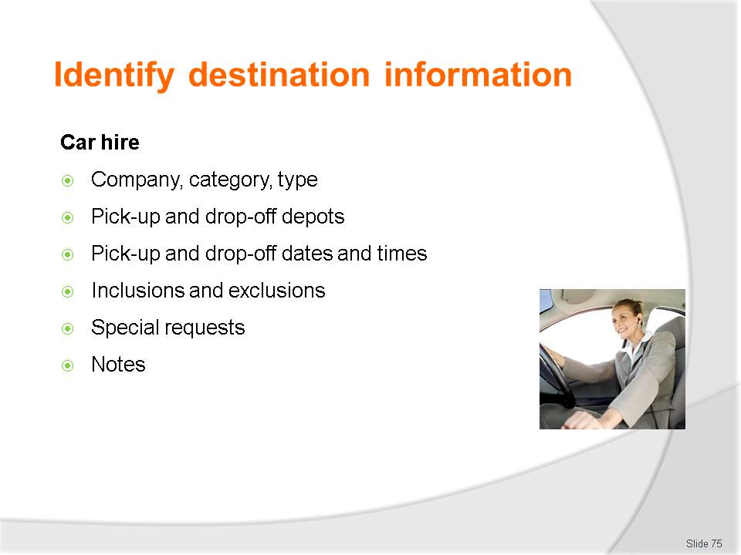
Slide No | Trainer Notes
Class Activity – Question
- Discuss the types of information to be collected under each point?
- How can you collect this information?
- What format would you like it in?

Slide
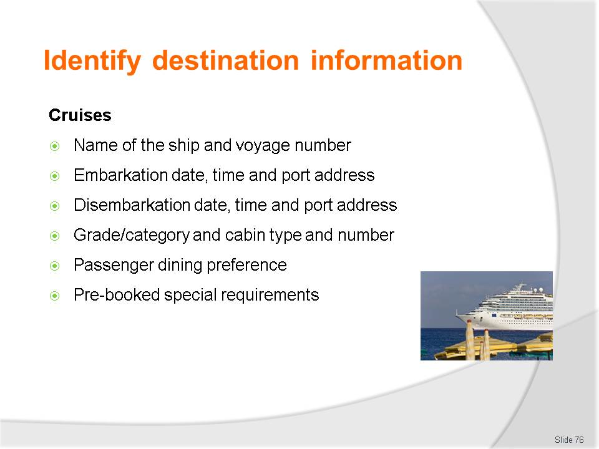
Slide No | Trainer Notes
Class Activity – Question
- Discuss the types of information to be collected under each point?
- How can you collect this information?
- What format would you like it in?

Slide
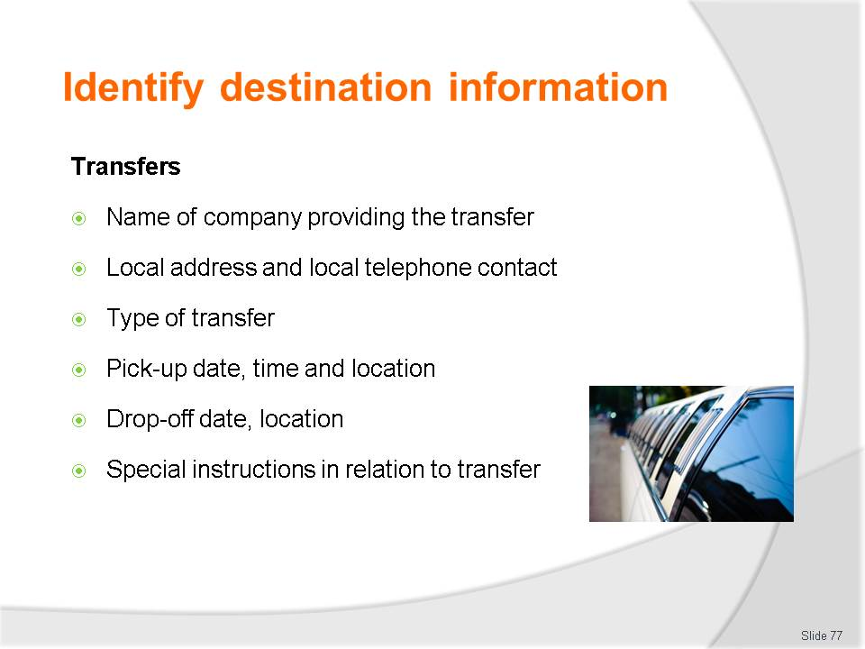
Slide No | Trainer Notes
Class Activity – Question
- Discuss the types of information to be collected under each point?
- How can you collect this information?
- What format would you like it in?

Slide
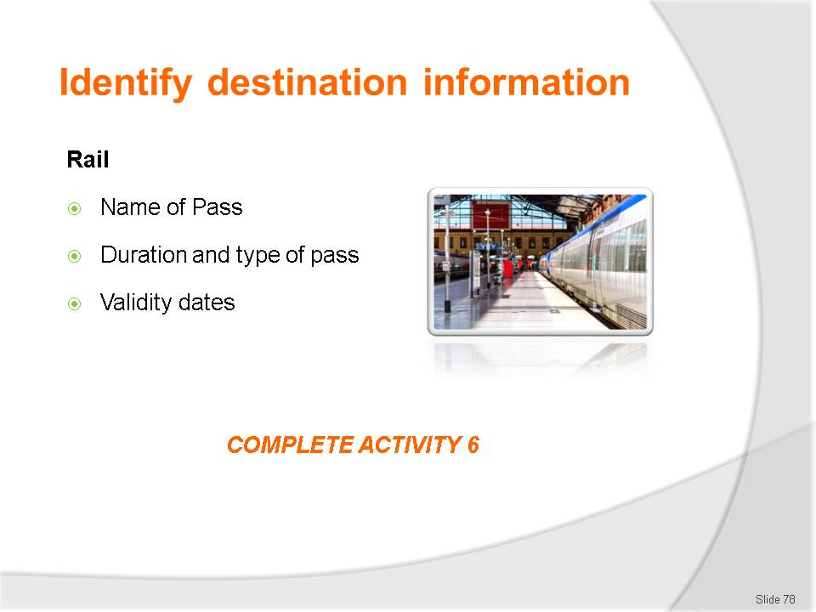
Slide No | Trainer Notes
Class Activity – Question & Activity
- Discuss the types of information to be collected under each point?
- How can you collect this information?
- What format would you like it in?
- Complete Activity 6.

Slide
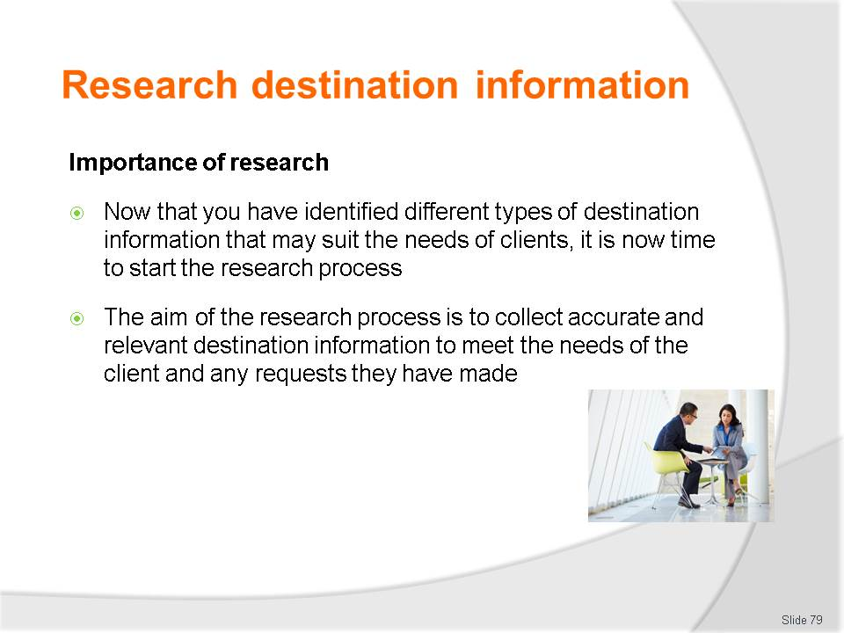
Slide No | Trainer Notes
Class Activity – Discuss
- Describe the process that you have used in the past when conducting research.

Slide
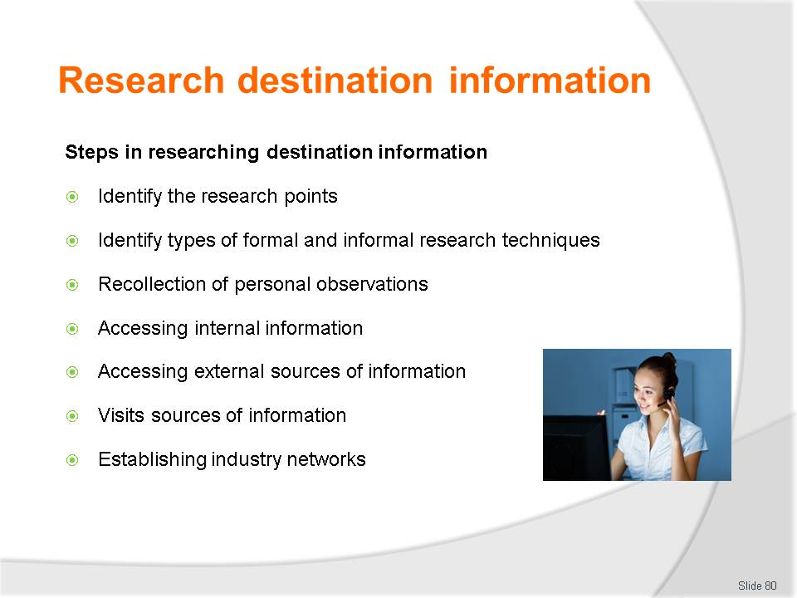
Slide No | Trainer Notes
Class Activity – Discuss
- What are the activities and benefits for each of these steps?

Slide
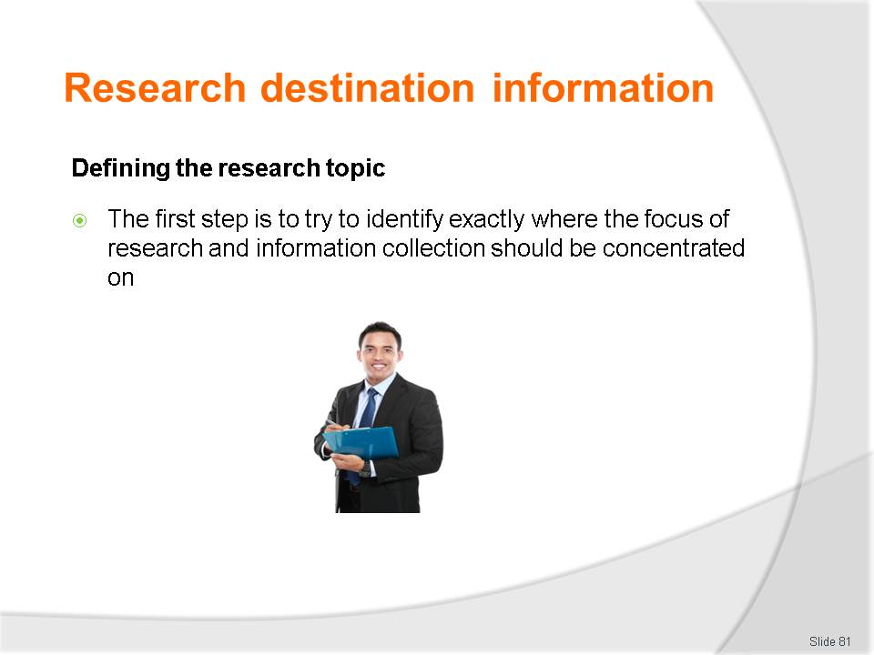
Slide No | Trainer Notes
Class Activity – Discuss
- What would be research topics you may have?

Slide
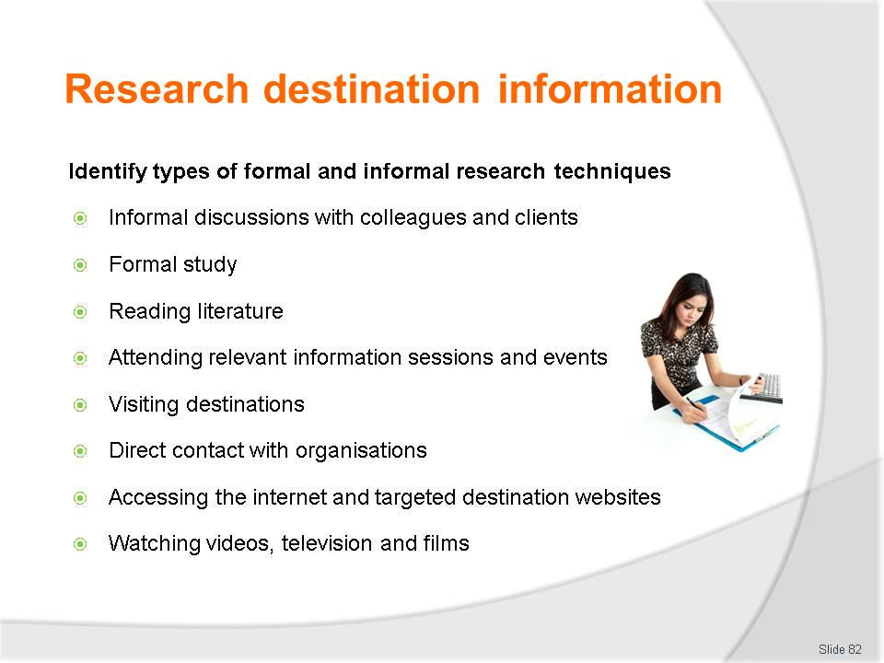
Slide No | Trainer Notes
Class Activity – Discuss
- What other techniques can be used?

Slide
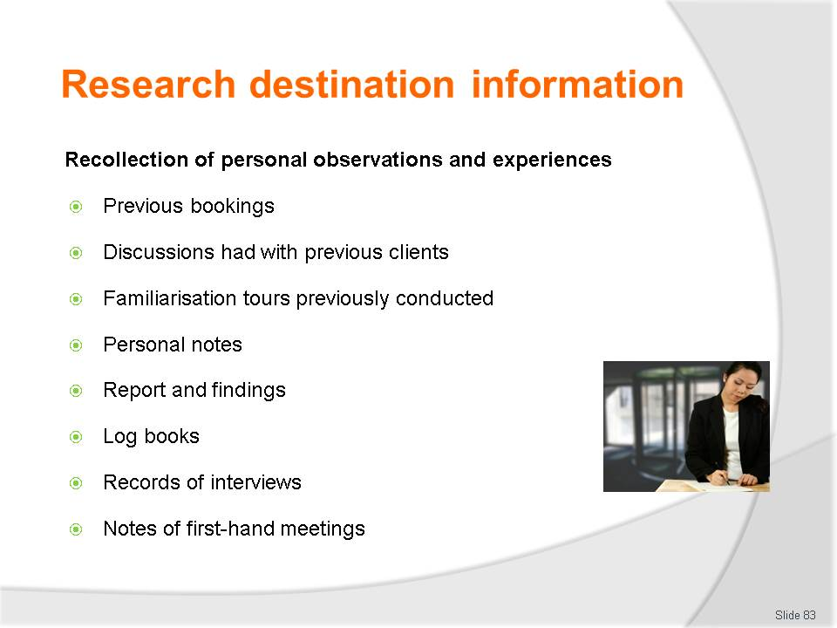
Slide No | Trainer Notes
Class Activity – Discuss
- Why is this source of information often the most effective?

Slide
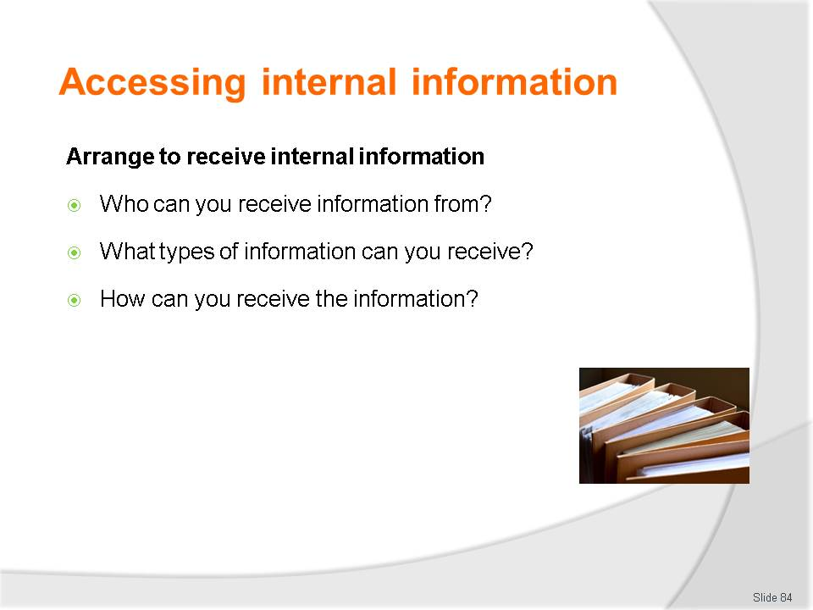
Slide No | Trainer Notes
Class Activity – Discussion
Ask general questions:
- Discuss the questions in the slide.

Slide
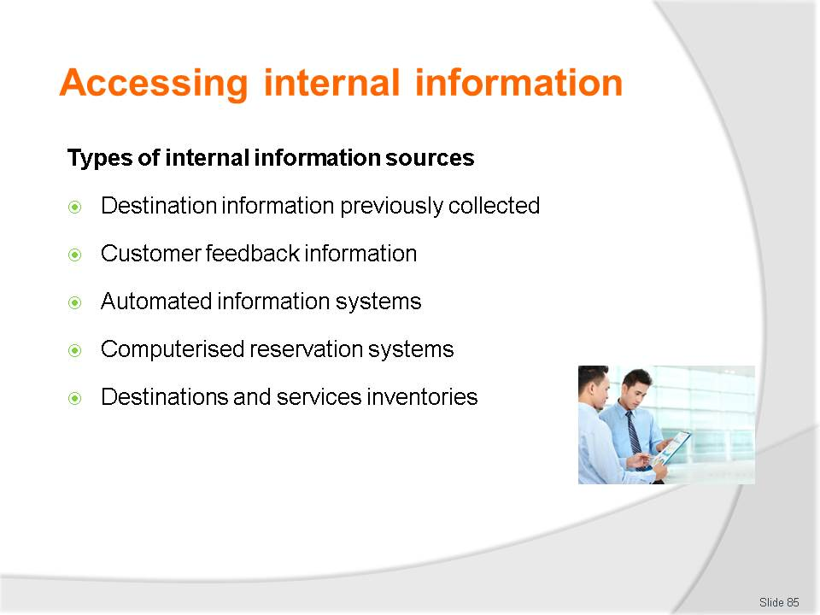
Slide No | Trainer Notes
Class Activity – Discuss
- What information can come from each of these sources?

Slide
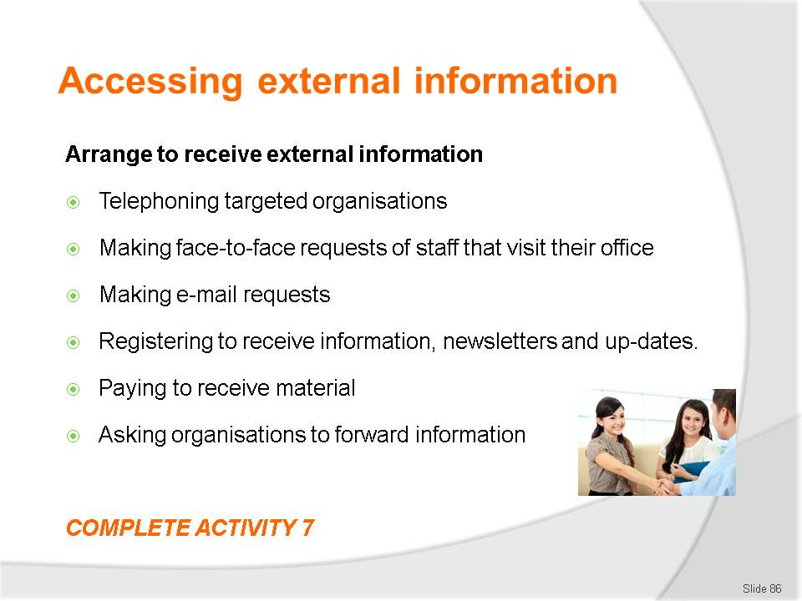
Slide No | Trainer Notes
Class Activity – Discussion & Activity
Ask general questions:
- Discuss activities associated with these points
- Complete Activity 7.

Slide
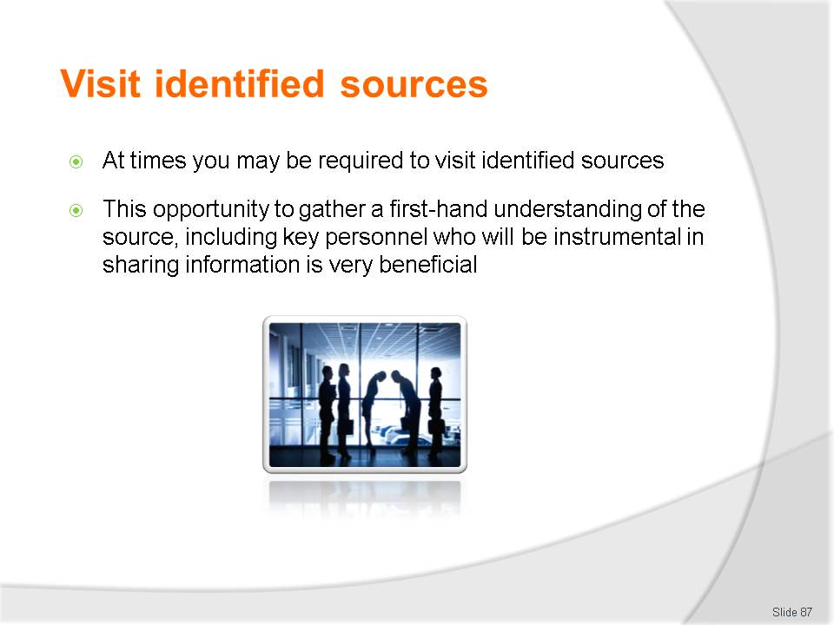
Slide No | Trainer Notes
Class Activity – Discuss
- What are the benefits of visiting identified sources?

Slide
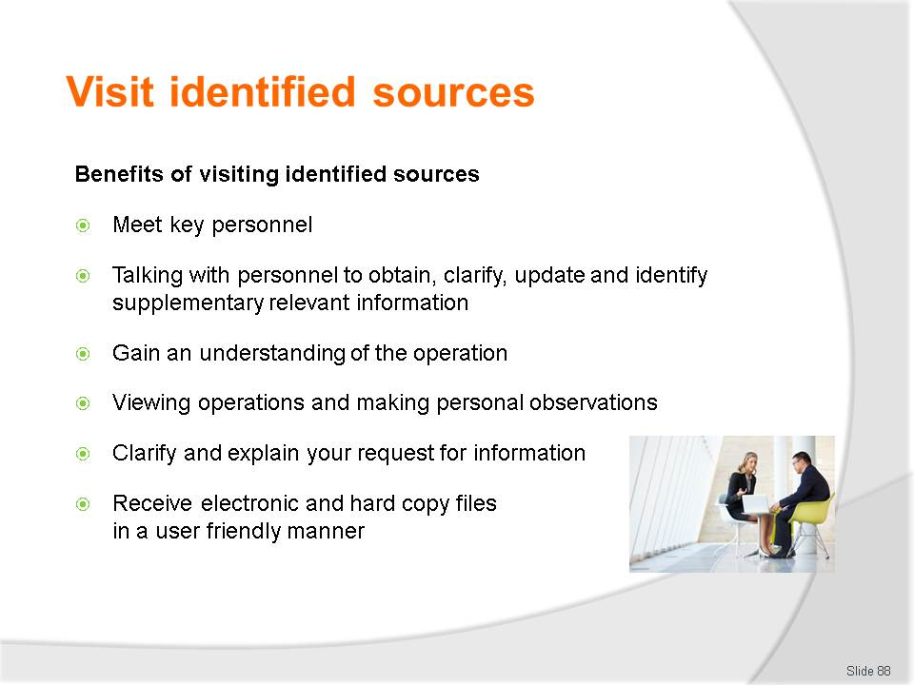
Slide No | Trainer Notes
Class Activity – Discuss
- Discuss these benefits of visiting identified sources.

Slide
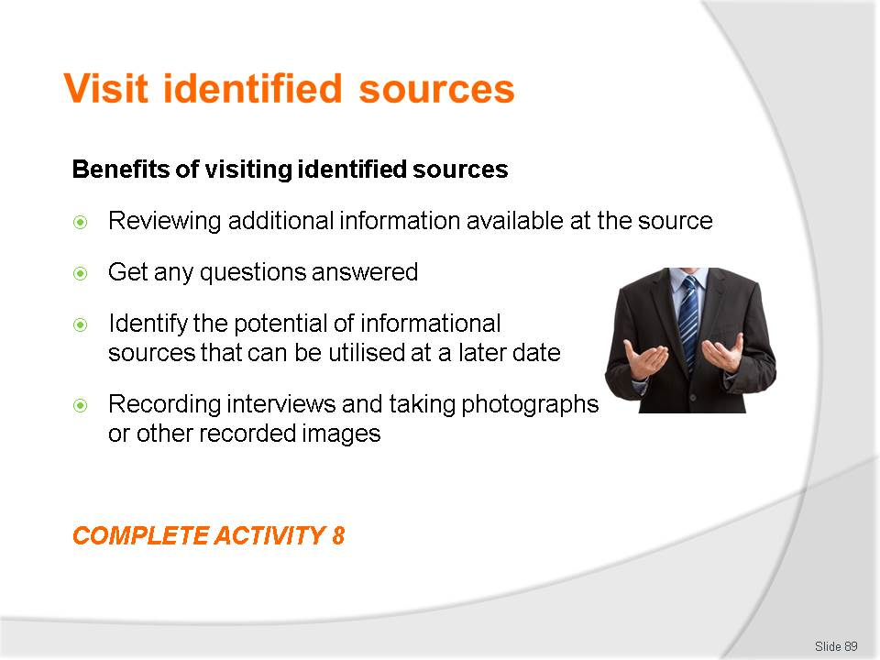
Slide No | Trainer Notes
Class Activity – Discuss & Activity
- Discuss these benefits of visiting identified sources
- Complete Activity 8.

Slide

Slide No | Trainer Notes
Class Activity – Discuss & Activity
- Discuss these benefits of setting up networks?
- Who would you have in your network?
- Complete Activity 9.

Slide

Slide No | Trainer Notes
Introduce topic.
Class Activity – General Discussion
Ask general questions:
- Why is it important to update knowledge?
- How do you know if your knowledge is up to date?
- How can you update your destination knowledge?

Slide
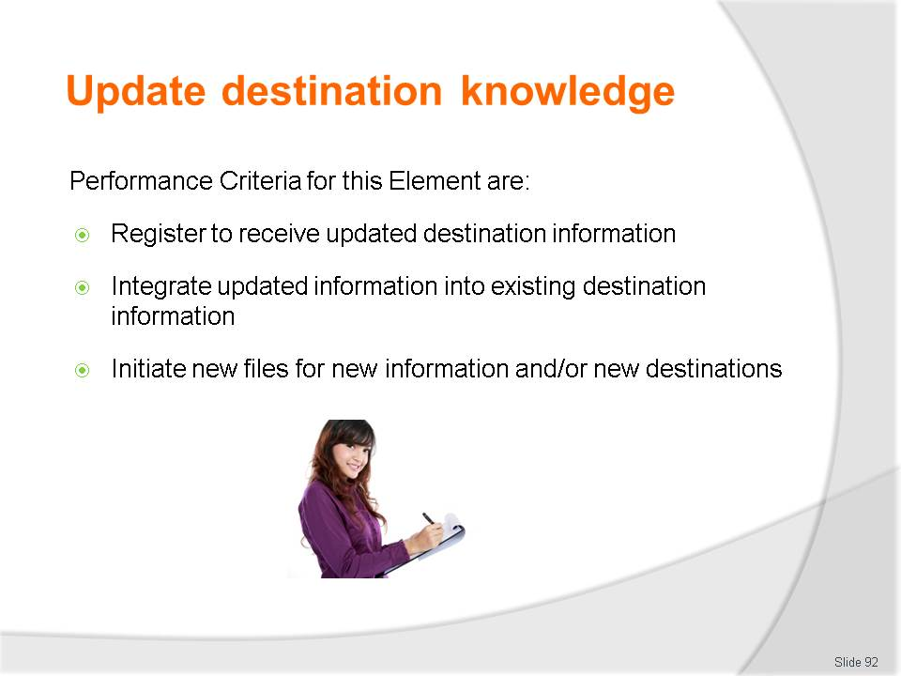
Slide No | Trainer Notes
 | Trainer identifies the Performance Criteria for this Element, as listed on the slide.

Slide
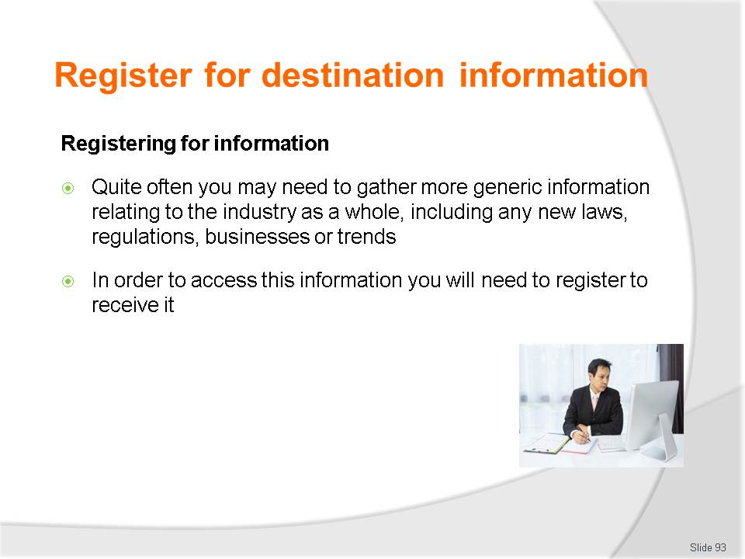
Slide No | Trainer Notes
Class Activity – Discussion
Ask general questions:
- What are examples of publications you need to register for?
- How can you register to access information?

Slide
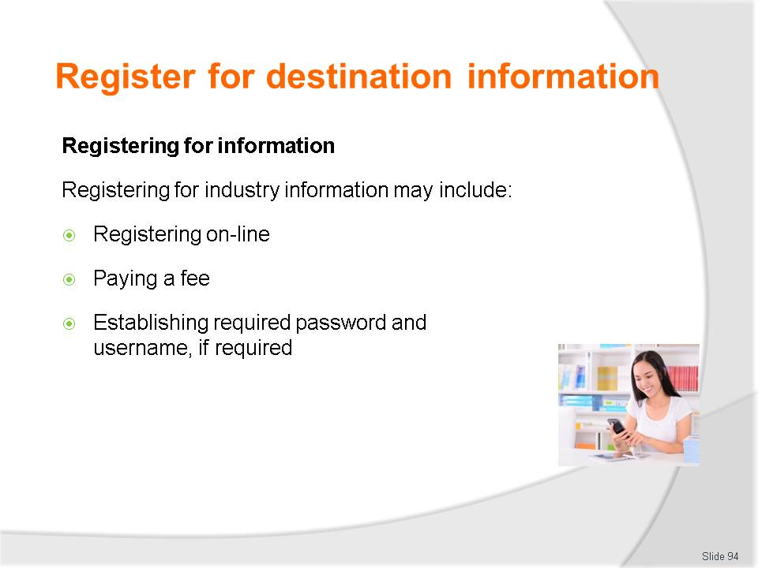
Slide No | Trainer Notes
Class Activity – Discussion
- Discuss these points
- Provide an example of each.

Slide
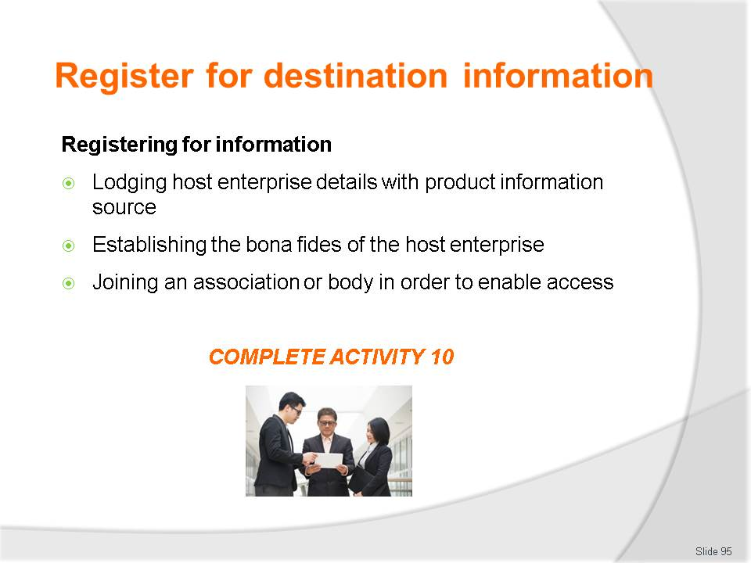
Slide No | Trainer Notes
Class Activity – Discussion & Activity
- Discuss these points
- Provide an example of each.
- Complete Activity 10.

Slide
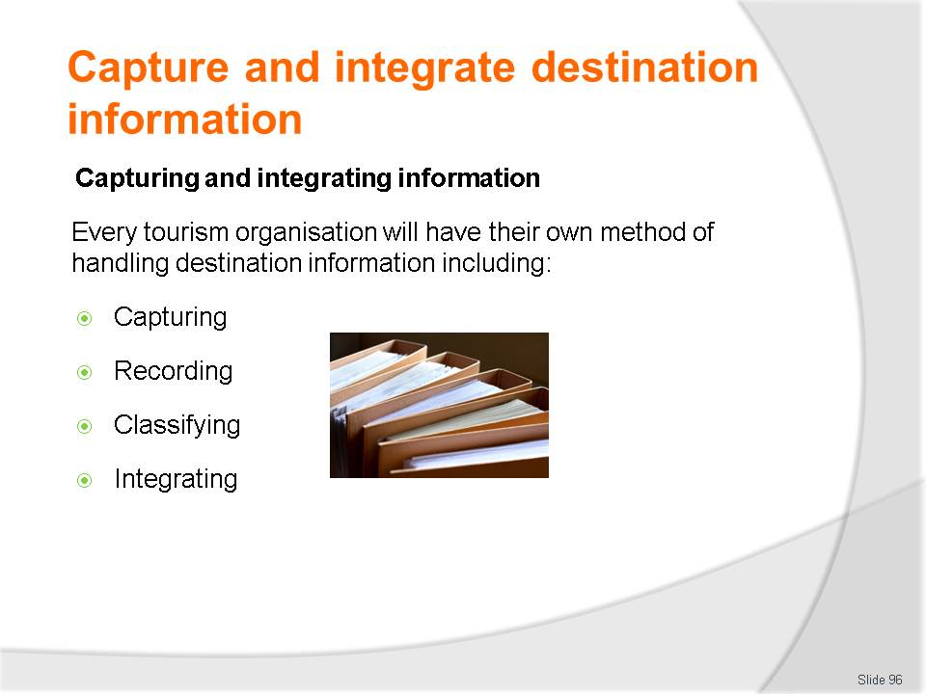
Slide No | Trainer Notes
Class Activity – Discuss
Discuss and explain the differences of these points
- How can you integrate information to meet the needs of the organisation?
- How can you integrate information to meet the needs of the client?

Slide
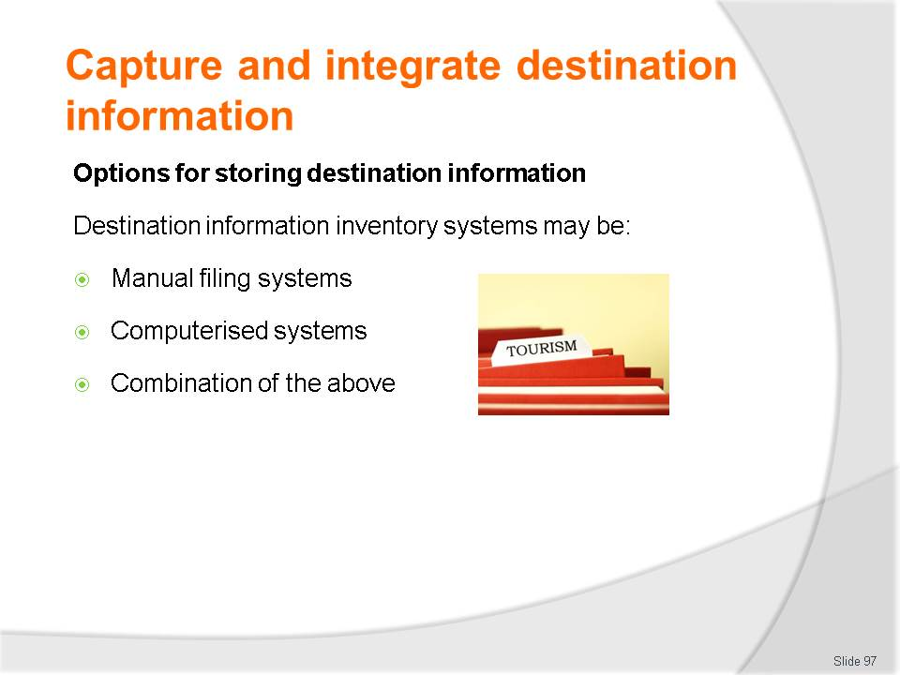
Slide No | Trainer Notes
Class Activity – Discuss
- Provide examples of each systems.

Slide
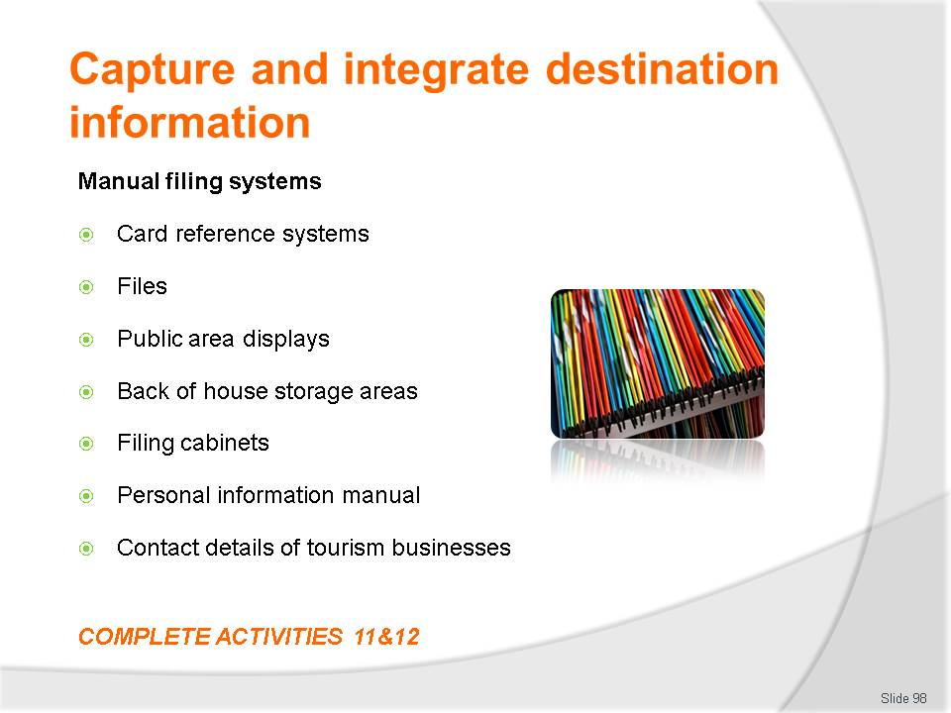e
Slide No | Trainer Notes
Class Activity – Discussion & Activities
- Discuss how these systems can be managed and maintained
- Complete Activities 11&12.

Slide
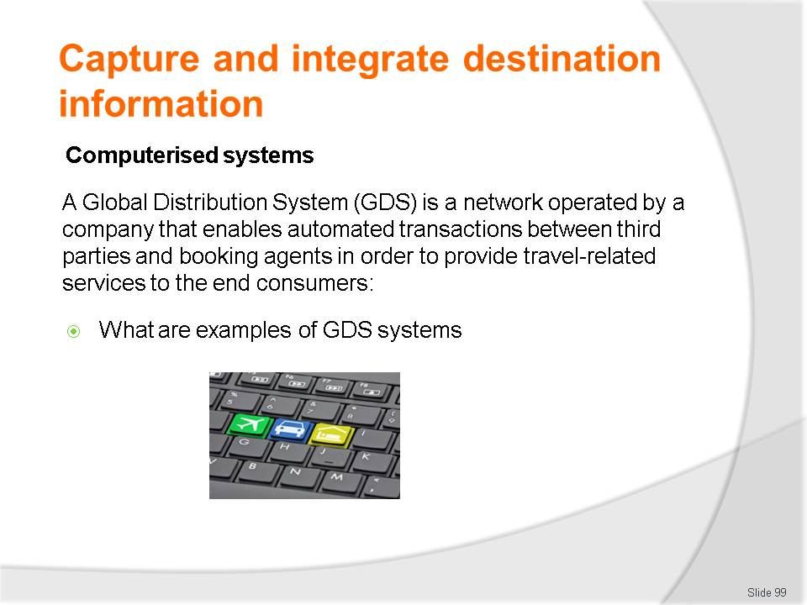
Slide No | Trainer Notes
Class Activity – Discussion
- Discuss question in the slide.

Slide
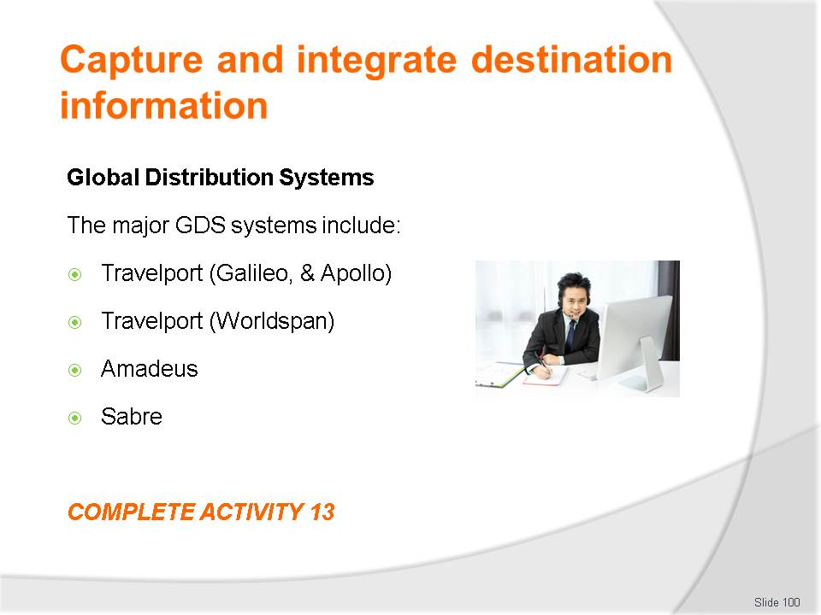
Slide No | Trainer Notes
Class Activity –Activity
- Complete Activity 13.

Slide
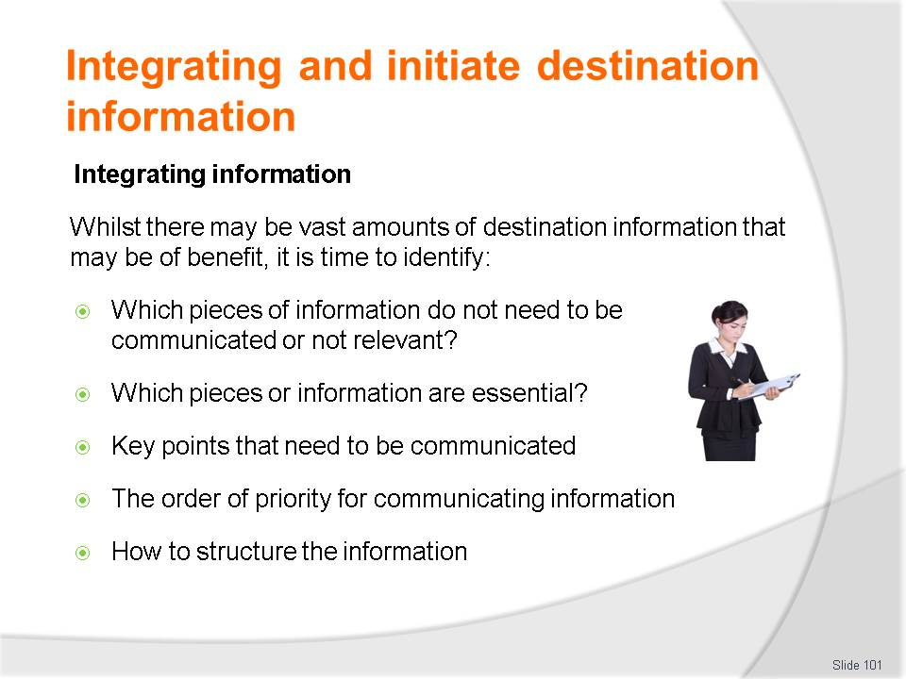
Slide No | Trainer Notes
Class Activity – Discuss
- Discuss importance of these points.

Slide
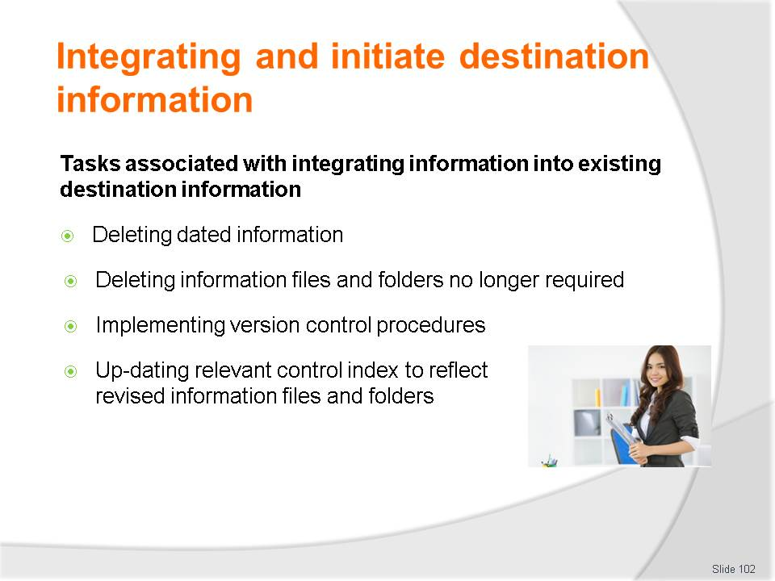
Slide No | Trainer Notes
Class Activity – Discuss
- Discuss importance of these points.

Slide
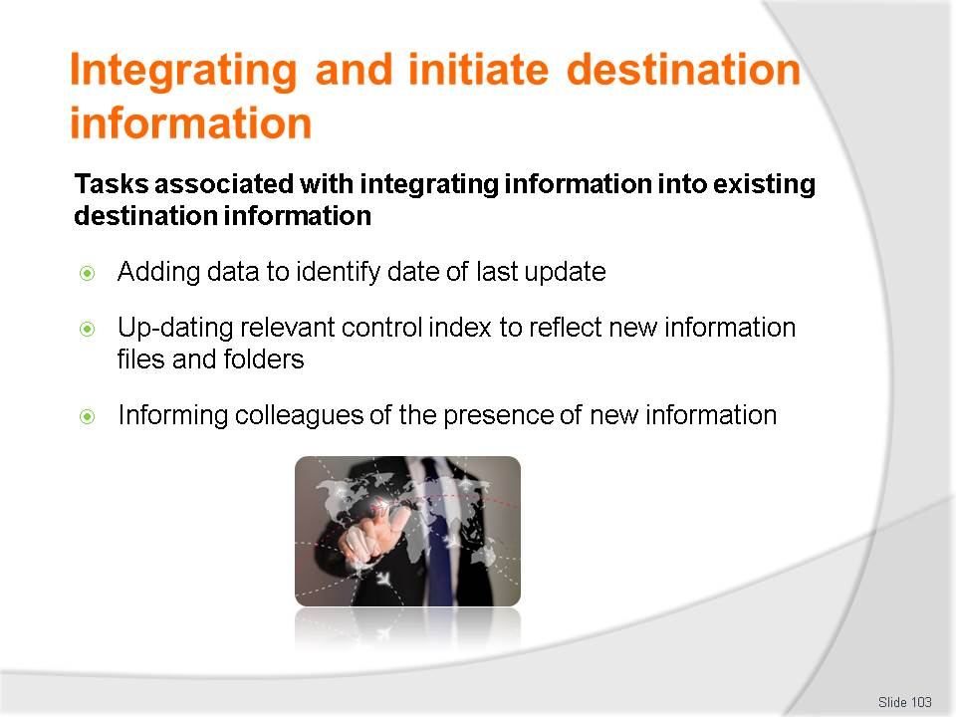
Slide No | Trainer Notes
Class Activity – Discuss
- Discuss importance of these points.

Slide
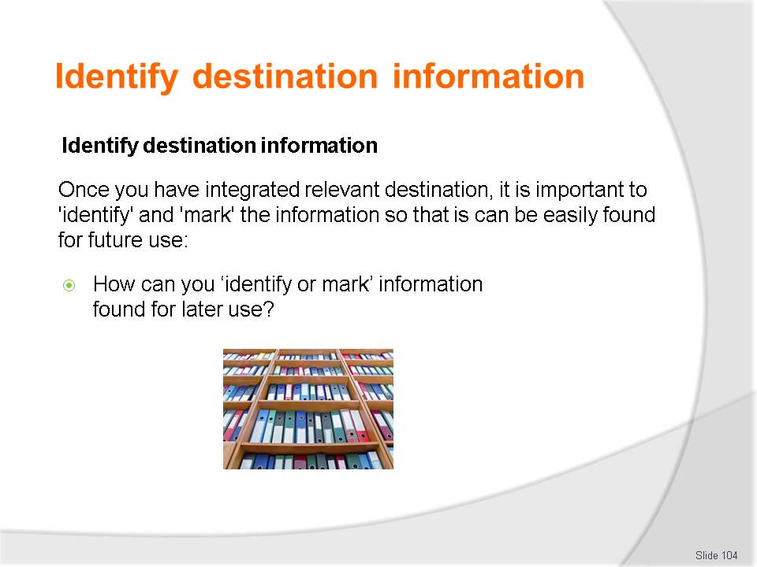
Slide No | Trainer Notes
Class Activity – Discussion
Ask general questions:
- Discuss the question in the slide.

Slide
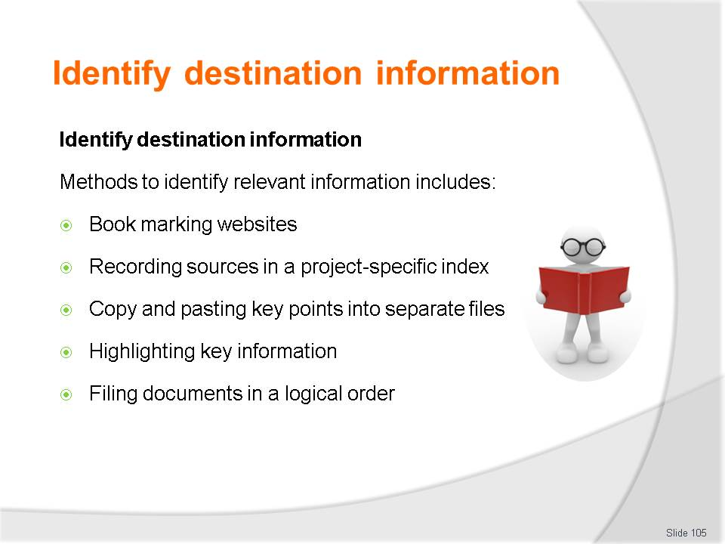
Slide No | Trainer Notes
Class Activity – Discussion
Ask general questions:
- What are the benefits of these methods?
- What other methods can be used?

Slide
e
Slide No | Trainer Notes
Introduce topic.
Class Activity – General Discussion
Ask general questions:
- How can you share destination information?

Slide
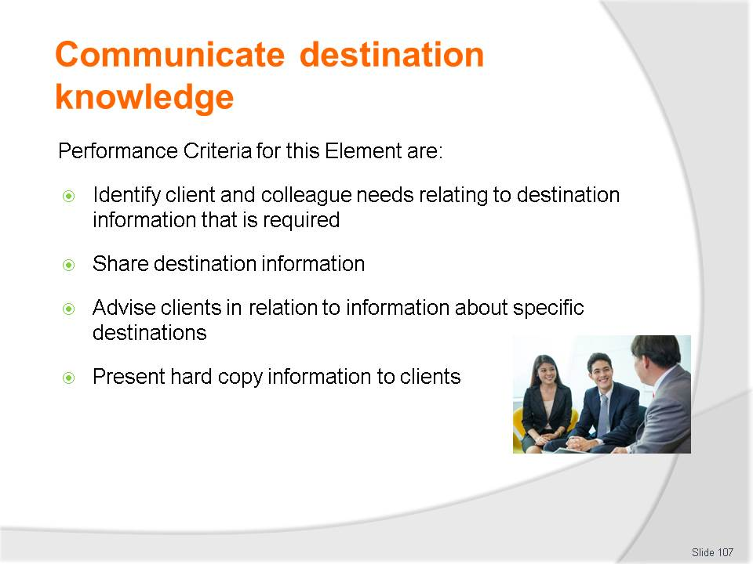
Slide No | Trainer Notes
 | Trainer identifies the Performance Criteria for this Element, as listed on the slide.

Slide
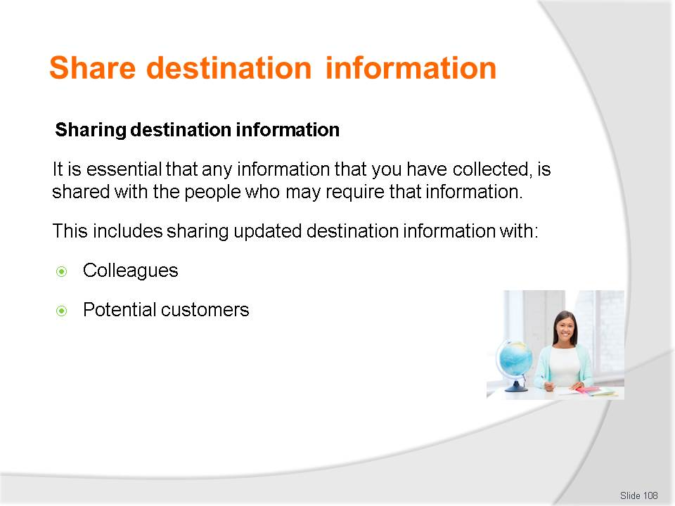
Slide No | Trainer Notes
Class Activity – Discuss
- How does the communication of information differ between these stakeholders?

Slide
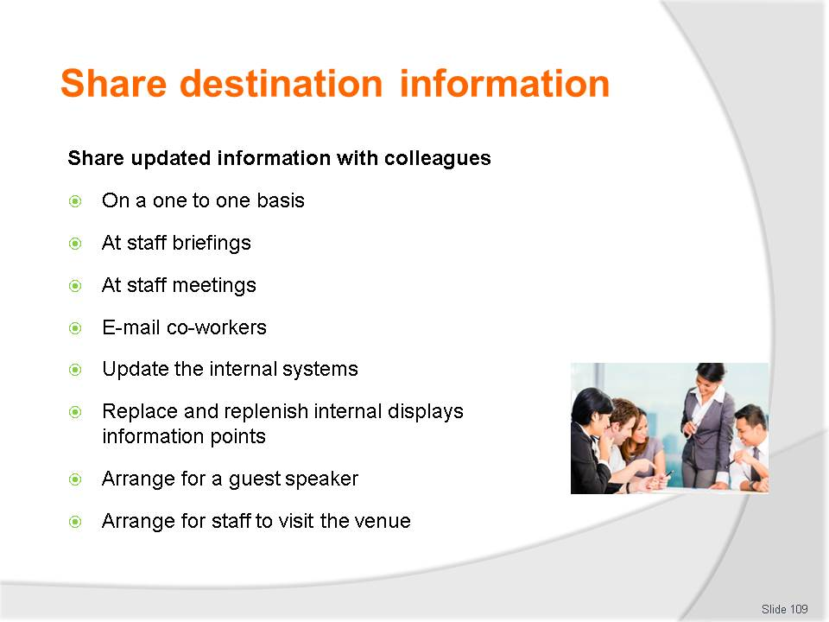
Slide No | Trainer Notes
Class Activity – Discuss
- What are the benefits of each method?
- When would you use each of these methods?

Slide
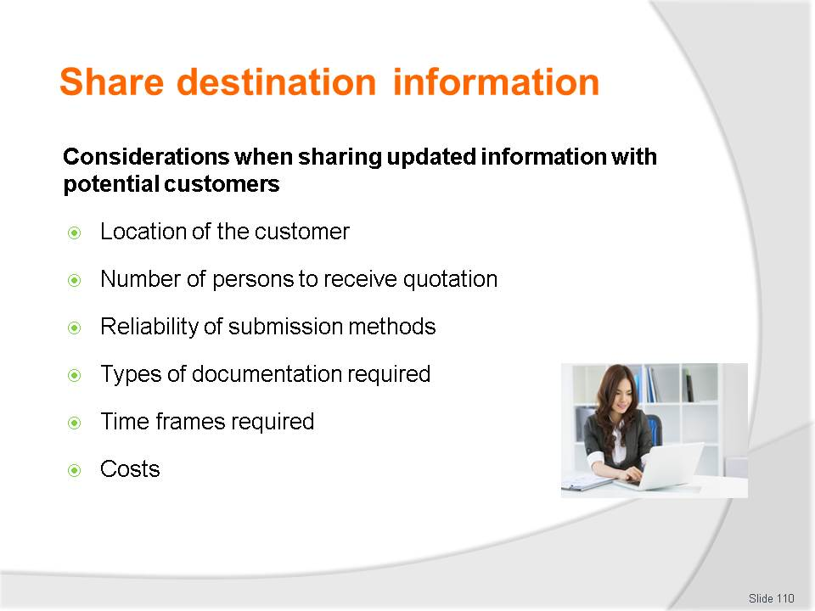
Slide No | Trainer Notes
Class Activity – Discuss these considerations
- How do they impact submission methods?

Slide
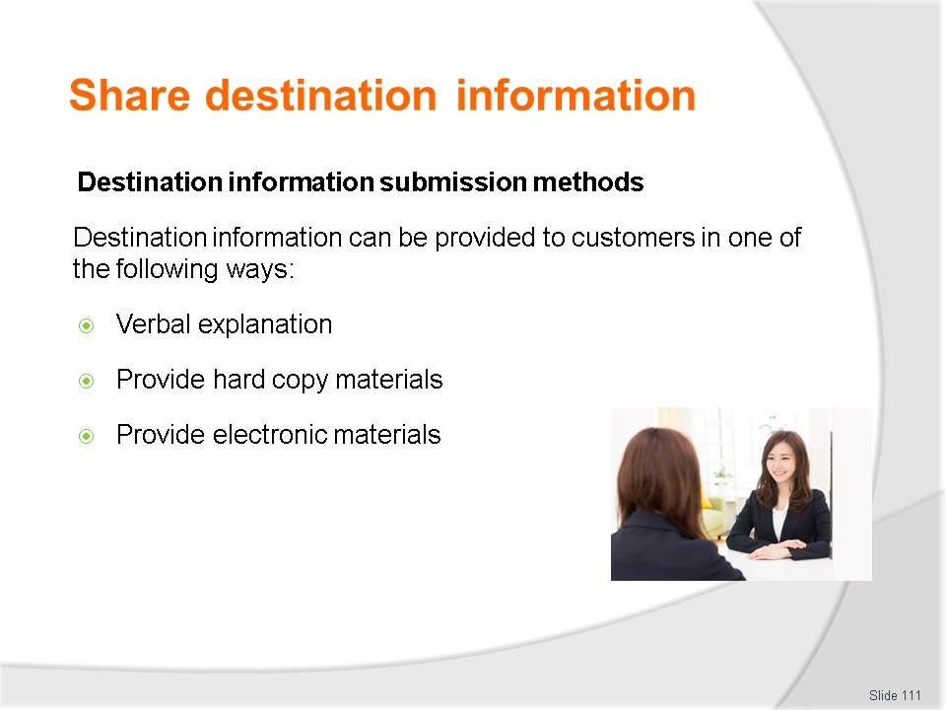
Slide No | Trainer Notes
Class Activity – Discuss submission methods
- What are the advantages and disadvantages of using each method?

Slide
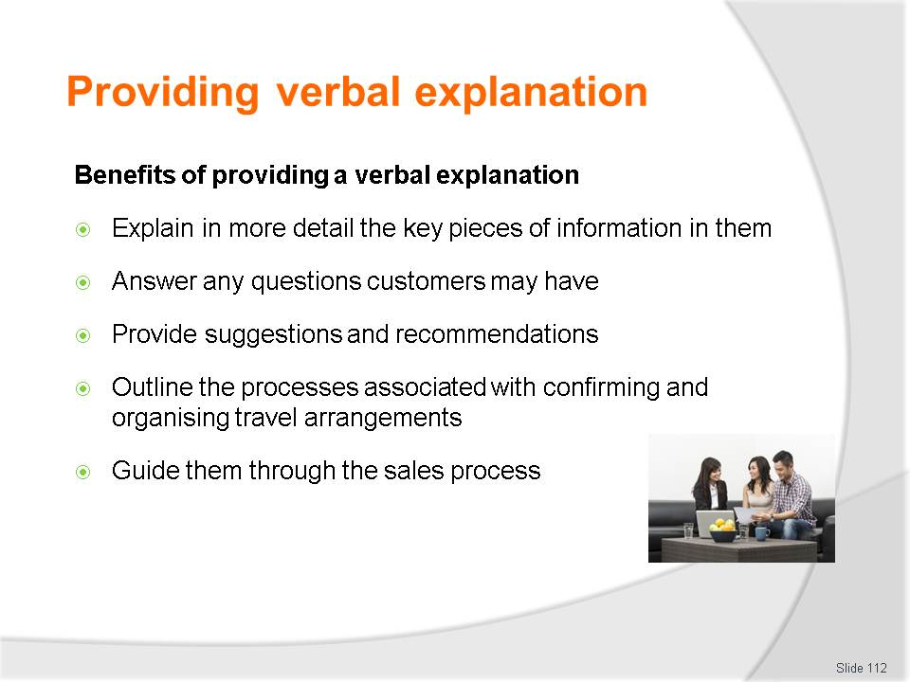
Slide No | Trainer Notes
Class Activity – Discuss
- Discuss these benefits.

Slide
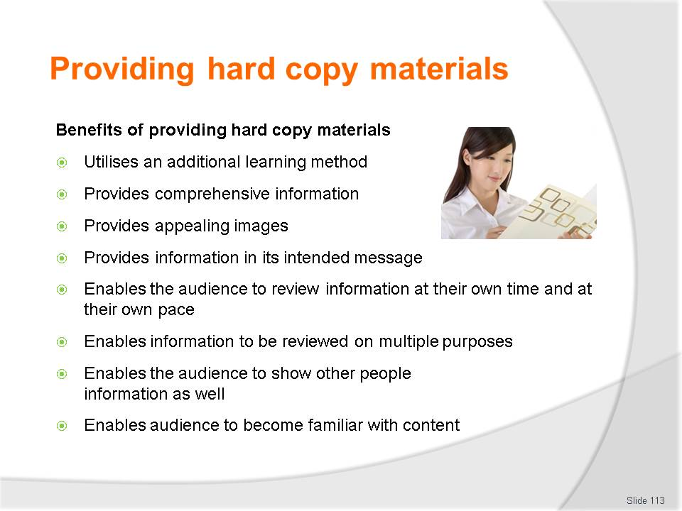
Slide No | Trainer Notes
Class Activity – Discuss
- Discuss these benefits.

Slide

Slide No | Trainer Notes
Class Activity – Show examples of hard copy materials
- Show examples.

Slide
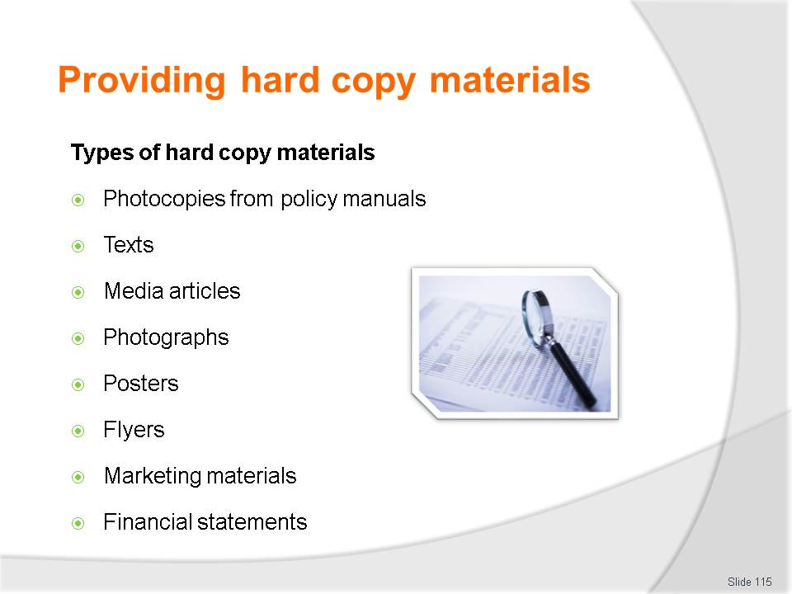
Slide No | Trainer Notes
Class Activity – Show examples of hard copy materials
- Show examples.

Slide

Slide No | Trainer Notes
Class Activity – Show examples of hard copy materials
- Show examples.

Slide
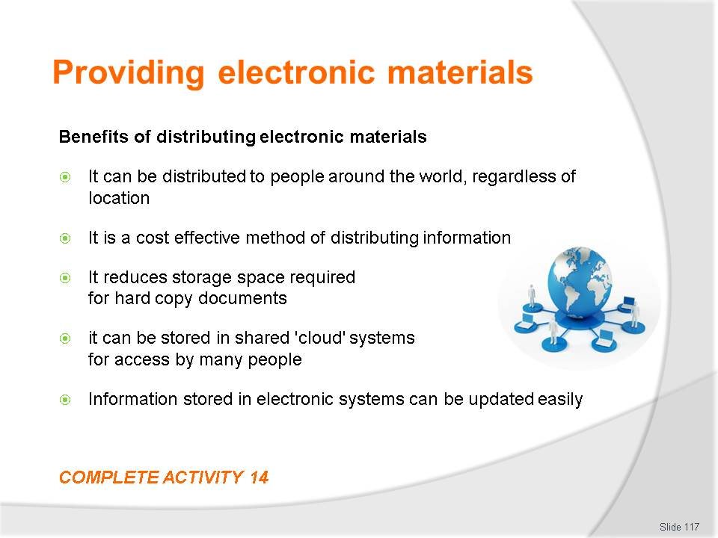
Slide No | Trainer Notes
Class Activity – Show examples of hard copy materials & Activity
- Show examples
- Complete Activity 14.

Slide
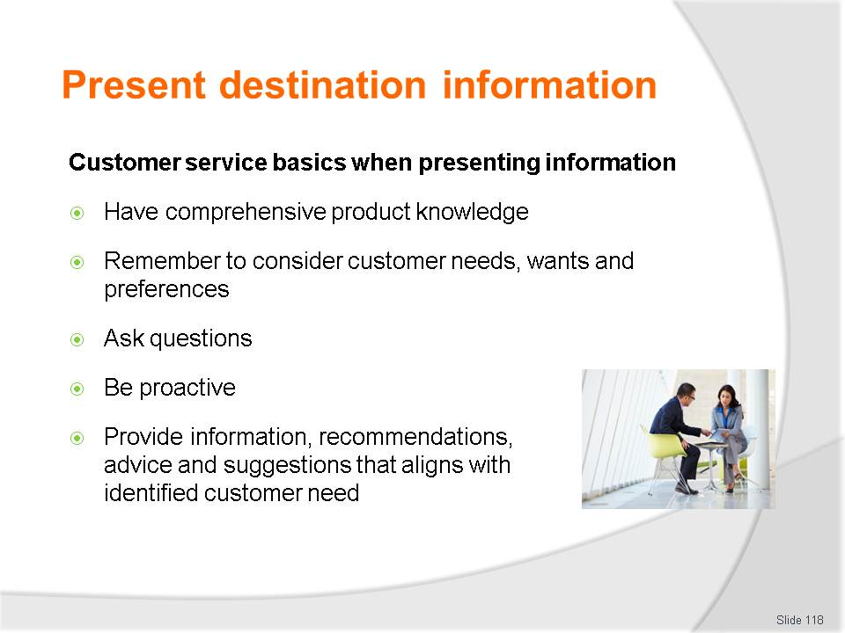
Slide No | Trainer Notes
Class Activity – Discuss importance of customer service basics
- Trainer to discuss importance of these customer service basics points.

Slide
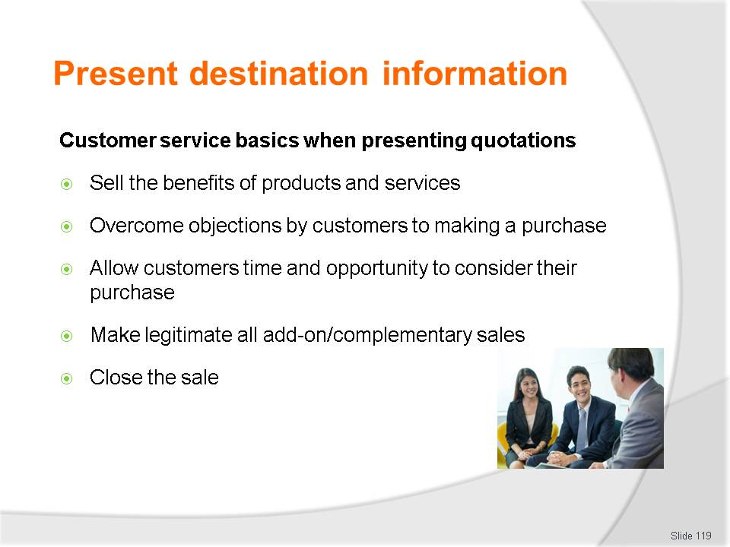
Slide No | Trainer Notes
Class Activity – Discuss importance of customer service basics
- Trainer to discuss importance of these customer service basics points.

Slide
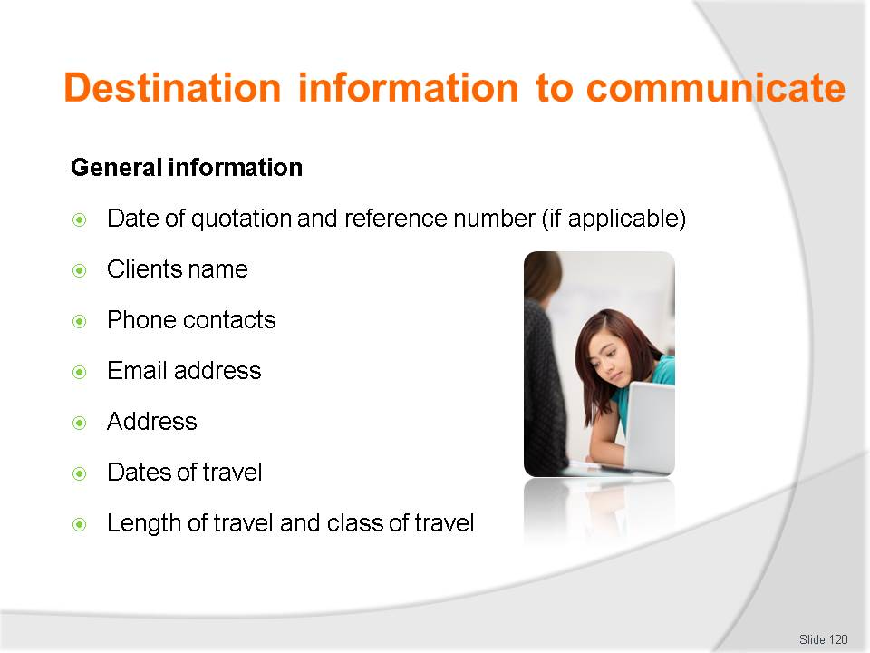
Slide No | Trainer Notes
Class Activity – Discuss & Review a quotation
- Discuss importance of these points.

Slide
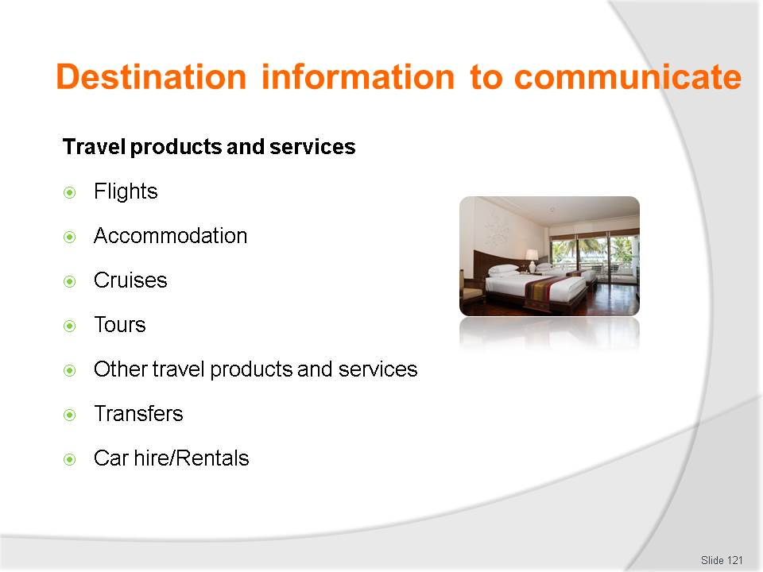
Slide No | Trainer Notes
Class Activity – Discuss destination information to communicate
- Discuss importance of these points.

Slide
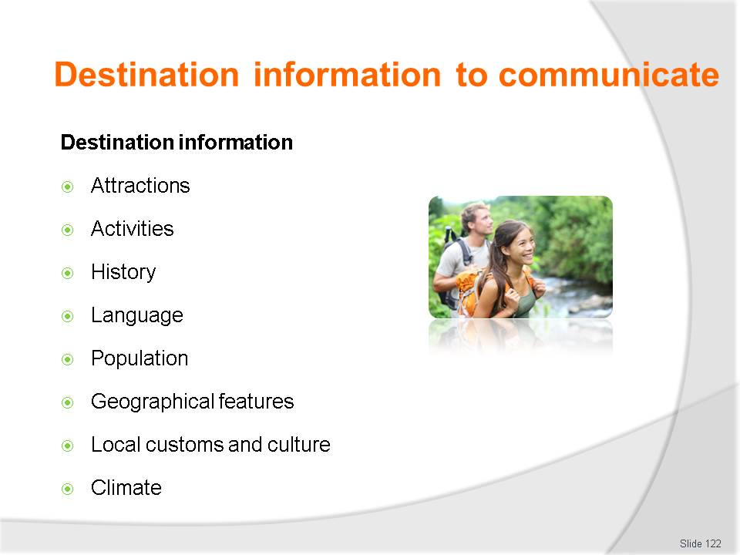
Slide No | Trainer Notes
Class Activity – Discuss destination information to communicate
- Discuss importance of these points
- Provide examples of information shared under each point.

Slide
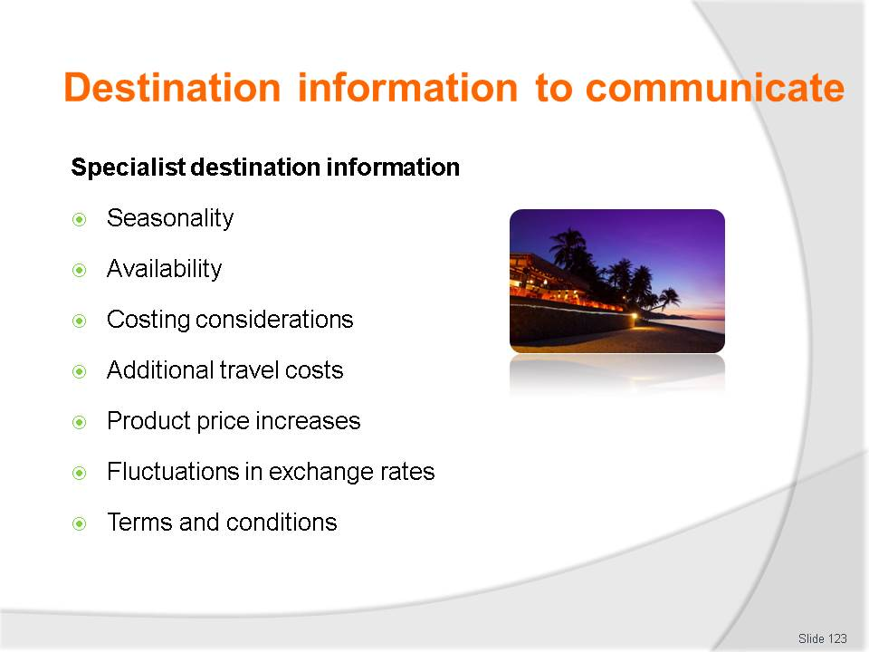
Slide No | Trainer Notes
Class Activity – Discuss destination information to communicate
- Discuss importance of these points
- Provide examples of information shared under each point
- Refer to points on Criteria 3.3 (Advise clients in relation to information about specific destinations) of Trainee Manual.

Slide
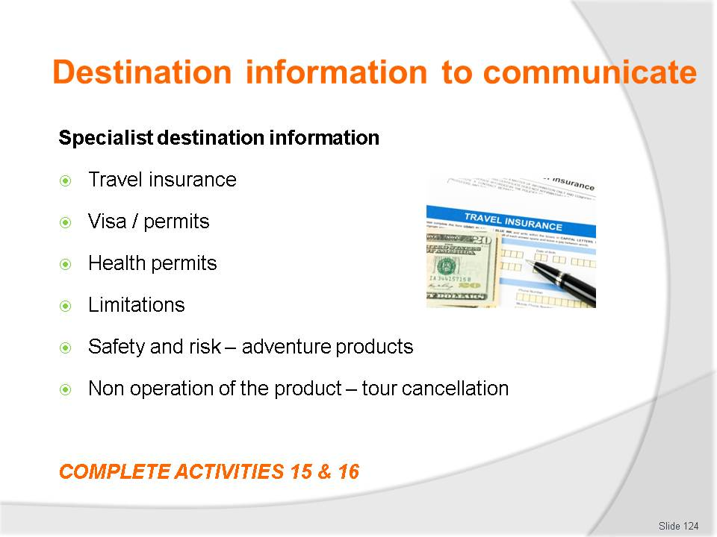
Slide No | Trainer Notes
Class Activity – Discuss destination information to communicate & Activities
- Discuss importance of these points
- Provide examples of information shared under each point
- Refer to points on Criteria 3.3 (Advise clients in relation to information about specific destinations) of Trainee Manual
- Complete Activities 15&16.

Slide
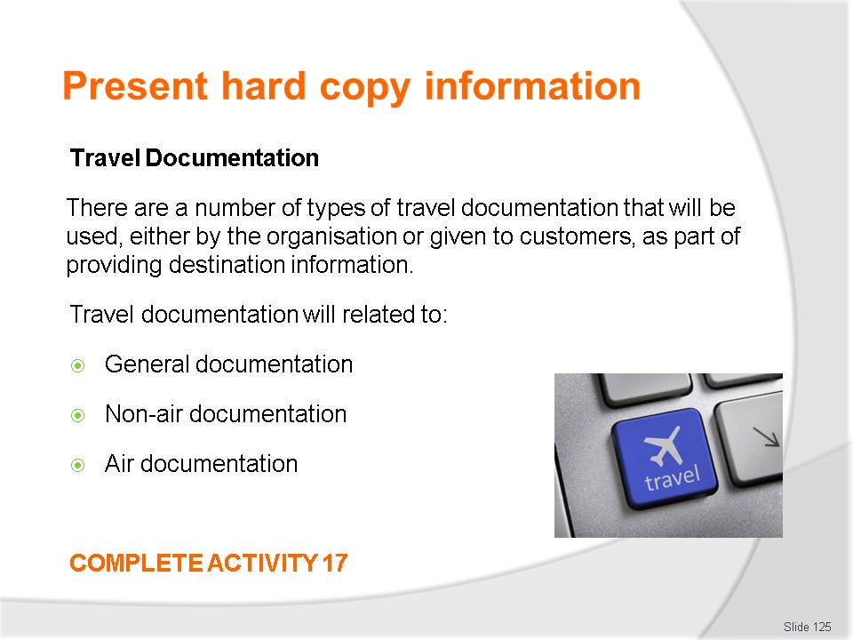
Slide No | Trainer Notes
Class Activity – Identify types of hard copy documents & Activity
- What are examples of each?
- Complete Activity 17.

Slide
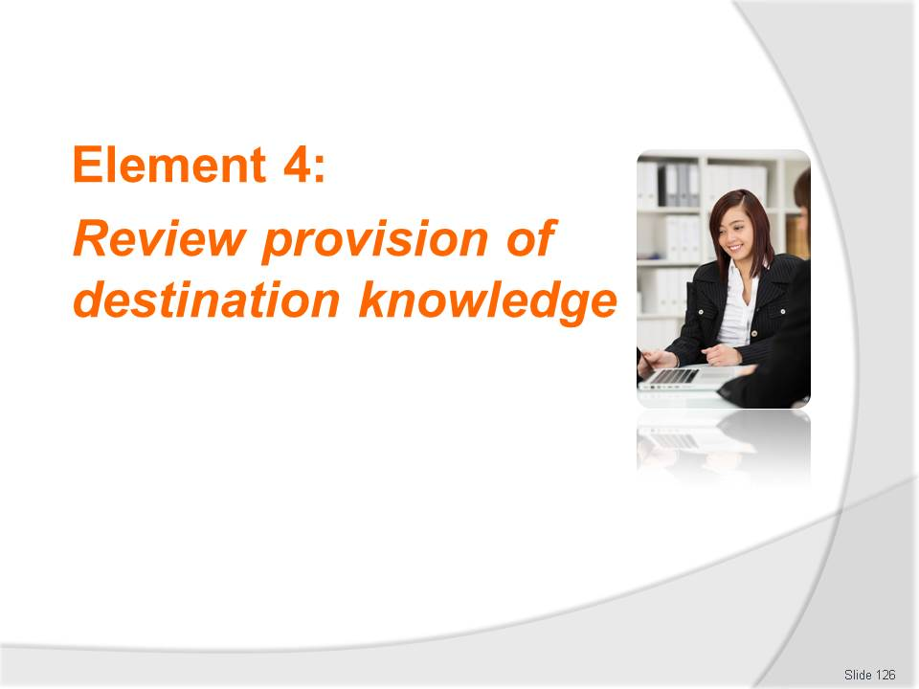
Slide No | Trainer Notes
Introduce topic.
Class Activity – General Discussion
Ask general questions:
- Why is a review important?
- How can you conduct a review?
- What needs to be considered when reviewing?
- What would be the focus of the review?

Slide
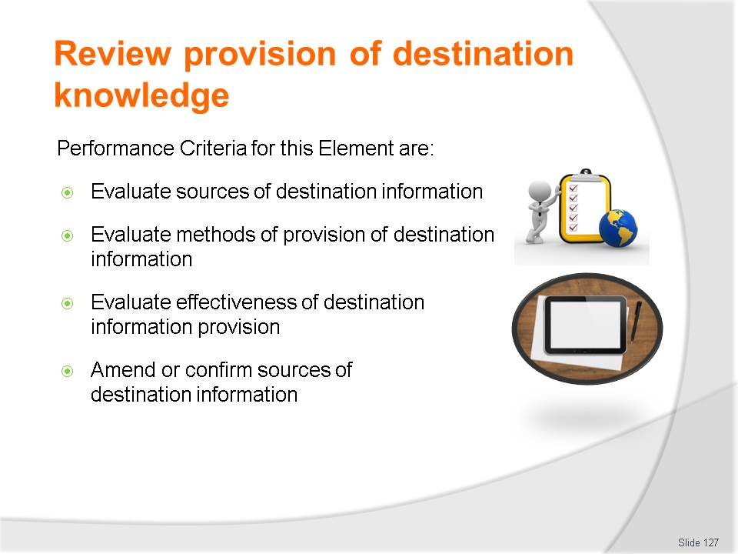
Slide No | Trainer Notes
 | Trainer identifies the Performance Criteria for this Element, as listed on the slide.

Slide
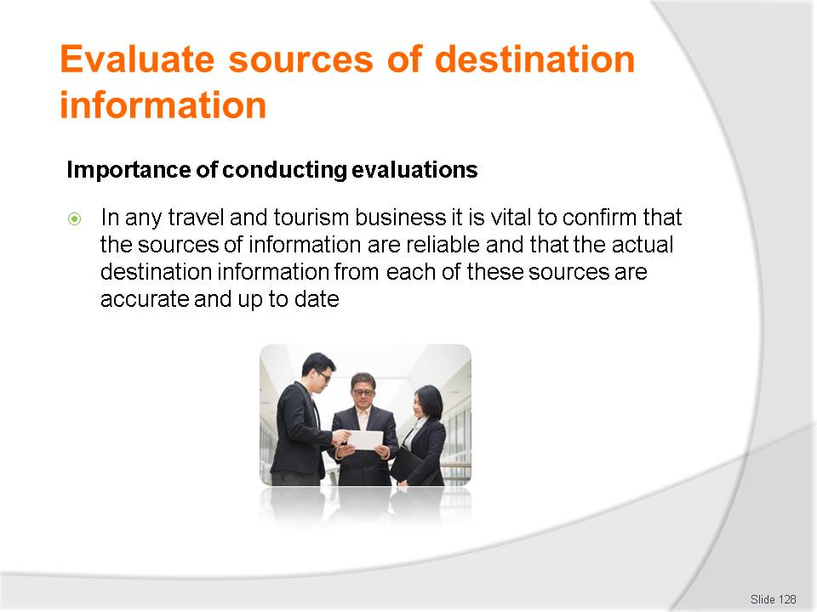
Slide No | Trainer Notes
Class Activity – Discussion
Ask general questions:
- Explain importance of conducting reviews.

Slide
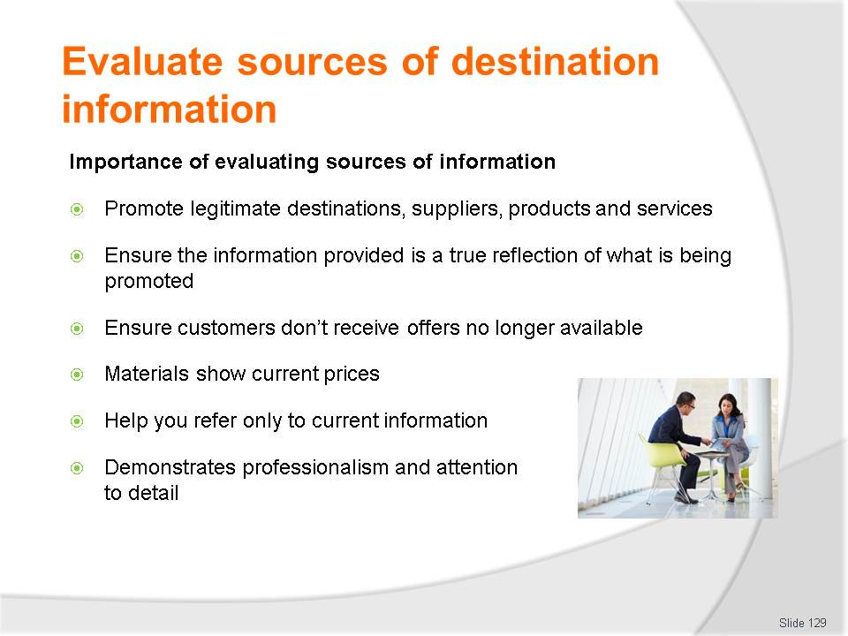
Slide No | Trainer Notes
Class Activity – Discussion
Ask general questions:
- Explain importance of these points.

Slide
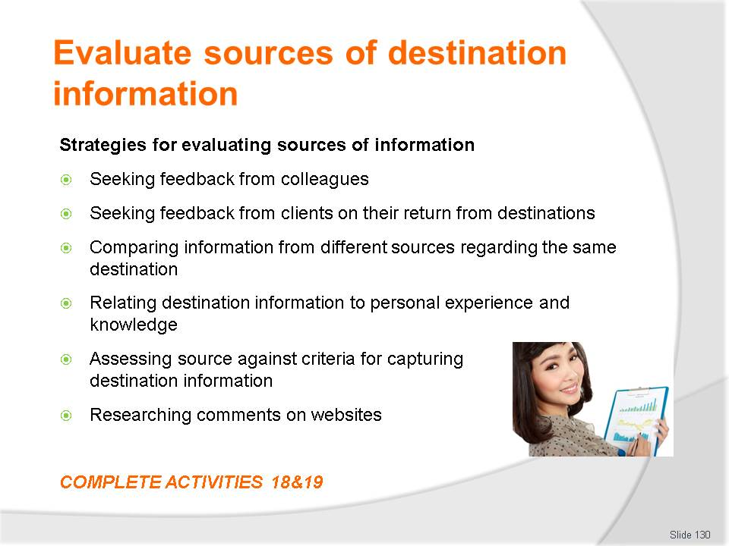
Slide No | Trainer Notes
Class Activity – Discussion & Activities
Ask general questions:
- Explain tasks associated with each of these points
- Complete Activities 18&19.

Slide
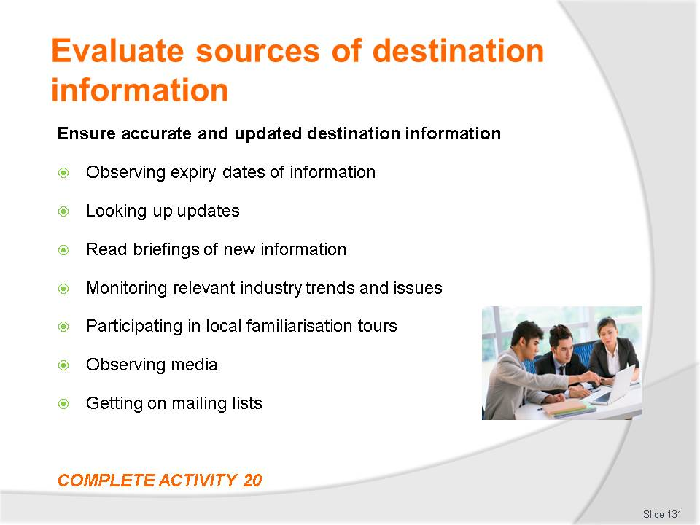
Slide No | Trainer Notes
Class Activity – Discussion & Activity
Ask general questions:
- Explain tasks associated with each of these points
- Complete Activity 20.

Slide
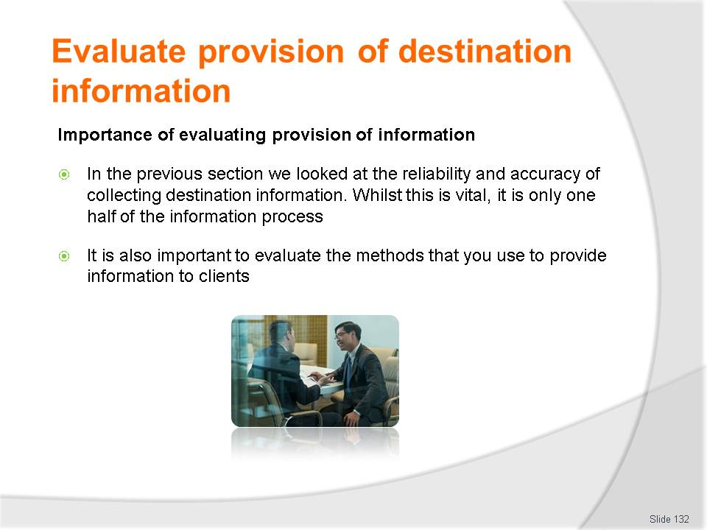
Slide No | Trainer Notes
Class Activity – Discussion
Ask general questions:
- Why is this important?
- How will this process differ?

Slide
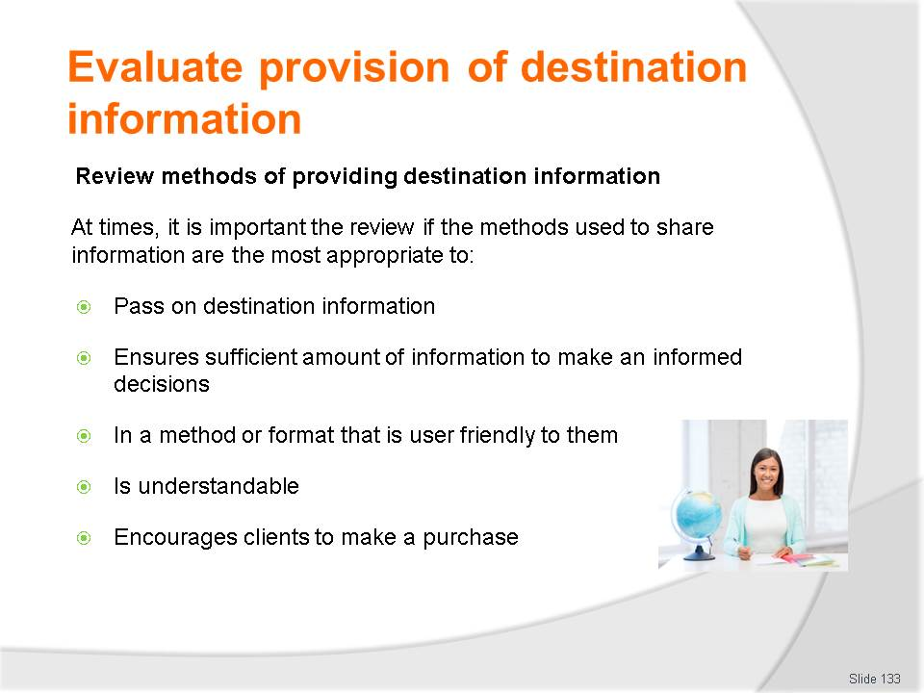
Slide No | Trainer Notes
Class Activity – Discussion
Ask general questions:
- What other considerations would you have?

Slide
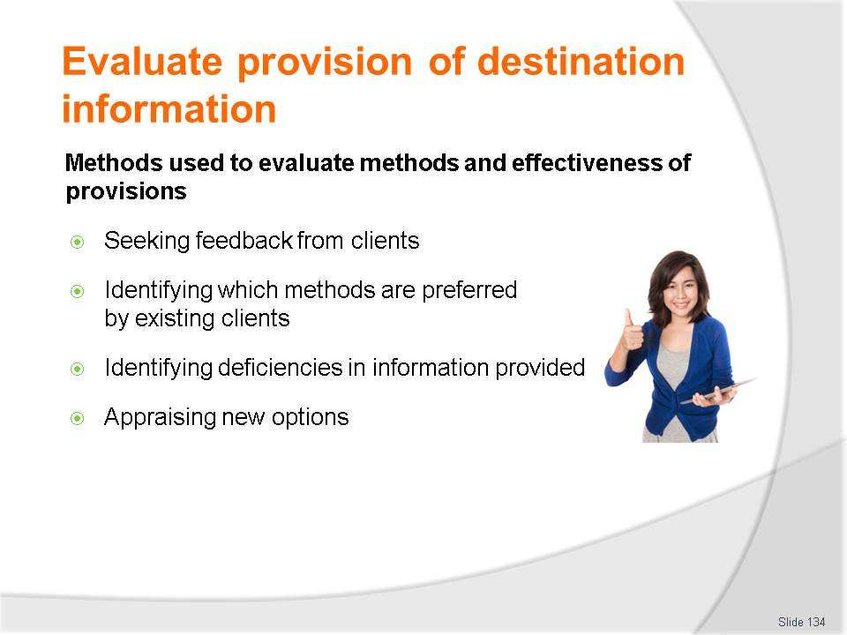
Slide No | Trainer Notes
Class Activity – Discussion
Ask general questions:
- What information would you wish to gather using each of these methods?

Slide
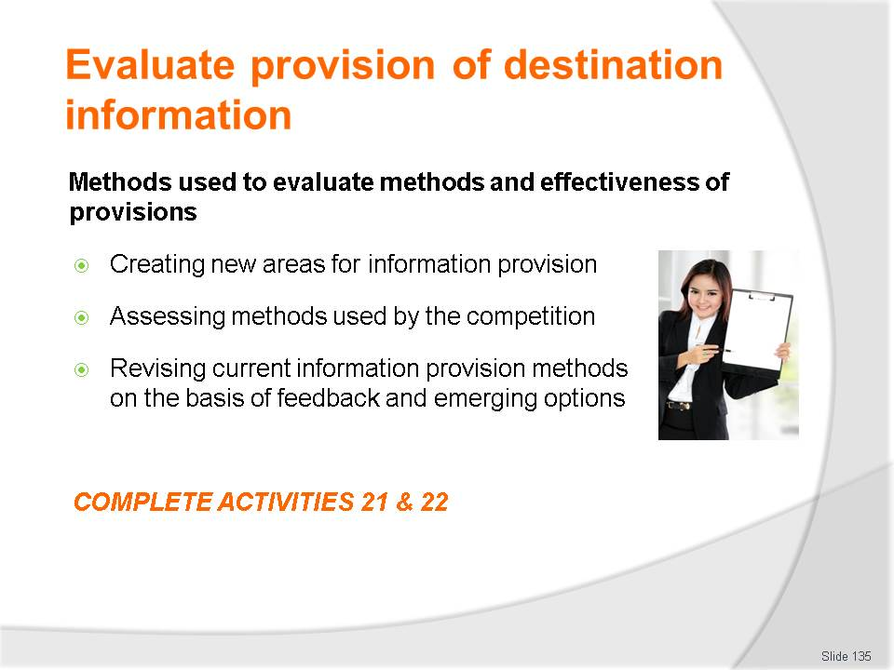
Slide No | Trainer Notes
Class Activity – Discussion & Activities
Ask general questions:
- What information would you wish to gather using each of these methods?
- Activities 21&22.

Slide
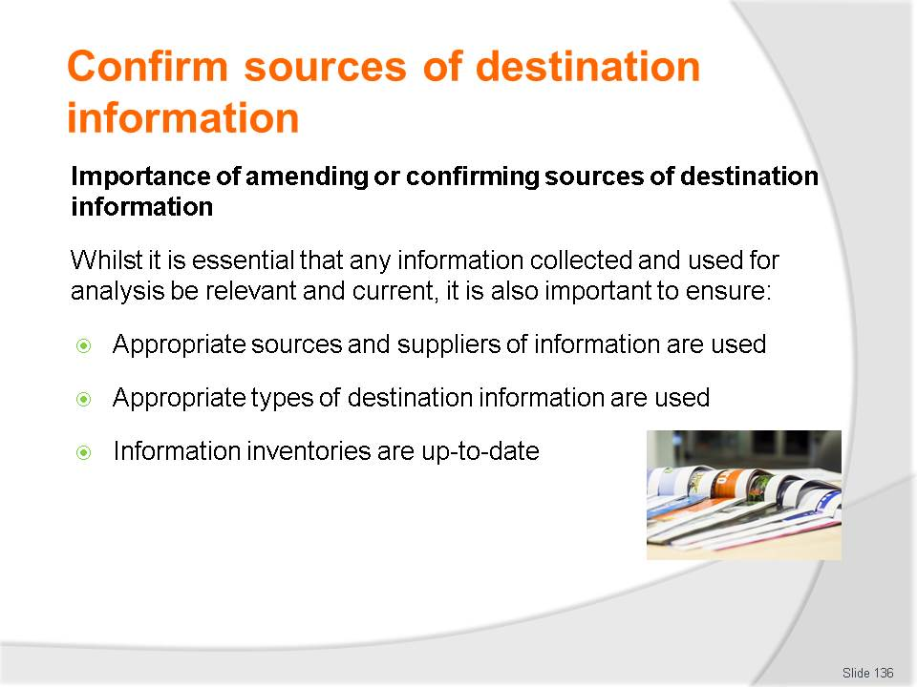
Slide No | Trainer Notes
Class Activity – Discussion
- Discuss the importance of these points.

Slide
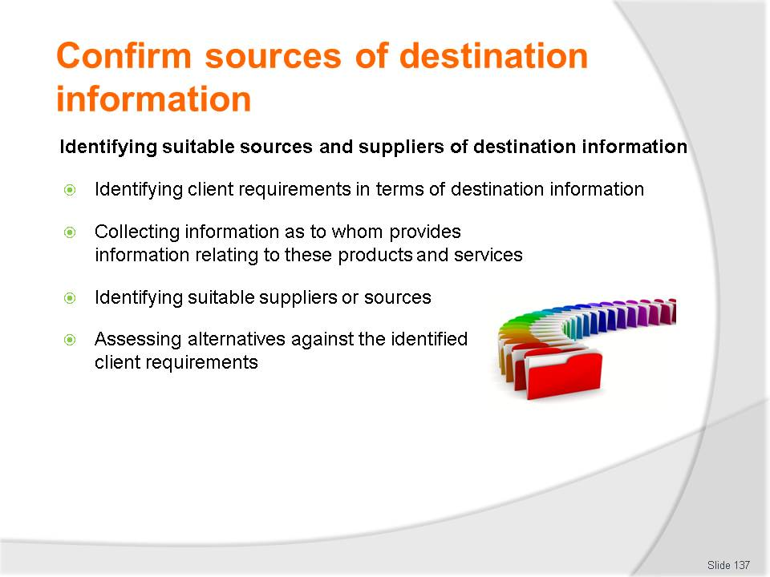
Slide No | Trainer Notes
Class Activity – Discussion
- Discuss the importance of these points.

Slide
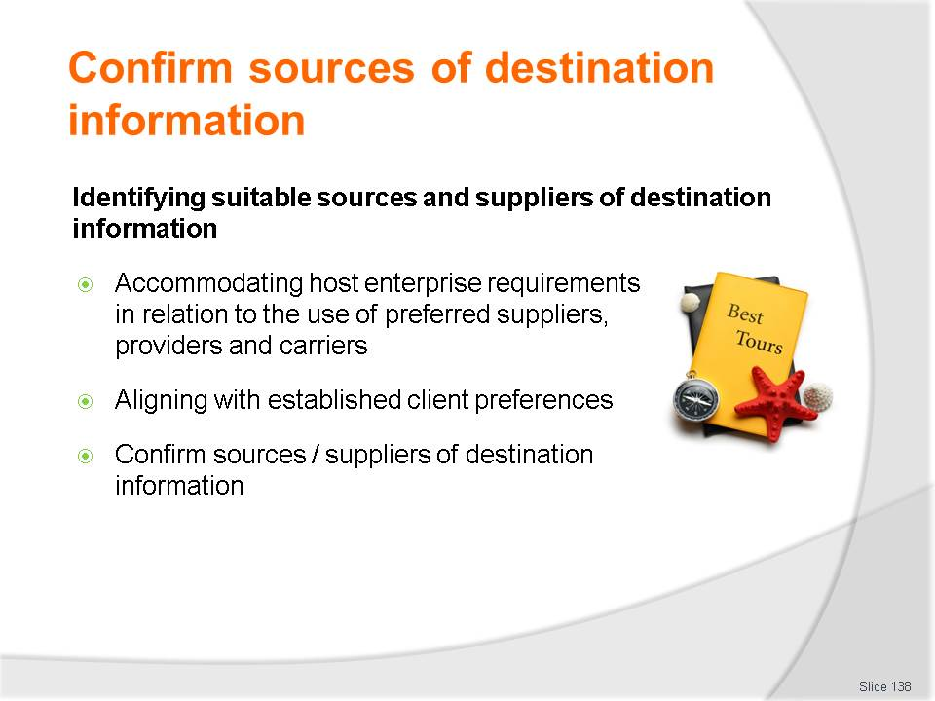
Slide No | Trainer Notes
Class Activity – Discussion
- Discuss the importance of these points.

Slide
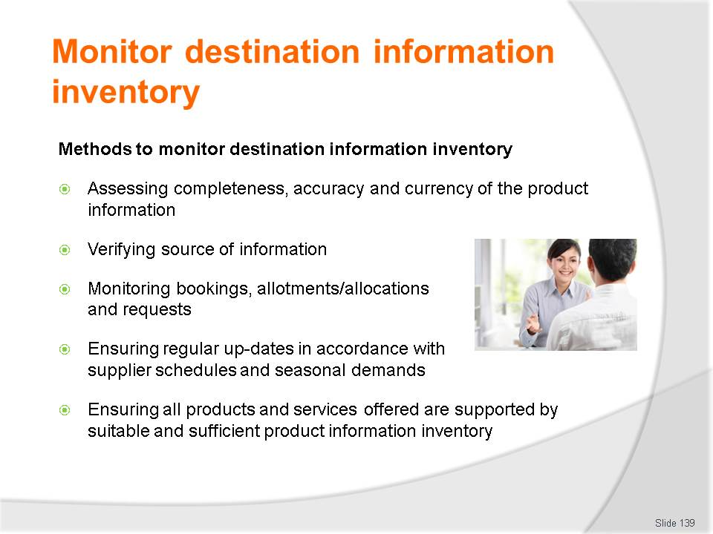
Slide No | Trainer Notes
Class Activity –Discussion
- What else can you do
- Provide examples of these points.

Slide
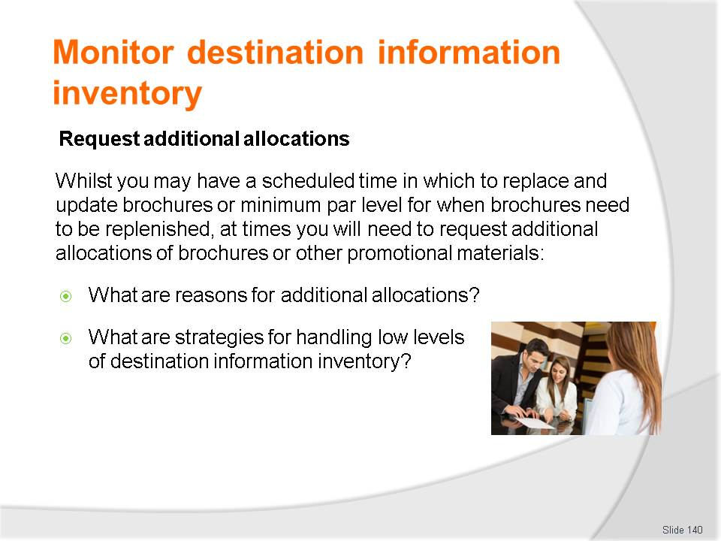
Slide No | Trainer Notes
Class Activity –Discussion
- Discuss questions in the slide.

Slide
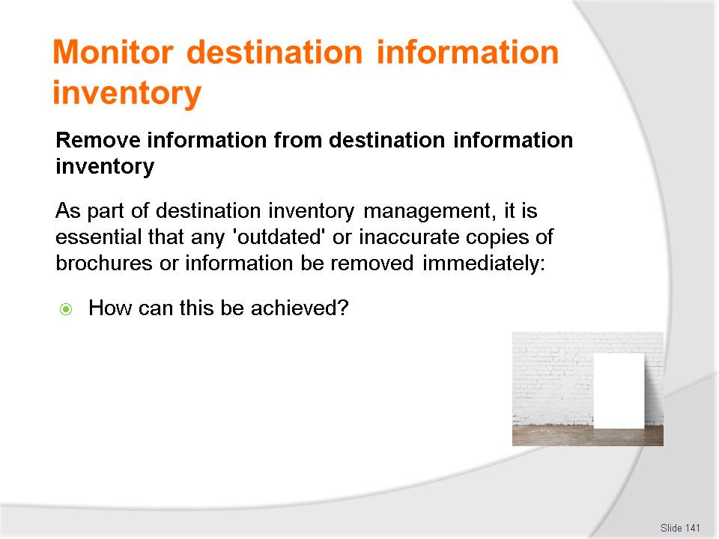
Slide No | Trainer Notes
Class Activity –Discussion
- Discuss questions in the slide.

Slide
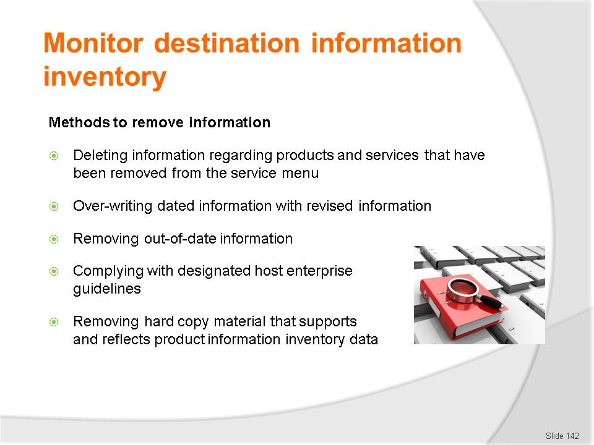
Slide No | Trainer Notes
Class Activity –Discussion
- Discuss points in the slide.

Slide
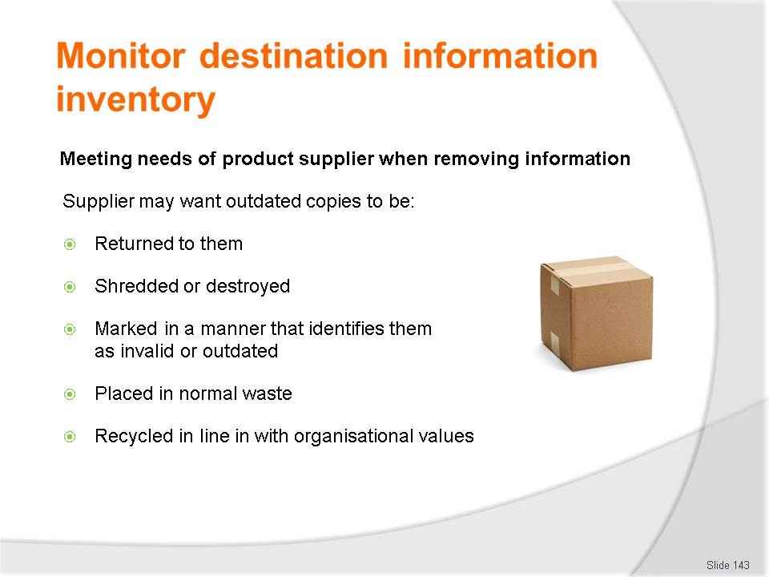
Slide No | Trainer Notes
Class Activity –Discussion
- Why is it important to contact suppliers when removing their brochures?

Slide
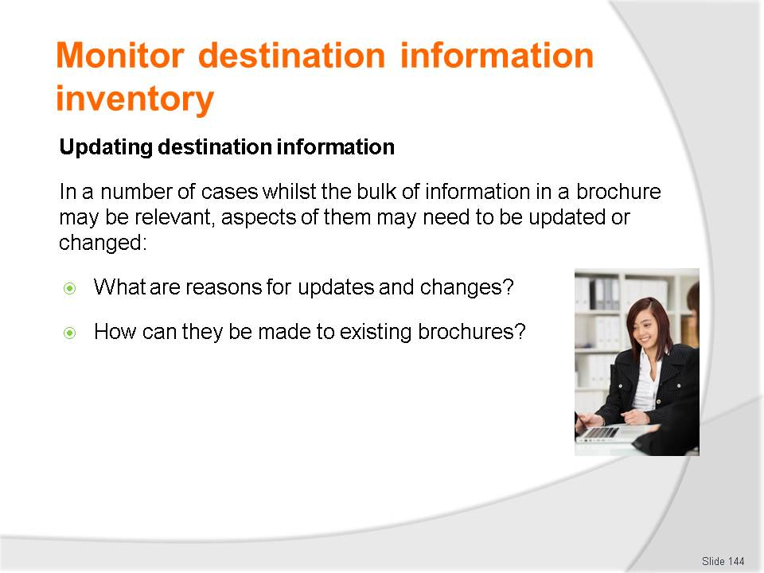
Slide No | Trainer Notes
Class Activity –Discussion
- Discuss questions in the slide.

Slide
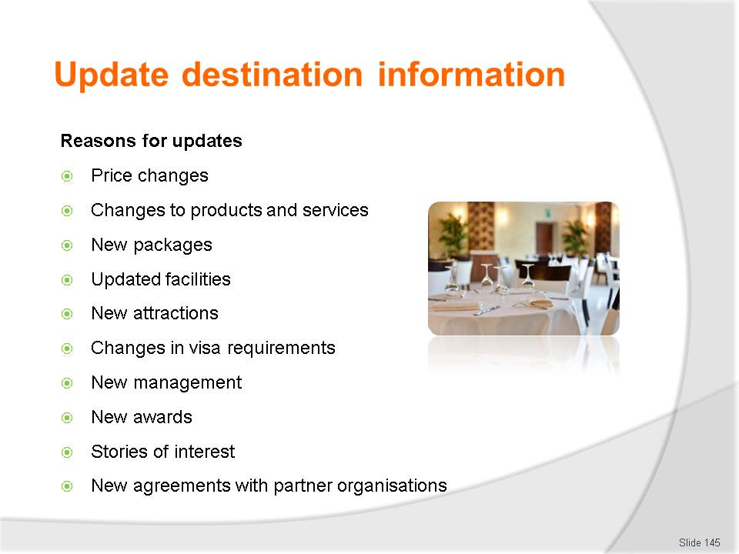
Slide No | Trainer Notes
Class Activity –Discussion
- What are other reasons?

Slide
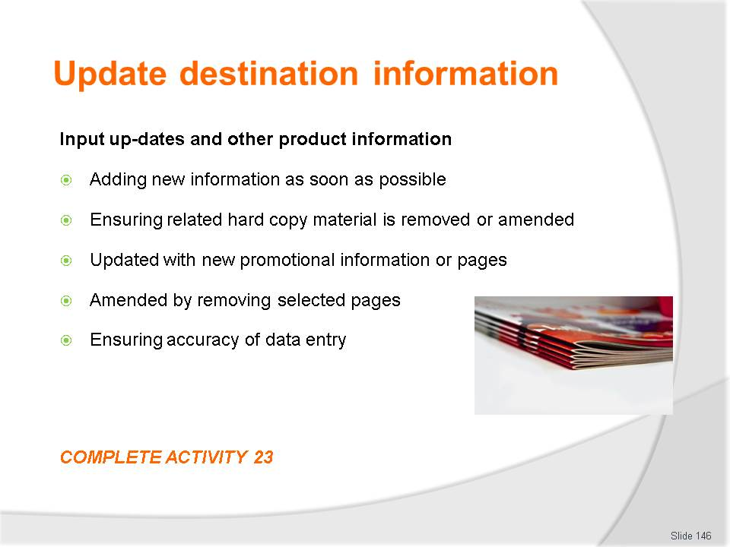
Slide No | Trainer Notes
Class Activity –Discussion & Activity
- Complete Activity 23.

Slide
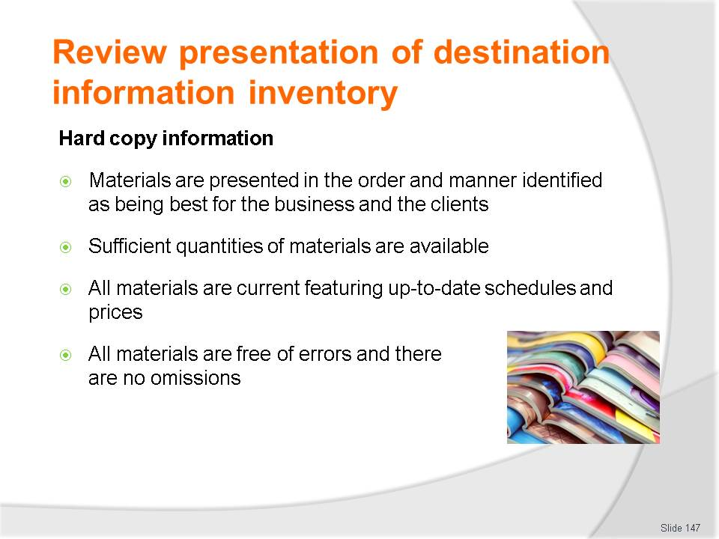
Slide No | Trainer Notes
Class Activity –Discussion
- What else can you do to manage hard copy materials?

Slide
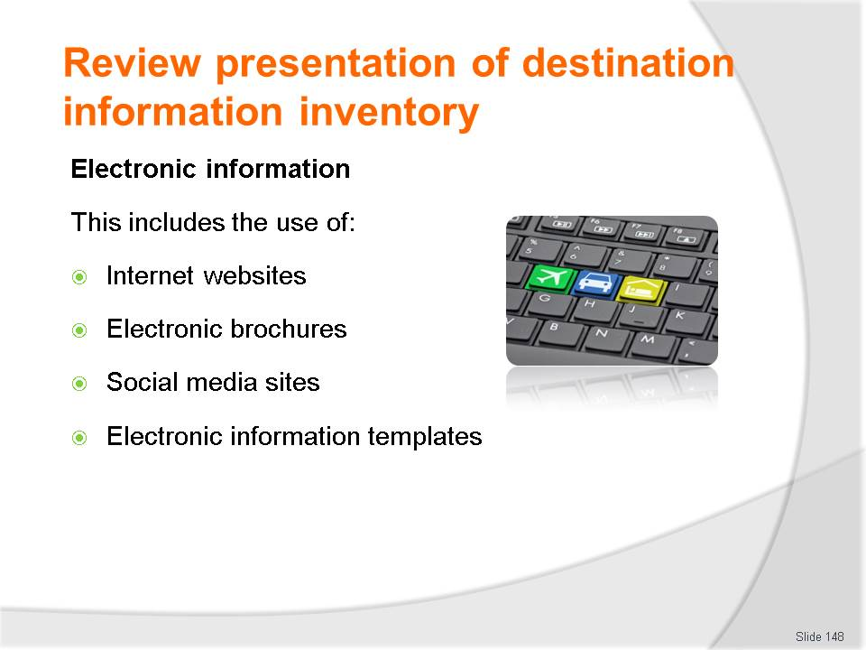
Slide No | Trainer Notes
Class Activity –Discussion
- What else can you do to manage electronic information?

Recommended training equipment
- Access to Global Distribution Systems:
- Travelport (Galileo, & Apollo)
- Travelport (Worldspan)
- Amadeus
- Sabre
- Booking conditions
- Computer and internet access
- Computerised systems
- Examples of travel documentation
- Examples of information relating to different tourism businesses:
- Transportation
- Airlines
- Cruise operators
- Railway operators
- Bus lines
- Car rental businesses
- Limousine hire
- Taxis
- Travel insurance providers
- Finance providers
- Currency exchange
- Conference and similar venues
- Interpreters
- Hotels and motels
- Guest houses
- Bed and breakfasts
- Caravan parks and camping grounds
- Resorts
- Time share properties
- Apartments, villas and cottages
- Conference and exhibition centres
- Museums and galleries
- National parks, wildlife parks and gardens
- Theme parks
- Heritage sites and centres
- Sport and activity centres
- Aquarium and zoos
- Tour Operators
- Inbound Tour Wholesaler
- Outbound Tour Wholesaler
- Retail Travel Agents
- Local, regional and national information services
- Ministries of Tourism
- Tourism Boards
- Examples of types of information:
- Destination information
- Local community information
- Tours
- Attractions
- Activities
- History
- Geographical features
- Local customs and culture
- Climate
- Accommodation
- Amenities and services
- Examples of different information formats:
- Brochures, flyers and pamphlets
- Product manuals
- Supplier information and sales kits
- Confidential and general industry tariffs
- Preferred contracts or agreements
- Clue cards
- Fare sheets
- Industry publications, advices and notices
- Videos
- Posters
- Timetables
- Atlases and maps
- Travel literature
- Travel Guides
- Newspapers and magazines
- Internal databases
- Online product training modules
- Formal quotation and itinerary templates
- Manual filing systems
- Terms and conditions including:
- Travel Agent Terms and Conditions
- Supplier Terms and Conditions
- Product or service provider terms and conditions.

Instructions for Trainers for using
PowerPoint – Presenter View
Connect your laptop or computer to your projector equipment as per manufacturers’ instructions.
In PowerPoint, on the Slide Show menu, click Set up Show.
Under Multiple monitors, select the Show Presenter View check box.
In the Display slide show on list, click the monitor you want the slide show presentation to appear on.
Source: http://office.microsoft.com
Note:
In Presenter View:
You see your notes and have full control of the presentation
Your trainees only see the slide projected on to the screen
More Information
You can obtain more information on how to use PowerPoint from the Microsoft Online Help Centre, available at: http://office.microsoft.com/training/training.aspx?AssetID=RC011298761033
Note Regarding Currency of URLs
Please note that where references have been made to URLs in these training resources trainers will need to verify that the resource or document referred to is still current on the internet. Trainers should endeavour, where possible, to source similar alternative examples of material where it is found that either the website or the document in question is no longer available online.

Appendix – ASEAN acronyms
AADCP | ASEAN – Australia Development Cooperation Program
ACCSTP | ASEAN Common Competency Standards for Tourism Professionals
AEC | ASEAN Economic Community
AMS | ASEAN Member States
ASEAN | Association of Southeast Asian Nations
ASEC | ASEAN Secretariat
ATM | ASEAN Tourism Ministers
ATPMC | ASEAN Tourism Professionals Monitoring Committee
ATPRS | ASEAN Tourism Professional Registration System
ATFTMD | ASEAN Task Force on Tourism Manpower Development
CATC | Common ASEAN Tourism Curriculum
MRA | Mutual Recognition Arrangement
MTCO | Mekong Tourism Coordinating office
NTO | National Tourism Organisation
NTPB | National Tourism Professional Board
RQFSRS | Regional Qualifications Framework and Skills Recognition System
TPCB | Tourism Professional Certification Board





